**Building Microservices on .Net using Asp.Net Web API, Docker, RabbitMQ,Ocelot API Gateway, MongoDB,Redis,SqlServer**

<https://cognizant.udemy.com/course/microservices-architecture-and-implementation-on-dotnet/learn/lecture/25664486#overview>

24.5 hours Total Last updated November 2021

**Instructor** [Mehmet Özkaya](https://cognizant.udemy.com/user/ff0e5c8c-dd71-443e-be0a-e73ba821f7d7/) Software Architect **GitHub** : **mehmetozkaya** **GitHub** : **aspnetrun**

<https://medium.com/aspnetrun/microservices-architecture-on-net-3b4865eea03f>

<https://github.com/aspnetrun/run-aspnetcore-microservices>

<https://github.com/PerProjBackup/AspnetMicroservices-UdMO>

<https://hub.docker.com/> <https://hub.docker.com/_/mongo/> <https://nuget.org/packages>

<https://docs.microsoft.com/en-us/aspnet/core/web-api/action-return-types?view=aspnetcore-5.0>

<https://hub.docker.com/r/mongoclient/mongoclient> <https://docs.portainer.io/v/ce-2.9/start/intro>

<https://hub.docker.com/r/portainer/portainer-ce> https://hub.docker.com/_/postgres

<https://pgAdmin.org> <https://hub.docker.com/_/postgres>

<https://www.pgadmin.org/docs/pgadmin4/latest/container_deployment.html>

<https://github.com/aspnetrun/run-aspnet-grpc>

<https://medium.com/aspnetrun/using-grpc-in-microservices-for-building-a-high-performance-interservice-communication-with-net-5-11f3e5fa0e9d>

RabbitMQ: un: guest; pw: guest

Portainer: un: admin; pw: admin1234

pgAdmin PostgreSQL: un: admin@aspnetrun.com; pw: admin1234

E:\DevProj\Udemy-Cogn\run-aspnetcore-mcosrvs\AspnetMicroservices\src

Catalog.API http://localhost:5000/swagger/index.html

docker pull mongo

docker run -d -p 27017:27017 --name shopping-mongo mongo

docker exec -it shopping-mongo /bin/bash

ls mongo show dbs use CatalogDb db.createCollection('Products') db.Products.insertMany([{…}]) db.Products.find({}).pretty() db.Products.remove({})

show databases show collections db.Products.find({}).pretty()

docker ps -a docker start 4characters docker stop 4characters docker compose

docker rm 4characters docker rmi 4characters

docker-compose -f docker-compose.yml -f docker-compose.override.yml up -d

docker-compose -f docker-compose.yml -f docker-compose.override.yml up --build

docker-compose -f docker-compose.yml -f docker-compose.override.yml down

docker ps -aq docker stop $(docker ps -aq) docker rm $(docker ps -aq)

docker rmi $(docker images -q) docker system prune

docker run -d -p 3000:3000 mongoclient/mongoclient

docker pull redis docker run -d -p 6379:6379 --name aspnetrun-redis redis

docker logs -f aspnetrun-redis docker exec -it aspnetrun-redis /bin/bash

root@04fb97a17a22:/data# redis-cli docker volume create portainer_datadocker run -d -p 8000:8000 -p 9443:9443 --name portainer --restart=always -v var/run/docker.sock:/var/run/docker.sock -v portainer_data:/data cr.portainer.io/portainer/portainer-ce:2.9.3 docker pull portainer/portainer-ce Portainer Username admin; password: admin1234

docker pull postgres

docker run --name some-postgres -e POSTGRES_PASSWORD=mysecretpassword -d postgres

docker pull dpage/pgadmin4

docker run -p 80:80 -e 'PGADMIN_DEFAULT_EMAIL=user@domain.com' -e 'PGADMIN_DEFAULT_PASSWORD=SuperSecret' -e 'PGADMIN_CONFIG_ENHANCED_COOKIE_PROTECTION=True' -e 'PGADMIN_CONFIG_LOGIN_BANNER="Authorised users only!"' -e 'PGADMIN_CONFIG_CONSOLE_LOG_LEVEL=10' -d dpage/pgadmin4 POSTGRES user=admin password=admin1234 docker pull dpage/pgadmin4

Basket.API microservice repository docker-compose and docker-compose.override

**What you'll learn**

* ASPNET Core Web API Development of Microservices
* REST API Principles, CRUD Operations
* Mongo DB and Redis NoSQL Database Connection on Docker
* Entity Framework Core with SQL Server Database Connection on Docker
* N-Layer implementation with Repository Pattern
* Swagger Open API implementation
* Consume Discount Grpc Service for inter-service sync communication to calculate product final price
* Publish BasketCheckout Queue with using MassTransit and RabbitMQ
* Build a Highly Performant inter-service gRPC Communication with Basket Microservice
* Using Dapper for micro-orm implementation to simplify data access and ensure high performance
* PostgreSQL database connection and containerization
* Async Microservices Communication with RabbitMQ Message-Broker Service
* Using RabbitMQ Publish/Subscribe Topic Exchange Model
* Using MassTransit for abstraction over RabbitMQ Message-Broker system
* Implementing DDD, CQRS, and Clean Architecture with using Best Practices
* Developing CQRS with using MediatR, FluentValidation and AutoMapper packages
* Consuming RabbitMQ BasketCheckout event queue with using MassTransit-RabbitMQ Configuration
* Using Entity Framework Core ORM and auto migrate to SqlServer when application startup
* Ocelot API Gateway Development of Microservices
* Call Ocelot APIs with HttpClientFactory
* The Gateway aggregation pattern in Shopping Aggregator
* ASPNET Core Web Application with Bootstrap 4 and Razor template
* Docker Compose Containerization of All Microservices
* Use Portainer for Container lightweight management UI which allows you to easily manage your different Docker environments
* pgAdmin PostgreSQL Tools feature rich Open Source administration and development platform for PostgreSQL

**Description**

*This course comes from a* ***live github aspnetrun microservices repository*** *which verified from community with* ***870+ stars*** *and* ***500+ forks.***

You will learn how to build **Microservices on .Net** platforms which used **Asp.Net Web API, Docker, RabbitMQ, MassTransit, Grpc, Ocelot API Gateway, MongoDB, Redis, PostgreSQL, SqlServer, Dapper, Entity Framework Core, CQRS** and **Clean Architecture** implementation with **24.5 hours** fully upgraded videos.

You will develop **e-commerce** modules over **Product, Basket** and **Ordering** microservices with **NoSQL (MongoDB, Redis)** and **Relational databases (PostgreSQL, Sql Server)** with communicating over **RabbitMQ Event Driven Communication** and using **Ocelot API Gateway**. You can find **Microservices Architecture and Step by Step Implementation on .NET** which **step by step developing** this course with extensive explanations and details.

Along with this you’ll develop following microservices and items:

**Catalog microservice which includes;**

* ASP.NET Core Web API application
* REST API principles, CRUD operations
* **MongoDB database** connection and containerization
* Repository Pattern Implementation
* Swagger Open API implementation

**Basket microservice which includes;**

* ASP.NET Web API application
* REST API principles, CRUD operations
* **Redis database** connection and containerization
* **Consume** Discount **Grpc Service** for inter-service sync communication to calculate product final price
* **Publish** BasketCheckout Queue with using **MassTransit and RabbitMQ**

**Discount microservice which includes;**

* ASP.NET **Grpc Server** application
* Build a Highly Performant **inter-service gRPC Communication** with Basket Microservice
* Exposing Grpc Services with creating **Protobuf messages**
* Using **Dapper for micro-orm implementation** to simplify data access and ensure high performance
* **PostgreSQL database** connection and containerization

**Microservices Communication**

* Sync inter-service **gRPC Communication**
* Async Microservices Communication with **RabbitMQ Message-Broker Service**
* Using **RabbitMQ Publish/Subscribe Topic** Exchange Model
* Using **MassTransit** for abstraction over RabbitMQ Message-Broker system
* Publishing BasketCheckout event queue from Basket microservices and Subscribing this event from Ordering microservices
* Create **RabbitMQ EventBus.Messages library** and add references Microservices

**Ordering Microservice**

* Implementing **DDD, CQRS, and Clean Architecture** with using Best Practices
* Developing **CQRS with using MediatR, FluentValidation and AutoMapper packages**
* Consuming **RabbitMQ** BasketCheckout event queue with using **MassTransit-RabbitMQ** Configuration
* **SqlServer database** connection and containerization
* Using **Entity Framework Core ORM** and auto migrate to SqlServer when application startup

**API Gateway Ocelot Microservice**

* Implement **API Gateways with Ocelot**
* Sample microservices/containers to reroute through the API Gateways
* Run multiple different **API Gateway/BFF** container types
* The **Gateway aggregation pattern** in Shopping.Aggregator

**WebUI ShoppingApp Microservice**

* ASP.NET Core Web Application with Bootstrap 4 and Razor template
* Call **Ocelot APIs with HttpClientFactory**
* ASPNET Core Razor Tools — View Components, partial Views, Tag Helpers, Model Bindings and Validations, Razor Sections etc.

**Ancillary Containers**

* Use **Portainer** for Container lightweight management UI which allows you to easily manage your different Docker environments
* **pgAdmin PostgreSQL Tools** feature rich Open Source administration and development platform for PostgreSQL

**Docker Compose establishment with all microservices on docker;**

* **Containerization** of microservices
* Containerization of databases
* Override Environment variables

On top of all these, you'll learn **how to write quality code,** not just how to build microservices. In this course you will see the demonstrating a **layered application architecture** with **DDD** best practices. Implements NLayer **Hexagonal architecture** (Core, Application, Infrastructure and Presentation Layers) and **Domain Driven Design** (Entities, Repositories, Domain/Application Services, DTO's...) and aimed to be a **Clean Architecture**, with applying **SOLID principles** in order to use for a project template. Also implements **best practices** like **loosely-coupled, dependency-inverted** architecture and using **design patterns** such as **Dependency Injection**, logging, validation, exception handling and so on.

**Is this course for you?**

This course is very practical, about 90%+ of the lessons will involve you coding along with me on this project. If you are the type of person who gets the most out of learning by doing, then this course is definitely for you.

**Tools you need for this course**

In this course all the lessons are demonstrated using Visual Studio 2019 as a code editor. You can of course use any code editor you like and any Operating system you like as long as it's Windows or Mac. Also using Docker Desktop in order to use different database providers.

**Who this course is for:**

* Beginner of AspNet Core developers who interested in APIs and Microservices
* C# developers interested in learning how to build Microservices on .Net
* Senior Developers who want to engage with Microservices on .Net

**Requirements**

* C# knowledge (generics, async/await, anonymous methods, action, predicate)
* Aspnet core basics knowledge

Course Content

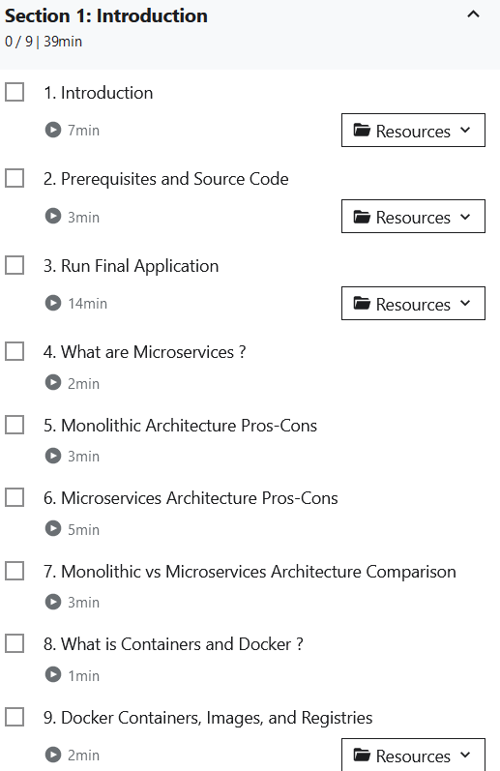 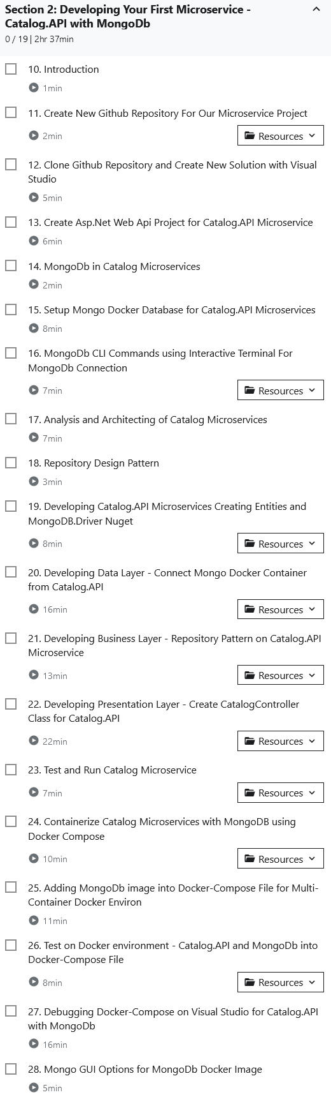

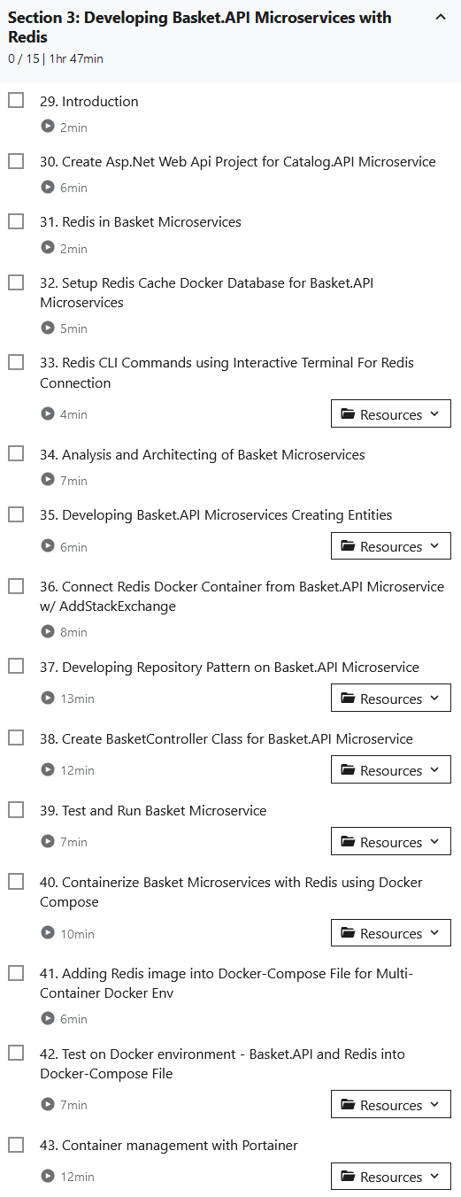 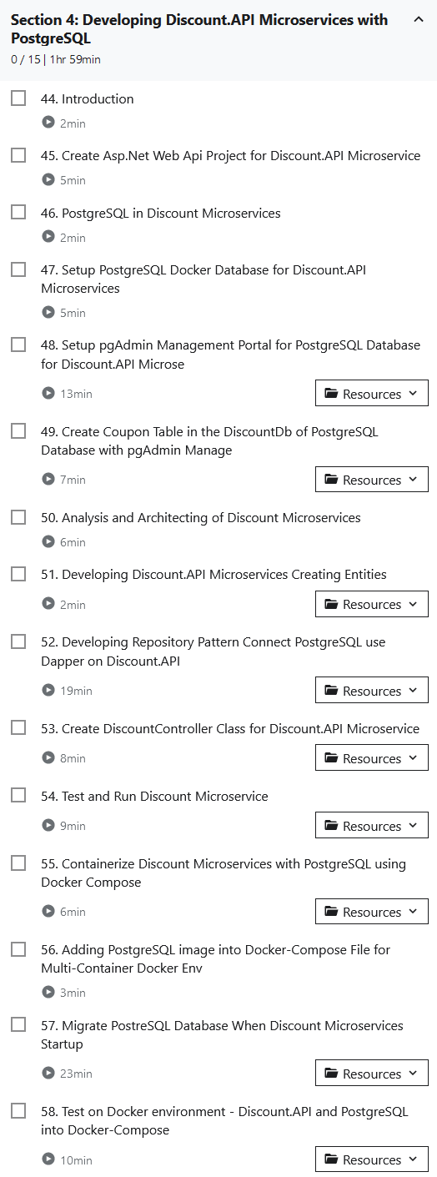

**Section 1: Introduction 9 39min**

**1. Introduction 7min**

Microservices Architecture on .NET with applying CQRS, Clean Architecture and Event-Driven Communication

Hi, my name is Mehmet Ozkaya and Welcome to my course, Microservices Architecture and Implementation on .Net. I am a software architect and currently focusing on the microservices architecture design and the implementations. In this course, we're going to learn how to design and developing microservices with using .net platforms. This project will includes Microservices Development and Containerization with Asp.Net Web API, Docker, Microservices Communications with using RabbitMQ, MassTransit, Grpc. We will following the API Gateways with Ocelot API Gateway, storing Different databases like MongoDB, Redis, PostgreSQL, SqlServer. And using best practices with applying the Entity Framework Core, Dapper, CQRS and Clean Architecture implementation.

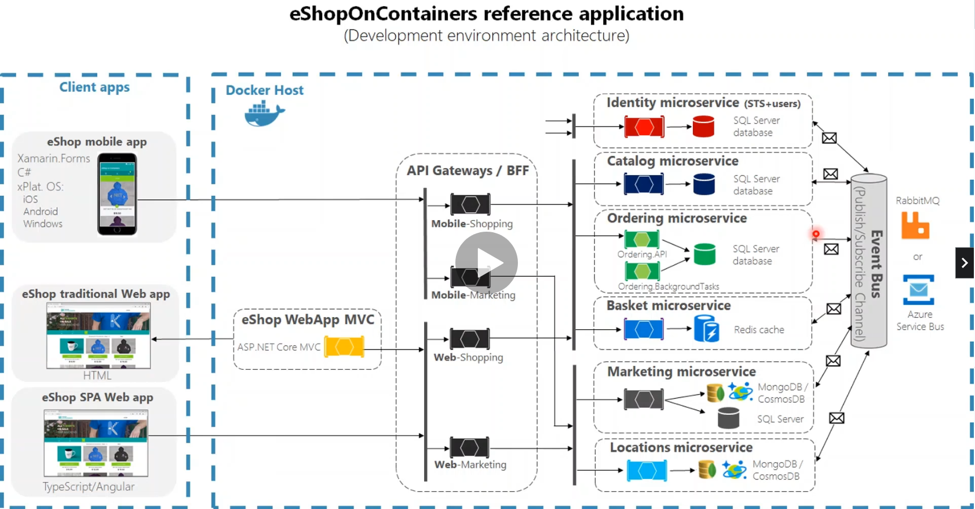

Here is the Sample eShopOnContainers .NET Microservices Reference Application This Sample application, powered by Microsoft, based on a simplified microservices architecture and Docker containers.

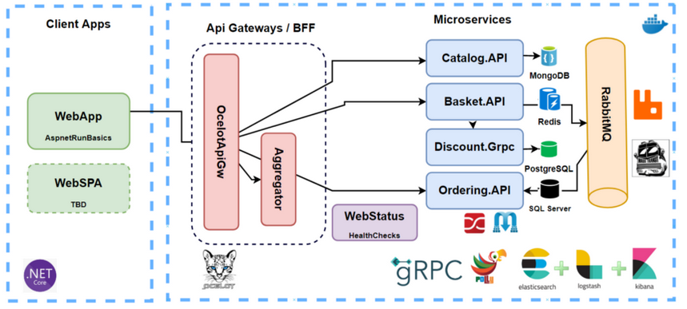

<https://medium.com/aspnetrun/microservices-architecture-on-net-3b4865eea03f>

So we are going to follow this reference application and create our own e-commerce microservice application with using latest implementation and best practices on cloud-native microservices architecture. See the our big picture what we are going to develop Microservices Architecture and Step by Step Implementation with together. There is a couple of microservices which implemented e-commerce modules like Catalog, Basket, Discount and Ordering microservices And this microserices datas will store NoSQL (MongoDB, Redis) and also Relational databases (PostgreSQL, Sql Server). Of course, with communicating over RabbitMQ Event Driven Communication and using Ocelot API Gateway. transit and as a API gateway, we are going to use Ocelot API Gateway. Also will includes Cross-Cutting concerns in following course which is Implementing Centralized Distributed Logging with Elasticsearch and Kibana.

The course proposes a microservice oriented architecture implementation with multiple autonomous microservices and each one owning its own databases with seeding some data and implementing different design approaches within each microservice, for example simple CRUD or Domain Driven Design DDD/CQRS design patterns implementations. and using Http and Grpc as the communication protocol between the microservices and supports asynchronous communication for microservices updates across multiple services based on Integration Events and an Event Bus as a RabbitMQ.

Let me give a brief about the microservices. The first one is the **Catalog** microservices which includes ASP.NET Core Web API application, Following REST API principles, performing CRUD operations Using MongoDB database connection and containerization, applying Repository Pattern Implementation Swagger Open API implementation

In the second microservice will be the **Basket** microservices which includes ASP.NET Web API application Following REST API principles, CRUD operations, using Redis database connection and containerization and Basket. API also will consume Discount Grpc Service for inter-service sync communication to calculate product final price. And also Basket microservices will publish BasketCheckout Queue event to the RabbitMQ with using MassTransit.

So the third one is the **Discount.Grpc** microservices, which includes the ASP.NET Grpc Server application and Build a Highly Performant inter-service gRPC Communication with Basket Microservices Exposing Grpc Services with creating Protobuf messages, Using Dapper for micro-orm implementation to simplify data access and ensure high performance and PostgreSQL database connection and containerization. And also, we will create an **API Gateway laye**r in the API Gateway we will use Ocelot microservices this will be implementing the API gateways with Ocelot and will implement Sample microservices/containers to reroute through the API Gateways. And Runing multiple different API Gateway/BFF container types

And implementing the Gateway aggregation pattern in Shopping.Aggregator microservices.

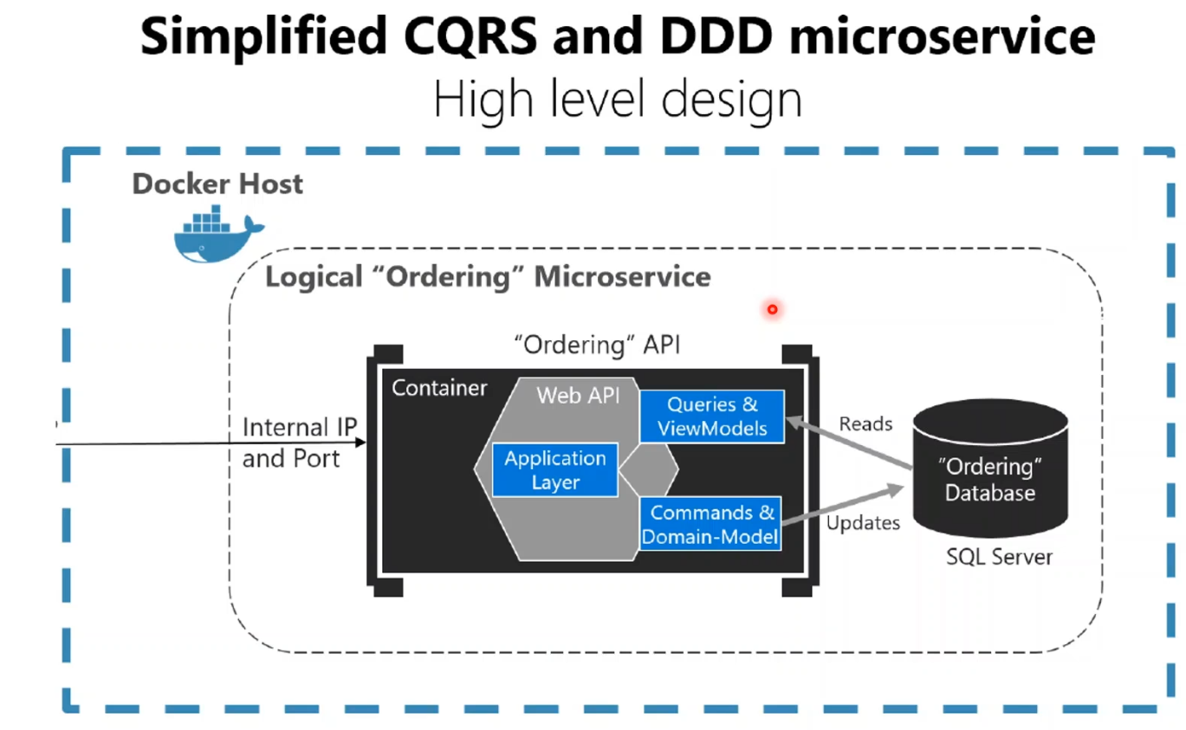

And the other one is the **Ordering.API** microservices In the Ordering microservices, we basically Implementing DDD, CQRS, and Clean Architecture with using Best Practices. will developing CQRS with using MediatR, FluentValidation and AutoMapper nuget packages. We will Consuming RabbitMQ BasketCheckout event queue with using MassTransit-RabbitMQ Configuration MassTransit-RabbitMQ Configuration. and using SqlServer database connection and containerization. And in this microservices, we will using the Using Entity Framework Core ORM and auto migrate to SqlServer when the application startup.

<https://github.com/aspnetrun/run-aspnetcore-microservices>

So This course comes from a live github repository that community develop and grow with together.

I am also developing aspnetrun repositories on Github and create courses from these repositories.

So this course is the main repository of the aspnetrun ecosystem and this is a lively course and evolves with repository changes. When repository has changes I will also change this course videos accordingly.

So by the end of this course, you'll learn how to design and developing microservices architecture with using .net platforms. Before beginning the course, you should be familiar with C#, ASP.NET Core and Docker. This course will have good theoretical information but also will be 90% of hands-on development activities. All course steps will developed step by step and together. You can see our reference application in the lecture 3, please check also that video.

I hope you join me on this journey and develop this project with me.

**2. PreReq**

Microservices on .Net platforms which used Asp.Net Web API, Docker, RabbitMQ, MassTransit, Grpc, Ocelot API Gateway, MongoDB, Redis, PostgreSQL, SqlServer, Dapper, Entity Framework Core, CQRS and Clean Architecture implementation.

<https://github.com/aspnetrun/run-aspnetcore-microservices>

In this video, we are going to talk about prerequisites.First of all you don't need to know anything about Microservices Architecture. We will cover all these topics in the course. But this course assumes you have some basic knowledge of C#, .Net Web Applications and Docker Container knowledge. Nevertheless, I will develop all parts from the beginning. So you don't need to worry about that. We will see all the definitions of Microservices, Architectures, Docker Container Process, Databases and so on.

You can find full source code on GitHub. I'm sharing the link in the source of this video.You can fork the repository and if you have any findings of expectations please open an issue on github as well as writing to me on Q&A of the course. I am quick responder on Q&A section. Also we are going to create a new repository and step by step develop together from the beginning. No worries. Bu the main repo will store in aspnetrun organization which I can refactor or adding other features apart from the course.

Let's have a look at the tooling we'll use. First of all, we are going to build our project on .Net 5 Framework. It should be installed on your computer, if you have visual studio its already installed. If you have already installed Visual Studio, it already comes with Visual Studio. We will use Visual studio 2019 or Visual Studio Code for IDE developments. You can use both of them because these tools have great features for functionality. I will use Visual studio 2019 for developing and dockerize our microservice application. Also, we need to install Docker Desktop. Please install Docker Desktop for containerizing our aspnet microservices. Also, we will use Postman, for consuming microservices apis, we will consume over swagger and postman. Of course, we need to download Git on Local and Github Account also will be good, because I will expecting to you develop your repositories on github. In case of any getting error ,I can easily reach your repository and understand where error in your github codebase. as a Operating system I am using Windows 10 but These microservices project is cross-platform at the backend and frontend side, so you can develop repository on mac or linux computers, I will use mostly commands so you can follow course on that operation systems.

If you look at the configuring Docker Desktop, Once Docker for Windows is installed, go to the Settings > Advanced option. From the Docker icon in the system tray, to configure the minimum amount of memory and CPU like this; Memory should be at least 4 GB and CPU should be two. (You are using the WSL 2 backend., so resource limits are managed by Windows.)

**3. Run Final Application**

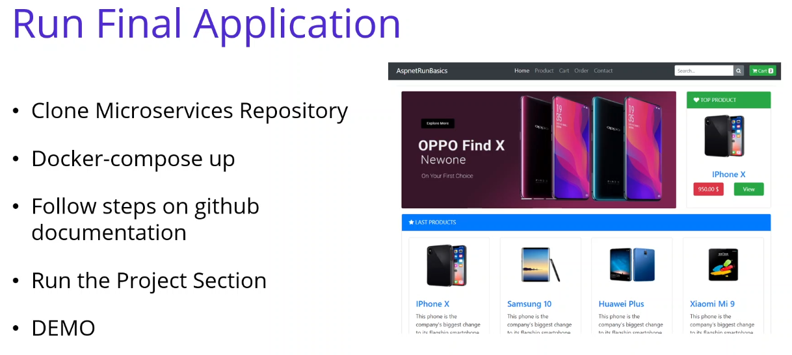

<https://github.com/aspnetrun/run-aspnetcore-microservices>

In this video, we are going to run the final application, We will use docker-compose up command.

So make sure that your Docker Desktop is running on your local computer.So now we are going to following these steps on the github documentation, please open the github aspnetrun repositories and let me open. So this is the aspnetrun organization of github repositories. you can see in here; run-aspnetcore-microservices repository which we are going to build one by one in this course.

So let me scroll down.

This is our big picture and I'm locating the run the project section and the installing part.

We are going to following these steps one by one. So according to these steps we have, the first action is the clone the repository. So before we start, please start your Docker Desktop and Clone this repository. Once Docker for Windows installed We, of course, go to the settings and advanced option and increase the memory as a 4 GB. So after all, we are going to run these docker-compose command. In order to run this command.

I'm going to open the visual studio. After you clone this repository, you will see these micro services and docker-compose files. If we right click to docker-compose item and open in Terminal. We have started the powershell terminal inside of the our microservices repository and in the same direction

of the docker-compose files. if you check the "docker ps" and make sure that docker is running on your local environment. docker is running fine your local environment. And I have no any running container on my local cluster.

docker-compose -f docker-compose.yml -f docker-compose.override.yml up -d

So let me copy and paste this command in here. -d, we are going to run with detach mode, command is "docker-compose" and giving -f docker-compose.yml file and override yaml file for the configurations. And running in the detach mode. Just hit the Enter and see how it is working the containers.

When you are first running this command, it takes maybe more than 10 minutes because you should download all of these images from the DockerHub. But for me, I have already downloaded

That's why it is very fast for me and just for the second time for me. OK, as you can see that we have several microservices, all of them working fine now. If we check the "docker ps" for running containers, you will see that lots of microservices working on my local computer now.

1. You can **launch microservices** as below urls:

* **Catalog API ->** [**http://host.docker.internal:8000/swagger/index.html**](http://host.docker.internal:8000/swagger/index.html)
* **Basket API ->** [**http://host.docker.internal:8001/swagger/index.html**](http://host.docker.internal:8001/swagger/index.html)
* **Discount API ->** [**http://host.docker.internal:8002/swagger/index.html**](http://host.docker.internal:8002/swagger/index.html)
* **Ordering API ->** [**http://host.docker.internal:8004/swagger/index.html**](http://host.docker.internal:8004/swagger/index.html)
* **Shopping.Aggregator ->** [**http://host.docker.internal:8005/swagger/index.html**](http://host.docker.internal:8005/swagger/index.html)
* **API Gateway ->** [**http://host.docker.internal:8010/Catalog**](http://host.docker.internal:8010/Catalog)
* **Rabbit Management Dashboard ->** [**http://host.docker.internal:15672**](http://host.docker.internal:15672) -- guest/guest
* **Portainer ->** [**http://host.docker.internal:9000**](http://host.docker.internal:9000) -- admin/admin1234
* **pgAdmin PostgreSQL ->** [**http://host.docker.internal:5050**](http://host.docker.internal:5050) -- [admin@aspnetrun.com](mailto:admin@aspnetrun.com)/admin1234
* **Elasticsearch ->** [**http://host.docker.internal:9200**](http://host.docker.internal:9200)

So let's following the description inside of the github. So we have waited and compose all microservices and now we are ready to launch these microservices. If we check the big picture, we will open the one by one these microservices and see the RabbitMQ Dashboard. Also check the health checks, Shopping.Aggregator, API Gateway and Web application ... So let's follow the these API Urls. I'm starting with the Catalog.API url This is basically the implementation of the Mongo DB database operation with performing CRUD implementations. Catalog.API is working fine. This Catalog.API is traditional ASP.NET Core Web API application and it is cover REST API principles, CRUD operations MongoDB database connection and containerization and we applied the Repository Pattern Implementation Of course you see that we have a Swagger Open API implementation So the second microservice is the Basket.API. In the basket API is the same with the Catalog microservices

This is the ASP.NET Web API application and implementing the REST API principles, performing CRUD

operations, but this time in Basket.API is using the Redis database and we connect Redis in the Basket.API microservice and containerize this application in the Basket.API and these microservice also Consume Discount Grpc Service for inter-service sync communication to calculate product final price. And this microservice will be publish BasketCheckout Queue with using MassTransit and RabbitMQ.

OK, let me continue to Discount Microservices. Discount.API microservice is also using ASP.NET Web API and following the CRUD operations, I have created Discount API for retrieving and seeing the RESTFull Apis in Swagger environment.

So let's continue with the Discount.Grpc. Discount.Grpc is not in here because there is no user interface for it, but we have also Discount.Grpc microservice which including the ASP.NET Grpc Server application.

We are building a Highly Performant inter-service gRPC Communication with Basket Microservice

and the Discount.Grpc microservices and in the Discount microservices API and Grpc We are going to using Dapper for micro-orm implementation to simplify data access and ensure high performance

operations and for the database discount microservices using the PostgreSQL database connection. And we have all containerization with the PostgreSQL and the discount microservices.

If we continue with the Ordering.API. This is the Ordering.API microservices, it is basically implementing to DDD, CQRS, and Clean Architecture with using Best Practices. We are developing CQRS with using MediatR, FluentValidation and AutoMapper packages. We are consuming RabbitMQ RabbitMQ BasketCheckout event queue with using MassTransit-RabbitMQ Configuration and SqlServer database connection and containerization using in here. As a database, Ordering.API using the SqlServer database.

And of course we are going to use Entity Framework Core ORM and auto migrate to SqlServer when application startup.

If we continue the Shopping.Aggregator And the API gateway microservices. Also, both of them working fine for the API gateway, we are using the Ocelot nuget package, Ocelot microservices, so we have implementing API Gateways with Ocelot nuget packages and we have sample microservices, containers to reroute through the API Gateways

**{.** Returns an empty array, no the catalog as in the video**}**

We are running multiple different API Gateway with using Backend for Frontend BFF container types and the gateway aggregation pattern will be applied in the Shopping.Aggregator microservices. You can see the shopping aggregator we are using to the gateway aggregation pattern in the shopping aggregator. Basically we are providing the user name and these aggregator microservice retrieve information from several microservices behind of the scene. So if we continue with our microservices, you can see the RabbitMQ management dashboard this will login as a guest, guest username and password. So this will cover the queue operations and which we are going to publish queue from the basket microservice and consume from the Ordering microservice. These operations will be seen in the RabbitMQ dashboard and is a Microservice communication, We have Sync inter-service gRPC Communication with the Grpc communication for the basket and the discount microservices. And we have Async Microservices Communication with RabbitMQ Message-Broker Service We are going to use RabbitMQ Publish/Subscribe Topic Exchange Model and using MassTransit

for abstraction over RabbitMQ Message-Broker system. We are going to Publishing BasketCheckout event queue from Basket microservices and Subscribing this event from Ordering microservices. And of course we we are going to Create RabbitMQ EventBus.Messages common library and add references Microservices common library reference into Basket and Ordering microservices. So let me continue to our urls, this is the Portainer. Portainer is a management tool for the Docker containers. We can use Portainer admin - admin1234 admin - admin1234 Let me create a user the first time it needs to create user. And let me refresh. OK, come back to the dashboard. It cannot connect when the first time if we can log out and log in again. Let me login again. admin - admin1234, yes, this time it is asking to in which contain orchestration that you are going to use.

We are going to use Docker We have a Docker environment. Let's connect. OK, this time it is connected properly. If we check the local environment, you can see that the 18 containers is running on my local computer. And also you can see the other details. We have almost 30 images and four networks and 17 volumes and so on. If we click the containers, you can see that all of the running containers on your local computer, Portainer is a management tool for the Docker containers. And let's continue with the other urls, this is the pgAdmin PostgreSQL so we can also connect the PostgreSQL database with using the user pgAdmin interface. We will see in the during the course I'm not going to take in here. And we have also Microservices cross-cutting concerns. Let me open the elasticsearch. You will see the elasticsearch is running in our computer. We are going to implementing Centralized Distributed Logging with Elastic Stack (ELK); which contains Elasticsearch, Logstash, Kibana and SeriLog for Microservices. And we will use the HealthChecks feature in back-end ASP.NET microservices.

* **Kibana ->** [**http://host.docker.internal:5601**](http://host.docker.internal:5601)
* **Web Status ->** [**http://host.docker.internal:8007**](http://host.docker.internal:8007)
* **Web UI ->** [**http://host.docker.internal:8006**](http://host.docker.internal:8006)

1. Launch <http://host.docker.internal:8007> in your browser to view the Web Status. Make sure that every microservices are healthy.
2. Launch <http://host.docker.internal:8006> in your browser to view the Web UI. You can use Web project in order to **call microservices over API Gateway**. When you **checkout the basket** you can follow **queue record on RabbitMQ dashboard**.

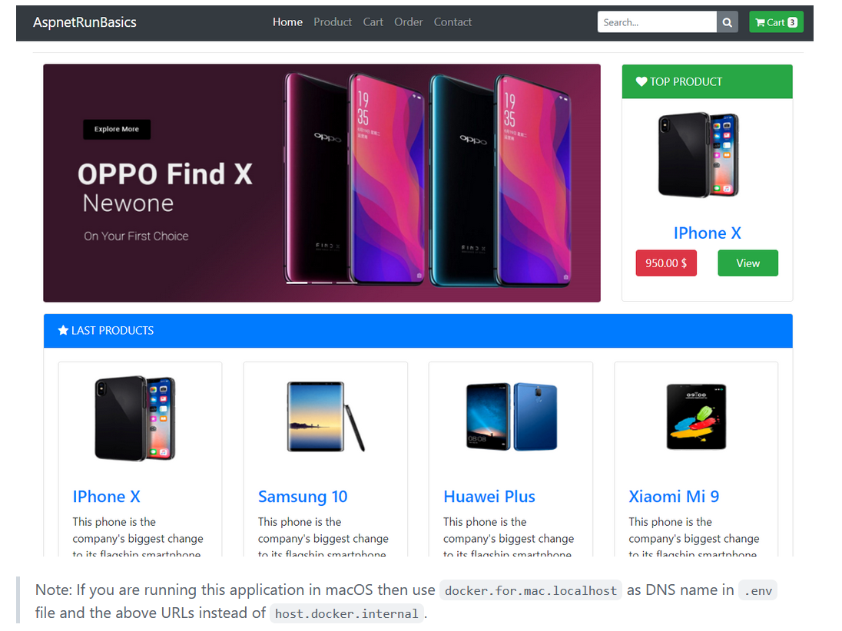

And let me open the WebStatus microservice. This will be use for Health Checks. Also we can see the Kibana, let me open Kibana You will see Kibana is going to come in here and this is the health checks. We are going to using Watchdog in separate service that can watch health and load across services, We are going to report health about the microservices by querying with the HealthChecks. So for example, if you check the Discount microservices, you can see the postgresql is ready or not. And when we are check the Basket microservice, you will see 2 connection, one for the Redis connection, the other for RabbitMQ connection with using mass transit.

OK, so the last one is the Web UI Application. is our Web UI Shopping microservice. This is traditional ASP.NET Core Web Application with Bootstrap 4 and Razor template. And this client application basically

Call Ocelot Api Gateway with consuming internal microservices and using HttpClientFactory and Polly. So we have launched all of the microservices in our browser and we saw that all microservices are healthy.

So now I'm going to perform a quick demo in using to our WebUI Shopping client application. We are going to make a quick demo adding the item into basket and check out the basket and see how we are creating orders. So let me click the products and if I add an item, add to cart, it is basically open. The card section, products comes from the product catalog microservices which retrieving the product information from the Mongo database and adding when we are adding to cart, it is comes from the Basket microservice and adding items into the Redis database. So if you check out these, continue to check out operation, basically it's comes from the checkout page. Let me. fill the blanks Let me provide some information. OK. and now I'm going to check out order, that means basket microservices will be check out the basket and my basket will be the removing and the new order will be creating. And this operation will be handled with the async microservice communication with creating a publishing an event to RabbitMQ and consume from Ordering microservices. Yes, order confirmation is successfully submitted. **{.** Only see the first purple Consumer ack, not the second gray Get (manual ack) **}** So if we check the RabbitMQ, you can see that basket microservice is creating a publishing a new Basket Checkout Event and consuming from the Ordering microservices. So if we check the orders now, you can see the newly created order comes in here.

**{.** Norton blocked Attack: Redis file upload**}**

As you can see that we have run all our microservices and we have provide to see these microservices big picture. And we have also tested a quick demo. with using the Web application from the client application. So let's see the all of the microservices and develop together one by one during the course.

**4. What are Microsservices?** 2 min

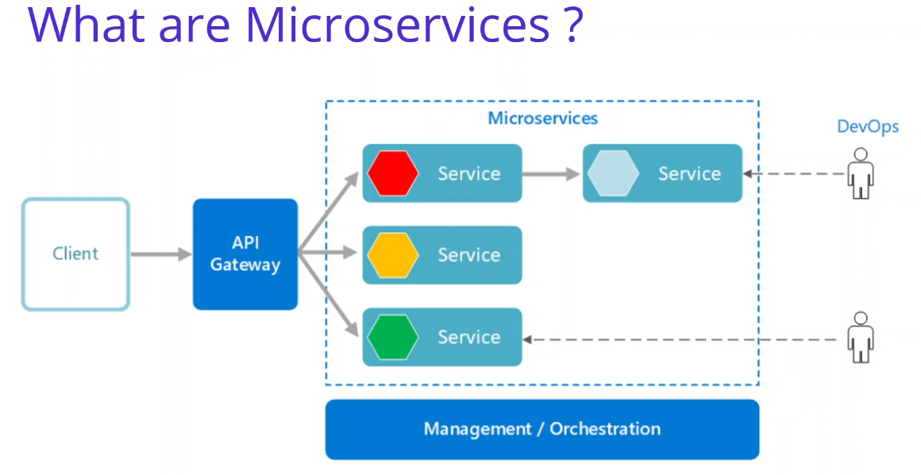

In this video we are going to talk about What are Microservices ? Microservice are small business services that can work together and can be deployed autonomously and independently. These services communicate with each other by talking over the network and bring many advantages with them. One of the biggest advantages is that they can be deployed independently. However, it offers the opportunity to work with many different technologies ,technology agnostic.

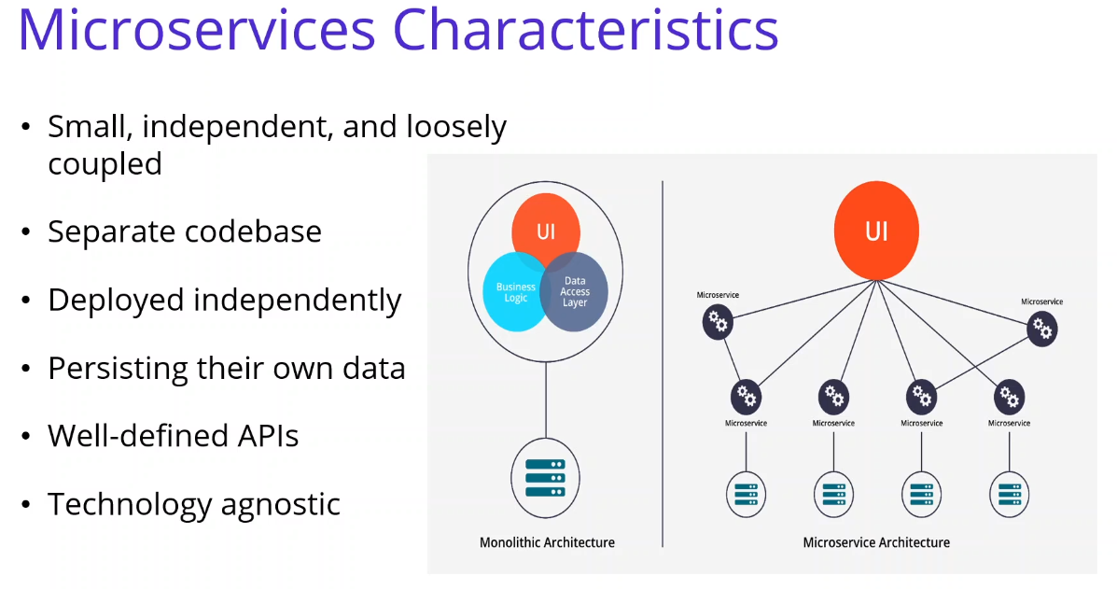 So if we look at the microservices characteristics, we will see that Microservices are small, independent, and loosely coupled. A single small team of developers can write and maintain a service. Each service is a separate codebase, which can be managed by a small development team. Services can be deployed independently. A team can update an existing service without rebuilding and redeploying the entire application. Services are responsible for persisting their own data or external state. This differs from the traditional model, where a separate data layer handles data persistence. And Services communicate with each other by using well-defined APIs. Internal implementation details of each service are hidden from other services. Services don't need to share the same technology stack, libraries, or frameworks. During the whole course, we are going to refer to these microservices characteristics when we develop our reference application.

**5. Monolithic Architecture Pros-Cons** 3 min

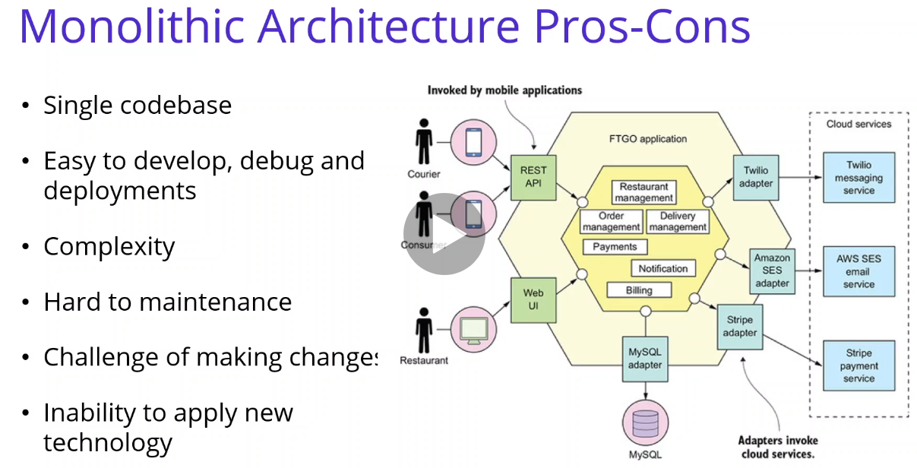

In this video we are going to talk about Monolithic Architecture Pros-Cons. You can find example architecture of monolithic architecture on right side. A monolithic application has a single codebase that contains multiple modules. Modules are divided according to their functional or technical characteristics. It has a single build system that builds the entire application. It also has a single executable or deployable file. If we check the strengths of the monolithic architecture. We can say that it is easier debugging and end-to-end testing. Unlike the Microservice architecture, monolithic applications are much easier to debug and test. It is easy to develop and maintain for small projects. Application can be developed quickly. We can say that it is easy to perform test operations, you can perform end-to-end tests much faster. And it is much easy deployment. An advantage associated with monolithic applications That being a single piece is easy deployment. It is much easier to deploy a single part than to deploy dozens of services. Also transaction management. It is very easy when we are talking about the monolithic architecture.

If we are looking for the weaknesses of the monolithic architectures, we can say that complexity, When a monolithic application grows, it becomes too complex to understand. As the application grows, it becomes difficult to develop new features and maintain existing code. With the increase in the number of teams and employees working on the project, development and maintenance becomes more difficult. Because of their dependencies on each other, changes made in one functionality can affect other places. And another weakness is the challenge of making changes; Making a new changes is very cumbersome in such a large and complex application. Any code change affects the entire system, so all parts must be thoroughly checked. This can make the overall development process much longer. Even with a small change in the application, the entire application must be deploy.

So another weaknesses We can say that inability to apply new technology, Implementing a new technology in a monolithic application is extremely problematic, The same programming language and same frameworks must be used. integrating the application into a new technology means redeveloping the whole application. And another weaknesses is Low Scaleable, You cannot scale components independently. You have to scale the entire application. In the next video, We are going to check Microservices architecture pros and cons.

**6. Microservices Architecture Pros-Cons** 5 min

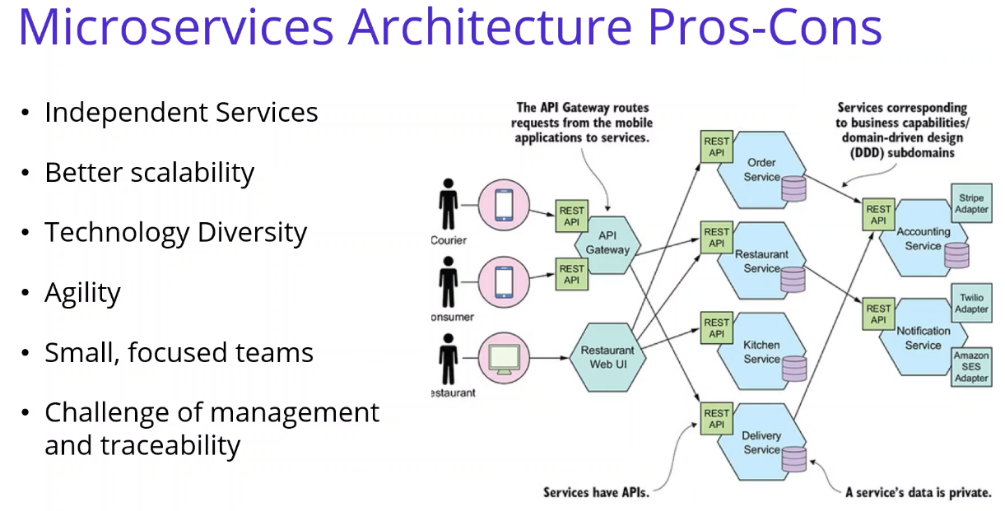

In this video we are going to talk about Microservices Architecture Benefits and challenges. You can find example architecture of microservices architecture on right side. Microservice are small business services that can work together and can be deployed autonomously and independently. If you talk about the strengths of the Microservices architecture, we can say that Independent Services, Each service can be deployed and updated independently, providing more flexibility. If you have any error in a microservices, only has an effect on a specific microservice and does not affect the entire application. Also, adding new features to a microservice application is easier than a monolithic one. Whether the application is very large or very small, adding new features and maintaining existing code is easy. Because it is sufficient to make changes only within the relevant service.

And we can say one of the strength is better scalability. Each service can be scaled independently. Therefore, the entire application does not need to be scaled. This saves a lot of time and money. Additionally, every monolithic application has limits in terms of scalability. However, multiplexing a service with traffic on the microservice is less inconvenient and able to handle the whole load. This is why most projects that appeal to a large user base, have begun to adopt the microservice architecture. And their strength is the Technology Diversity, Teams do not have to completely choose the technologies on which the services will be developed, they can choose the appropriate technology for the services they will develop over time. For example, a microservice can be developed with the python programming language in order to use machine learning machine learning features next to microservices developed on .Net environment. The desired technology or database can be used for each microservice. Another strength is Higher level of agility. Higher level of agility. Any errors in a microservice application only affect a particular service, not the entire application. Therefore, all changes and tests are carried out with lower risks and fewer errors. Teams can work more efficiently and quickly. Folks who are just starting the project can easily adapt without getting lost in the code base. And we can say another strength is that intelligibility, a microservice application broken down into smaller and and simpler components is easier to understand and manage. Since each service is independent from each other and only has its own business logic, the code base of the service will be quite simple. It is easier to understand and manage.

If you talk about the weaknesses of the Microservice architecture, we can say that Microservice architecture should never be preferred for small-scale applications. Because it becomes extra extra complexity. Since a microservice architecture is a distributed system, You need to configure each module and database separately. In addition, as long as such an application includes independent services, they must all be distributed independently. System distribution a microservice architecture is a complex system made up of multiple services and databases. so all connections need to be handled carefully. Deployment requires a separate process for each service.

And other weaknesses, we can say that the challenge of management and traceability, You will need to

to deal with multiple situations when creating a microservice application. It is necessary to be able to

monitor external configuration, metrics, health-check mechanisms and environments where microservices can be managed. Another challenge is the testing, the larger number of services deployed independently of each other makes the testing process extremely difficult. Because when you performed end-to-end test on the microservices you will see the several microservices is working on their environment. Since there are more than one service and more than one database, transaction management will be very difficult.

**7. Monolithic vsMicroservices Architecture Comparison** 3 min

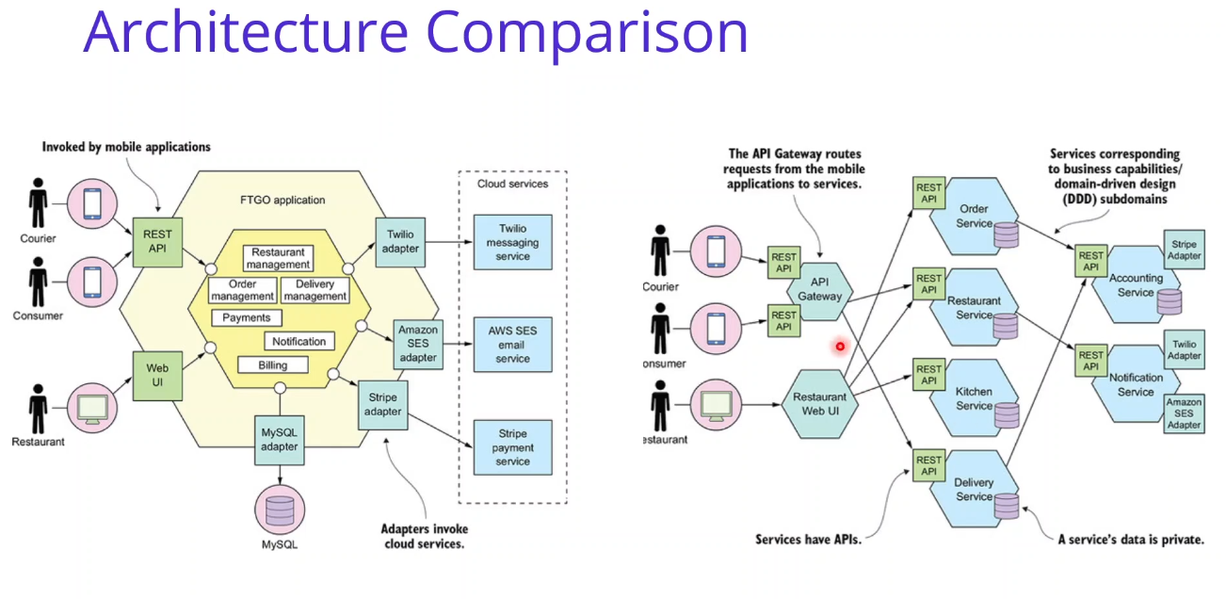

In this video we are going to talk about Comparison of Monolithic vs Microservices Architecture. You can find monolithic architecture on left side, and on the right side, you can see the microservices architecture. A monolithic application has a single codebase that contains multiple modules. And modules are divided according to their functional or technical characteristics. Modules are divided according to their functional or technical characteristics. It has a single build system that builds the entire application. It also has a single executable or deployable file.

But Microservices are small, independent, and loosely coupled. A single small team of developers can write and maintain a service. Each service is a separate codebase, which can be managed by a small development team. Services can be deployed independently. A team can update an existing service

without rebuilding and redeploying the entire application. Microservices are responsible for persisting their own data or external state. This is difference from the traditional model, where a separate data layer handles data persistence. and microservices communicate with each other by using well-defined APIs. Internal implementation details of each service are hidden from other services. Microservices don't need to share the same technology stack, libraries, or frameworks. Microservices are technology agnostic.

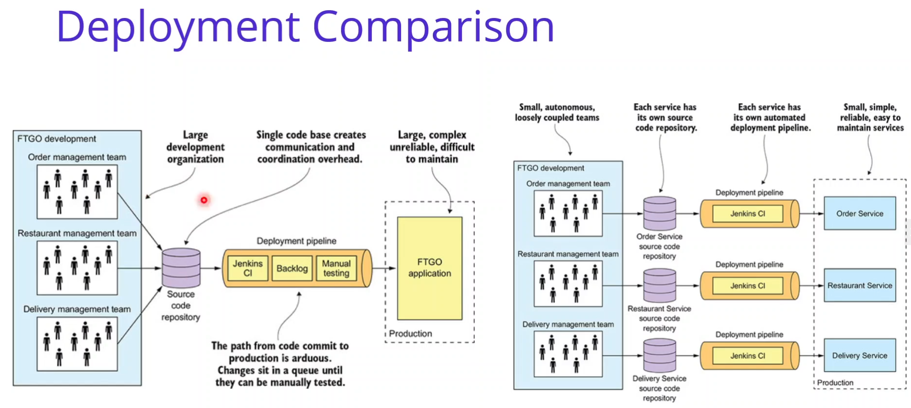

If you look at the deployment comparison, a monolithic architecture located in left hand side, and on the right hand side, you can see the Microservices deployment architectures. Let's talk about the Monolithic deployment architecture, A monolithic applications has large development organizations.

And Single code base created communication overhead. The path from code commit to production

is arduous. Changes sit in a queue until they can be manually tested. This architecture created a Large complex and unreliable difficult to maintain architecture. If you look at Microservices architecture, you can see the small autonomous and lose a couple teams. Each microservice has its own source code repository. and Each service has its own automated deployment pipelines. This architecture creates Small simple reliable maintained microservices.

**8. What is Containers and Docker** 1 min

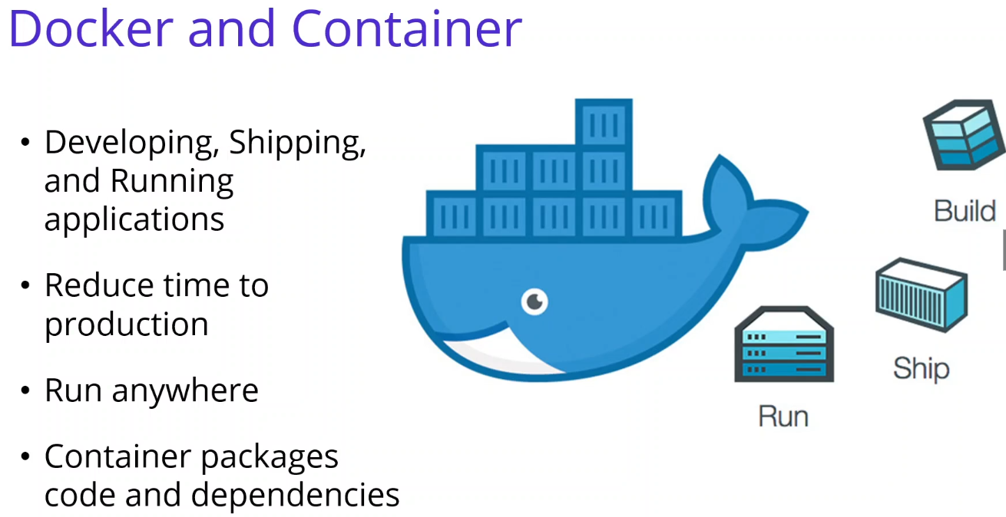

In this video we are going to talk about What is Docker and What is Container. Docker is an open platform for developing, shipping, and running applications. Docker provides to separate your applications from your infrastructure so you can deliver software quickly. Advantages of Docker’s methodologies for shipping, testing, and deploying code quickly, you can significantly reduce the delay between writing code and running it in production. Docker provides for automating the deployment of applications as portable, self-sufficient containers that can run on the cloud or on-premises. Docker containers can run anywhere, in your local computer to the cloud. Docker image containers can run natively on Linux and Windows. And a container is a standard unit of software that packages up code and all its dependencies so, the application runs quickly and reliably from one computing environment to another. A Docker container image is a lightweight, standalone, executable package of software that includes everything needed to run an application.

**9. Docker Containers, Images and Registries** 2 min

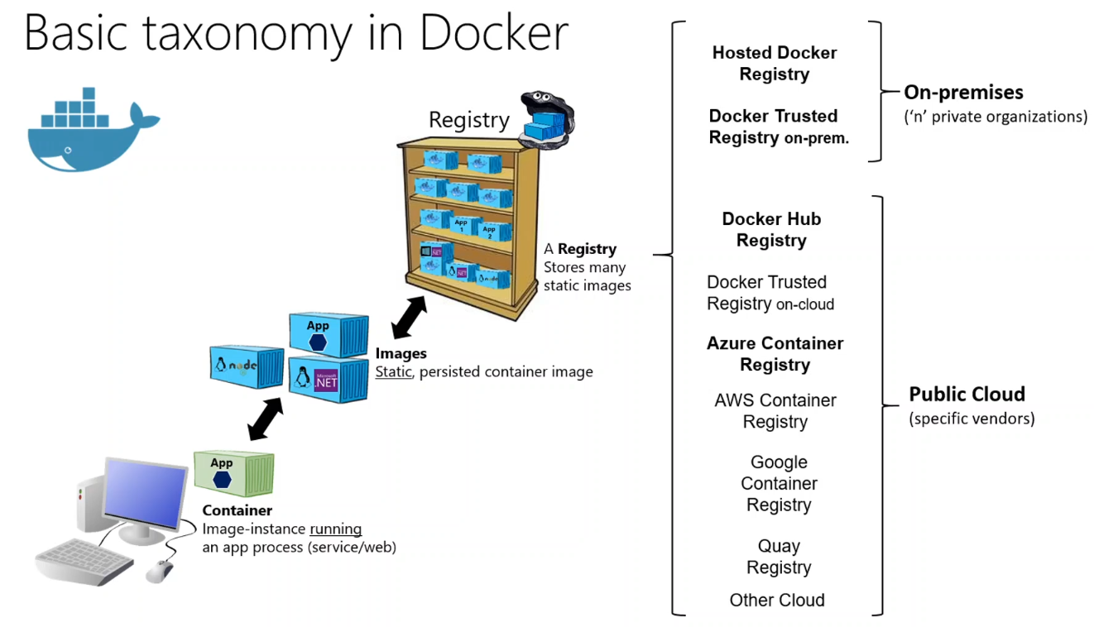

In this video we are going to talk about Docker containers, images, and registries. When using Docker, a developer develops an application and packages application with its dependencies into a container image. An image is a static representation of the application with its configuration and dependencies. In order to run the application, the application’s image is instantiated to create a container, which will be running on the Docker host. Containers can be tested in a development local machines. Developers should store images in a registry, which is a library of images and is needed when deploying to production orchestrators.

Docker images are stores a public registry via Docker Hub, other vendors provide registries for different collections of images, including Azure Container Registry. Alternatively, enterprises can have a private registry on-premises for their own Docker images. As you can see the images shows, how docker components related each other. Developer creates container in local and push the images the Docker Registry. Or its possible that developer download existing image from registry and create container from image in local environment.

Docker Application Containerization

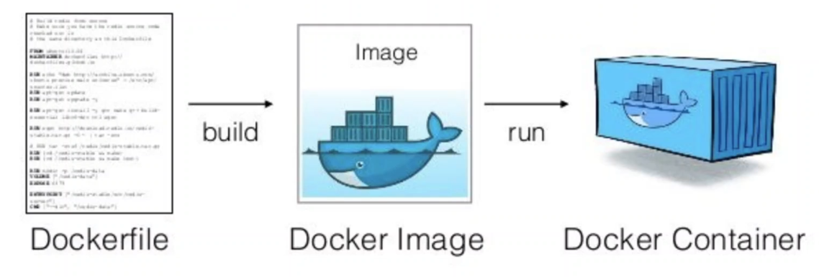

If we look at the more specific example of Application Containerization with Docker, First, we should write dockerfile for our application, Build application with this docker file and creates the docker images. And lastly run this images on any machine and creates running docker container from docker image. We will use all steps with orchestrating whole microservices application with docker and kubernetes for the next sections.

**Section 2: Developing Your First Microservice – Catalog.API with MongoDb** 2hr 37min

**10. Introduction** 1 min

In this section we are going to Developing Your First Microservice - Catalog.API with MongoDb database.

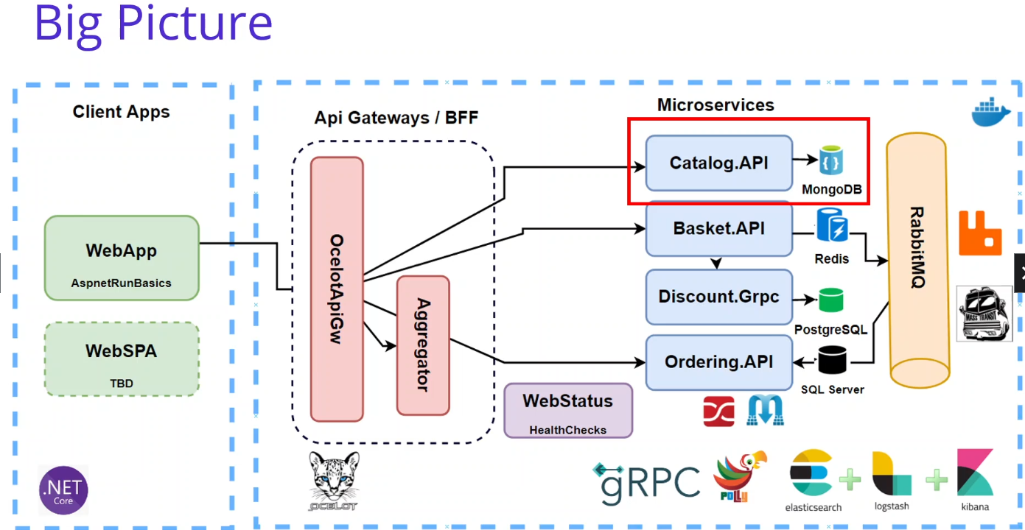

Let's check out big picture and see what we are going to do it one by one. As you can see that, we are in here and start to developing Catalog.API with MongoDb microservices. So we are going to cover the developing Catalog microservice which includes; ASP.NET Core Web API application REST API principles, CRUD operations, MongoDB database connection and containerization Repository Pattern Implementation and the Swagger Open API implementation.

We will start with creating a github repository for our reference application. Also Analysis and Architecting of Catalog Microservices, applying N-Layer architecture. Containerize Catalog Microservices with MongoDB using Docker Compose. Debugging Docker-Compose on Visual Studio for Catalog.API with MongoDb microservices So in this section, we are going to Develop our First Microservice - Catalog.API with MongoDb. database. By the end of the section, we will have a Web API which implemented CRUD operations over Product and Category documents database on MongoDB. After we’ve learned the basics, we can start with the coding part.

**11. Create New Github Repository For Our Microservice Project** 2 min

<https://github.com/mehmetozkaya/AspnetMicroservices>

In this video, we are going to create a GitHub repository for our resources project. Let's take an action. First of all, we are going to open it up. And, of course, you should have an account on get up after that. Go to the post office. And collecting Neubauten in order to create new depositary. So we are going to create and you will postulate and the poster name should be the Azmath, Microsoft says you can change your name or project. And I'm putting the description is the same name. This will be the public repository. And I am going to edit README file. And Technophile. This litigation filed will be the to do because I am going to develop with just just that. If you are using TerraCycle or any other idea, you can choose your custom and ignore file and let me choose license. And often and you can create the report by clicking these created button. <https://github.com/PerProjBackup/AspnetMicroservices-UdMO>

OK, we have created the repository and we are going to push our Microsoft developments into this repository. Very good. We have finished the first step, which is the creating our Microsoft repository on GitHub. I am also would like to create for you creating your proposal, because when you have any error or stock, any exertion, I can easily take your deposit on the GitHub and identify with your problem.

OK, see you next video.

**12. Clone GitHub Repository and Create New Solution with Visual Studio** 5 min

In this video, we are going to call on GitHub repository on our local environment and create a new solution with using user to do, let's say, connection. First of all, we are going to open Visual Studio should you let me open the we used to do and we are going to clone our newly created repository. In order to clone that, you can click the button and copy this clone and after that, come back to register and critical on a repository. We can provide the repository in the repository location and it is supporting for us. Let's create the KM. And you can see that we used to do a preparing to implement. And after cloning the depositary in our local environment, we should start to create our project. On this video, now we have the device which is created by the guitar, but we are going to create a new project. We will create a new project which including the blank solution. So in order to do that, I'm going to file New Project. And the project template is a blank. Because we will start with the solution, yes, black solution that will create the black solution and the name should be the aspnet-microservices, location should be the cloned repository folder.

So let's create a new solution. And see what's happened. It is created. OK, well, let's check our folder structures on our repository. OK, in order to check the folder structure, we can right click and open folder in the file explorer. Has same name as repository so to avoid conflicts rename solution folder to src. We should have one root folder aspnet-microservices and under that we can put our source code, src. We can then put other folders (ex. Deployment) in the root folder.

Reopen the solution in Visual studio and commit the changes to GitHub. Verify that the solution folder is inside the root folder. Now commit my first operation, ‘initial’, Commit All and Push.

Remove credentials from Git SoliQuid

<https://stackoverflow.com/questions/15381198/remove-credentials-from-git/39592537#39592537>

Control Panel → User Accounts → Credential Manager → Manage Windows Credentials -> Generic

Delete git:https://github.com/. When push new one will be generated with credentials of repository you are pushing to.

If we come back to our GitHub repository, you will see that we have initial comment and our source folder is ready, and you can see that only blank solution we have inside of our solution for. So as we can see that we have created and put our project to GitHub so now we are ready to develop our first microservices.

**13. Create Asp.Net Web Api Project for Catalog.API Microservice** 5 min

In this video, we are going to create our first microservices, which is Catalog.API Asp.Net Web API microservices. Let's say, connection. Before we start, let me right click and open folder in the file explorer and make sure that you are in the source folder. OK, so first of all, we are going to start with creating services for that pointing going to right. Clicking here. A naive solution, folded services. And also, I'm going to right click on the resources it needs solution folder, which is the catalog, because we are going to create AMICA services under the services folder and the first Microsoft Services is catalog what we are going to develop. So we have to fold them now. After that, we can create our first microservice for that purpose. Just click the catalog right. Click add new project. So once we are creating a new project, we should choose the of course, is to be done at. Web API project. You will use the Asp.Net core Web API template. And the project name will be the catalog that API, so before collecting next, you can see the location should be changed because we are going to develop our micro sources under the services and catalog folder. But when we are creating a new solution folder, it will not be created a physical folder for that purpose. We are going to adding these folder structure under this location, but it's Services and Catalog. So we are creating. We are going to create a core services folder and inside of that we are going to create a Catalog folder under the Catalog folder. We will have a Catalog API microservices. So just click the next button. And I'm going to select the but at .NET 5.0 with the current target framework and we have no authentication type and please uncheck the configurator HTTPS because we will continue to HTTP version in order to deploy on the Kubernetics without certification and enable open API support. hit the great button. And this will be our first microservice.

OK, after we have created our Catalog.API Asp.Net Web API microservices, you can double click the project folder and verify that your target framework is at 5.0. And also, you can right. Click and. Open in an open folder, in a public suit and verify that the folder structure is also correct, false. So this catalog catalog API and verifying this because we are containerized, these microservices insisted the files, the pets could be an issue. That's why the folder structure and the target framework should be correct.

After that, let's modified launch settings in order to set the port numbers correctly. Put them our big picture of the architecture. So right click properties. Go to the back section and you can see the profile is is IIS Express, change to Catalog. The the launch also changing to Project. After that, as you can see, that the App URL: is 5000. And I'm kreeping as is. It is. You can see the changes under the properties and launchSettings.json, while we can see that we have creating a new running profile, which name is Catalog.API and the commandName is Project. So we are providing the applicationUrl: 5000 for the Catalog.API microservice and this is our development environment.

OK, so let's run our first microservice, change the profile from IIS Express Catalog.API. Hit F5 in order to run. Let's wait for awhile. It will open a Project, console window and also, as you can see, that there is a Swagger implementation, we selected the open API integration, so that's why it is creating is Swagger for us. And yes, we it is the our first Catalog.API microservice. You can commit your changes in GitHub. e into your chains, into your GitHub, as you can see our project running on the 5000 port number, with default Swagger implementation.

**14. MongoDb in Catalog Microservices** 2 min

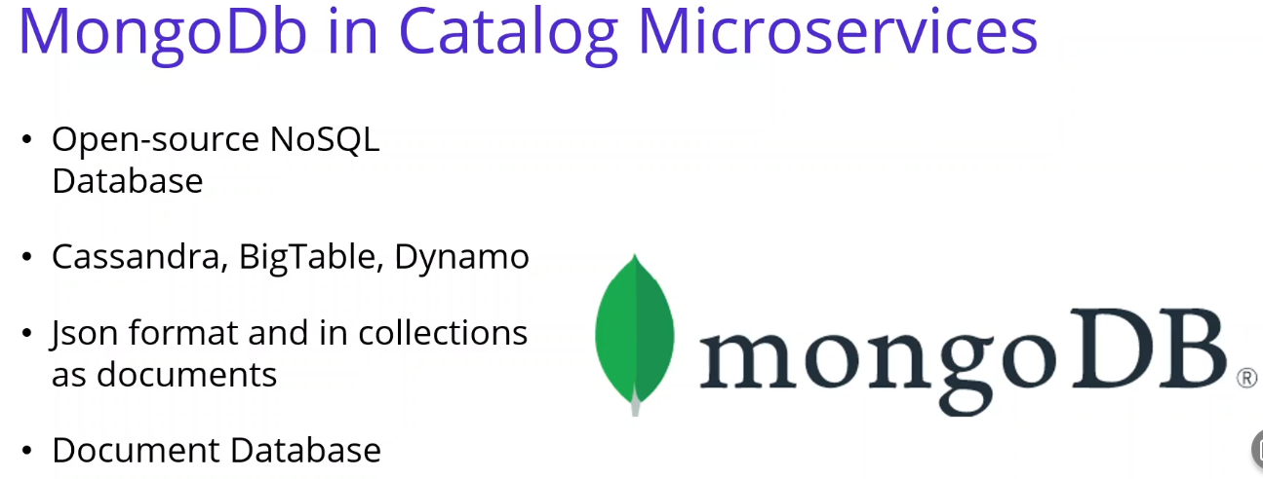

In this video we are going to talk about MongoDb database in Catalog Microservices. MongoDB introduces us as an open source, document-oriented NoSQL database designed for ease of development and scaling. There are many NoSQL databases on the market today such as Cassandra, BigTable, Dynamo. MongoDb is a document based NoSQL database. It keeps the data structurally in Json format and in collections as documents. Every record in MongoDB is actually a document. Documents are stored in MongoDB in JSON like Binary JSON (BSN) format. BSON documents are objects that contain an ordered list of the elements they store. Each element consists of a domain name and a certain type of value. It is a document-based NoSQL database. It keeps the data structurally in Json format and in documents. Queries can be written in any field or by range. If we compare the structures in MongoDB with the structures in their relational databases, it uses Collection instead of Tables and uses Documents instead of rows. So For Catalog microservices, we are going to store Product collections into MongoDb NoSQL database In JSON format.

We will see listing databases, seeing collections, adding, deleting, updating and listing data on MongoDB. In the next video, as you can see that, we have analysis and design our Catalog microservices,

so now it is time to develop Catalog microservices. But before that, let's set up our MongoDb database, which using Docker. In this video we are going to talk about MongoDb database in Catalog Microservices. MongoDB introduces us as an open source, document-oriented NoSQL database designed for ease of development and scaling.

There are many NoSQL databases on the market today such as Cassandra, BigTable, Dynamo.

MongoDb is a document based NoSQL database. It keeps the data structurally in Json format and in collections as documents. Every record in MongoDB is actually a document. Documents are stored in MongoDB in JSON like Binary JSON (BSN) format. BSON documents are objects that contain an ordered list of the elements they store. Each element consists of a domain name and a certain type of value. It is a document-based NoSQL database. It keeps the data structurally in Json format and in documents. Queries can be written in any field or by range. If we compare the structures in MongoDB with the structures in their relational databases, it uses Collection instead of Tables and uses Documents instead of rows. So For Catalog microservices, we are going to store Product collections into MongoDb NoSQL database In JSON format. We will see listing databases, seeing collections, adding, deleting, updating and listing data on MongoDB. In the next video, as you can see that, we have analysis and design our Catalog microservices, so now it is time to develop Catalog microservices. But before that, let's set up our MongoDb database, which using Docker.

**15. Setup Mongo Docker Database for Catalog.API Microservices** 8 min

In this video, we are going to set up Mongo the database for our Catalog.API microservice. Let's take an action. before we start. Make sure that your docker desktop is starting on your local computer. It is running properly. OK, first of all, we should go to Docker Hub and find them on the official image, so go to <https://hub.docker.com/> and search for the Mongo image. We can see that we have to officially meet, but we are looking for the Mongo database, you can click this one. Is the local official image of the Mongo database, we are going to set up Mongo database in the current moment in our local environment. So in the local official image, you can see the several information about Mongo image. You can see the tag names and also Mongo database information. You can see the basic commands of Tuesday's image and how to connect the Mongo database with using the interactive terminal. And also we can see the predefined to compose Yamal files. Also, we have a configuration section. You can see the Mongo database image configuration, for example, and why today was always important for us. We can see the in which environmental variables we can use for the Mongo database containers.

**{.** Deleted all the containers and images from the demo from my local Docker. **}**

OK, so after we have seen the basics of the Mongo database container. I am going to basically pull this the image into my local computer, so let me open Visual Studio and open Terminal. And if you check Docker running on my local computer it is running fine and I have no any running container in my local computer. So now we are going to pull Mongo image in our local computer. You can copy this command ‘docker pull mongo’ that could pull Mongo and paste in here. Local pool Mongo just hit enter and pulled the Mongo image in your local computer. OK, it is pulling the Mongo image into our computer. After installation piece, we are going to run and start Mongo database in our local computer. If we checked the official recommendation, you can see the basic command,

‘docker run --name some-mongo -d mongo:tag’, how we can run these Mongo image into our local environment, we can use the docker command and give the name of the image and the tagname. You can also go inside or to Mongo DB container using the interactive terminal.

‘docker run -d -p 27017:27017 --name shopping-mongo mongo’ So let's start with the running and the starting Mongo database. I'm going to use the docker run command and the id means working detachment. And I would like to provide the port number. No, because Mongo database exposing the port number 27017 providing the port number is the same number and forwarding to my local computer. These commands explain this. You can forwarding to ports into the local computer. This is the image port number (right) and this (left) is the are local computer port number. We are basically forwarding the same port into our local computer. After providing these port numbers basically I'm giving the name and the name is the shopping-mongo and of course at the end we should provide the image name. The image name is mongo the (pull name) image name. And by this way, we have to provide the image name, basically looking for the image name and check the image name is existing in local computer. It is running this mongo image inside of to our local computer with the name of the shopping-mongo and the number is the 27017. Press enter and see what's happened.

Yes, it is started, you can verify that it is started or not with the docker ps comment. As you can see, that we have one running container in our local computer, which name is the shopping-mongo, and the port number is 27017. And it seems we have successfully start mongo image into our local environment. So see that we have forwarding to port successfully for troubleshooting. We have some comments for that purpose. ‘docker run -d -p 27017:27017 --name shopping-mongo mongo’ Let me check the local logs with the get the name of the our container mongo. You can see the basics of the logs inside of these mongo image containers and control c and exits and cls.

And one more comment, if we go inside of these mongo containers in our local computer, we can use the exec command ‘docker exec -it shopping-mongo /bin/bash’, that means interactive terminal. We are going to open the interactive terminal. We should provide the container name, which is the shopping-mongo in our case, I would like to locate the bin/bash folder in order to create the bash scripts inside of these operations. and hit enter. We can now inside of these mongo containers in my local environment. We will see the details in the next video. As you can see that we have put the mongo image in our local computer and around this image in our local computer started the container in our local computer and exposing the port 27017. In the next video, we are going to use mongo cli commands with the interactive terminal.

**16. Setup Mongo Docker Database for Catalog.API Microservices** 7 min

In this video, we are going to connect to the interactive terminal for Mongo DB connection and we will see how to run Mongo comments inside of the Mongo container. Let's take an action. First of all, let me close the terminal and start from scratch. And we should connect the interactive terminal of Mongo the container, but Mongo comments working on power shell, that's why I had opened my interactive terminal in the power shell window. I am right. Click the solution and open internal. This terminal is starting with the powerful terminal and now we can open an interactive terminal for Mongo database.

(Need to start container if restarted computer

docker run -d -p 27017:27017 --name shopping-mongo mongo )

‘docker exec -it shopping-mongo /bin/bash’

root@0df1cbfaea76:/#

We were writing this. The crazy command, the code exec basically go inside of the container and they ship. It means interactive terminal shopping. After that, we are able to run Mongo comments.

Let's try with the create database create collection at items in the collection and list the collection. So let me start with the ‘ls’ command in order to see what's including in my container shopping-mongo container. You can see numerous folders and a js-yam.js file resources inside the container. So now, in order to run Mongo commands, we will start with the ‘mongo’ comment, just hit the monument and see that we can now able to run Mongo database commands, but using this opening the terminal.

>

So let's start with show databases, ‘show dbs’, hit enter

> show dbs

admin 0.000GB

config 0.000GB

local 0.000GB

and see that in our existing my local mongo database container, we have admin and local database, which is the default database comes from the official image. So if I would like to create a new database, I'm going to ‘use CatalogDb’. This will create a need database for me just to enter and see that it is switched to CatalogDb. It is creating a catalog to and locate the CatalogDb. From now on, we are running scripts over the CatalogDb.

So let me create a product collection ‘db.createCollection('Products')’, that great collection and I'm providing the collection, naming his which name is products, so it is common to provide to create a new collection inside of the catalog DB database on our Mongo DBE container just hit Enter. Yes, we have successfully created the products collections. So inside of this collection, I would like to insert many items. We have DBI that. Products. And insert comments, you can use the insert comment or insert mini comment in order to add new items inside of these products collection, I have pre-defined comments.

I am going to copy and paste in here.

‘db.Products.insertMany([{ 'Name':'Asus Laptop','Category':'Computers', 'Summary':'Summary', 'Description':'Description', 'ImageFile':'ImageFile', 'Price':54.93 }, { 'Name':'HP Laptop','Category':'Computers', 'Summary':'Summary', 'Description':'Description', 'ImageFile':'ImageFile', 'Price':88.93 } ])’

Let me copy and paste and I will also told you it is. Yes. So as you can see that dbe that products that insert and providing it in a decent format for the collections. These this is the first item, this is the second item, the json format yes, it is inserted the items under the products collection CatalogDb on the MongoDB container.

{

"acknowledged" : true,

"insertedIds" : [

ObjectId("6197bae87b270d1f552a6d5e"),

ObjectId("6197bae87b270d1f552a6d5f")

]

}

Copy and paste these commands from the video resource folder.

db.Products.find({}).pretty()

db.Products.remove({}) --Removes the objects not the collection.

show databases

show collections

db.Products.find({}).pretty()

We have successfully inserted the collections, so in order to check these commands we have. DB that products that point, we have not specifying any filtering and pretty Setanta see that we have to object under the product collection and it is assigning the ID column and the value is the missing ID, which is the object in front of our character. You can see that this is assigning from the Mongo database. And if you would like to remove the product collection, we can use the DBE that products that remove common ether and basically it is removed. OK, now we can check the show database. See, that catalog database is created, but we have to put a collection and also you can say that show collections now we have product collection, but we removed the items inside of that. If you check the product collection of.

You can see that we have no item inside of two products. OK, as you can see that we have run several commands into Mongo container terminal. So now we have Mongo database is running on our local computer and we are ready to connect Mongo database from our Catalog.API microservice.

**17. Analysis and Architecting of Catalog Microservices** 7 min

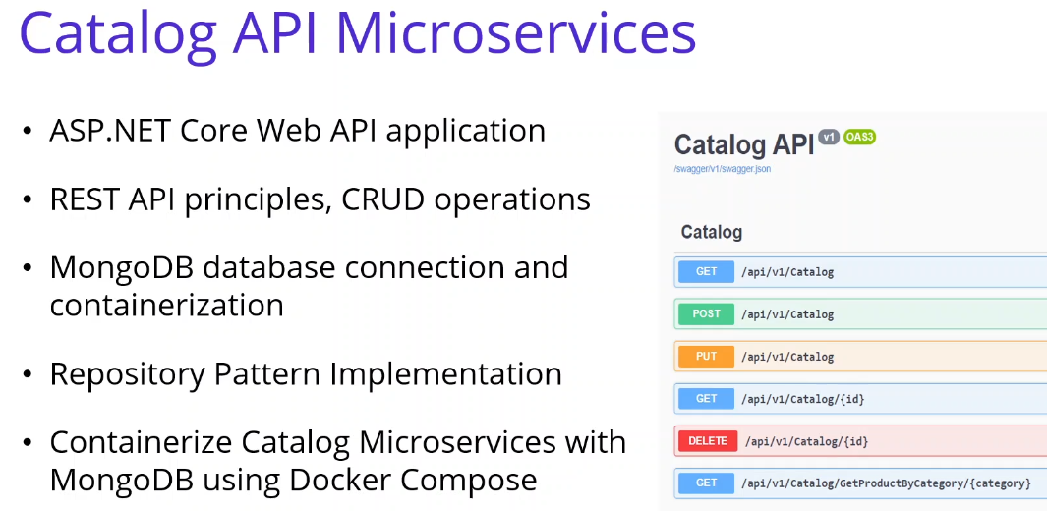

In this video we are going to Analysis and Architect the Catalog microservice. Let's take an action. we are going to Developing Our First Microservice - Catalog.API with MongoDb. So this project will be the REST APIs which basically perform CRUD operations on Catalog MongoDB databases. We are going to cover to Developing Catalog microservice which includes, ASP.NET Core Web API application,

REST API principles, perform CRUD operations, MongoDB database connection and containerization with the MongoDb database. Repository Pattern Implementation, and of course Swagger Open API implementation. And after these developments we will Containerize Catalog Microservices with MongoDB using Docker Compose. And we will Debugging Docker-Compose on Visual Studio for Catalog.API with MongoDb microservices.

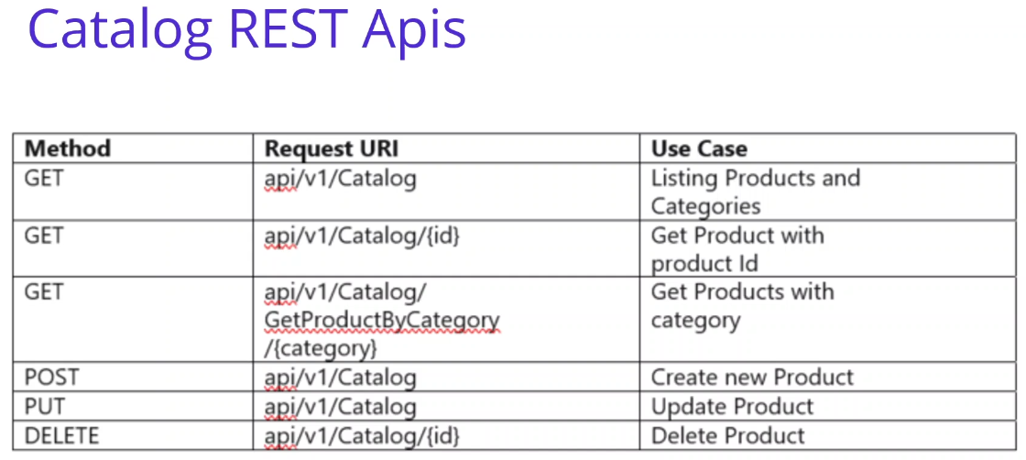

So let's check RestFull APIs If you check the restful apis, we should define our catalog use case analyses in this part, we will create a product and category entities. Our main use case are listing products and categories and able to search the products. Also perform CRUD operations on product entity.

When I say the entity this will be the Mongo database document. so our main use cases listing products

and categories, get product with the product ID, get product with the category name, create new product update, new product update product and delete product. Along with this we should design our APIs according to REST perspective.

So you can see our rest api, we have 3 get method and providing the API version one and the catalog we have ID with Get product with id and we have a category search products by the category and we have Post-Put and Delete in order to perform CRUD operations over the product entity. So if we look at the architecture of our Catalog microservices.

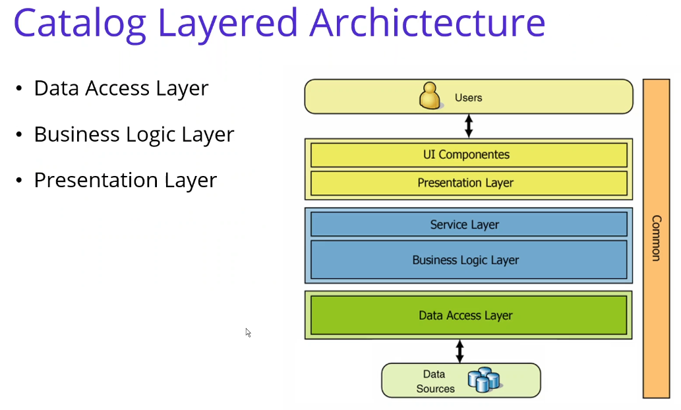

We will use the N-Layer architecture. we are going to use traditional N layer architecture. Layered architecture basically consists of **3 layers**. These 3 layers are generally the ones that should be in every project. You can create a layered structure with more than these 3 layers, which is called multi-layered architecture. But we are following the tradition. N-Layer architecture for Catalog microservice architecture. Let me explain briefly, we have **Data Access Layer**, Only database operations are performed on this layer. The task of this layer is to add, delete, update and extract data from the database. There is no other operation in this layer other than these operations. And we have also **Business Layer**: We implement business logic (and Service layer) on this layer. This layer will process the data taken by Data Access into the project. We do not use the Data Access layer directly in our applications. The data coming from the user first goes to the Business layer, from there it is processed and transferred to the Data Access layer. And we have a **Presentation Layer**: (UI Components) This layer is the layer on which the user interacts. It could be in Windows form, on the Web, or in a Console application. The main purpose here is to show the data to the user and to transmit the data from the user to the Business Layer and Data Access.

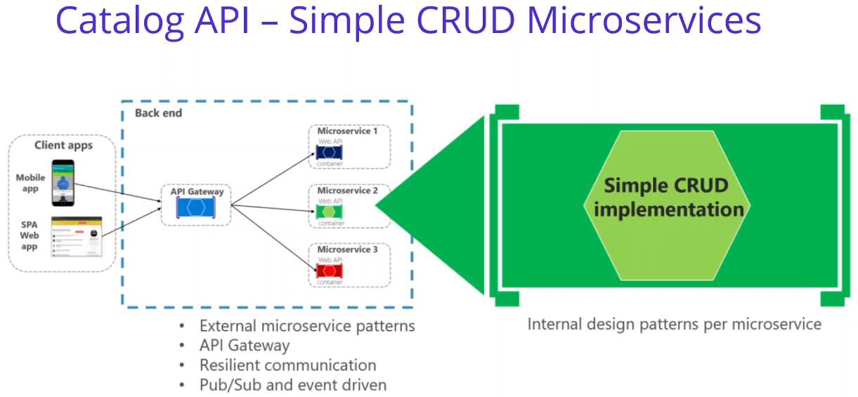

If you check this slide, we can see the Simple CRUD microservices Catalog api microservices will be simple crud implementation on Product data on Mongo databases. You can apply any internal design pattern per microservices. Since we have 1 project, so we are going to separate this layers with using folders into the project. But for the ordering microservices we will see that we also separate layers with projects with using clean architecture and cqrs implementation. We will see in the next sections.

But for this catalog microservices, we don't need to separate layers with the assemblies. We have only one assembly and we will separate these layers by using the folder structure.

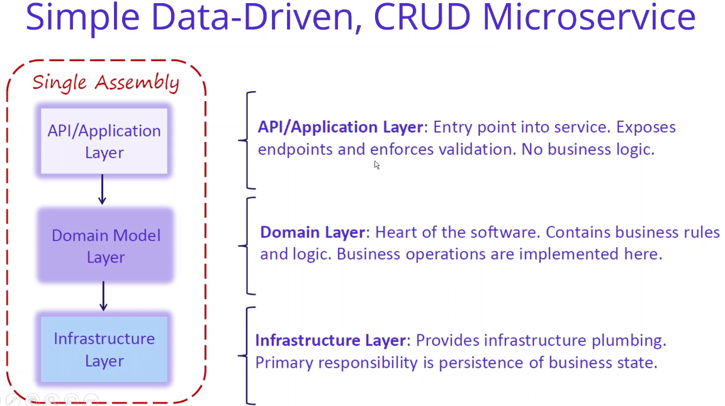

If you continue our operations, we can see that we have creating simple driven crud microservices. If you look at the project structure, we are planning to create these layers, these folders that mean Domain Layer - Contains business rules and logic. Application Layer - Expose endpoints and validations. API layer will be Controller classes. and Infrastructure Layer - responsible by persistence operations. operations. If we create a folder structure, we will have a entities folder which storing to Mongo DB entities and we will have a data folder which stored the Mongo data context object and we will have a repository folder which including the Mongo Repos and the business logic inside of that Repos folder. And finally is a presentation layer. We will have a controllers which storing the API controller classes.

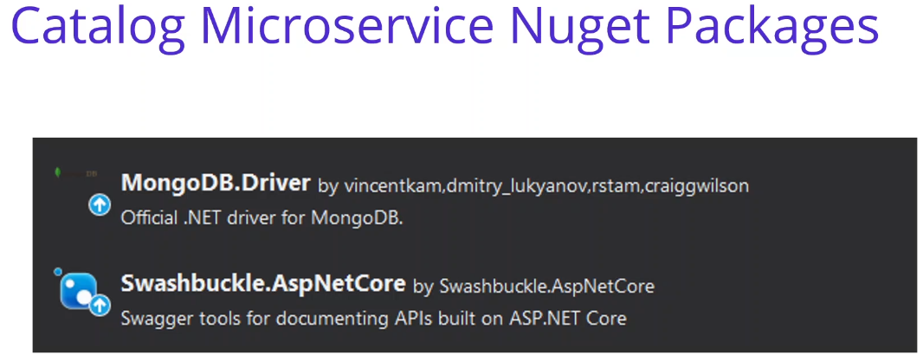

So if you look at the look at the nuget package, what we are going to use in our Catalog microservices we will use MongoDB.Driver , for communicating with the Mongo database and swashbuckle package aspnetcore It is already automatically installed - auto install from vs for swagger implementation. is provide for the swagger implementation. So as you can see that we have analyze and design our catalog microservices. now we are going to develop our catalog microservices.

**18. Repository Design Pattern** 3 min

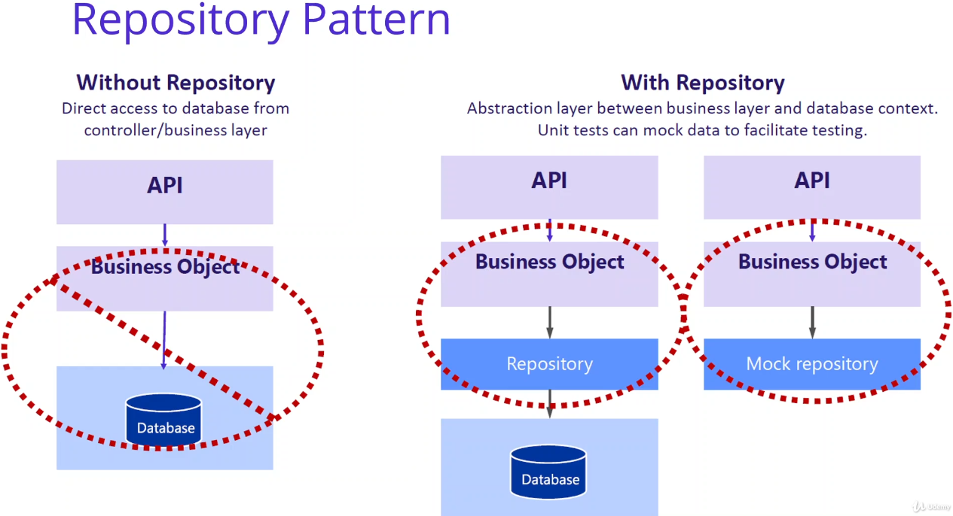

In this video we are going to talk about Repository Design Pattern. The repository pattern is one of the more popular patterns. It follows the solid principles and done right it is clean and easy to use. The repository pattern has two purposes; first it is an abstraction of the data layer and second it is a way of centralizing the handling of the domain objects. We can say that a Repository Design Pattern acts as a middleman or middle layer between the rest of the application and the data access logic. That means a repository pattern isolates all the data access code from the rest of the application. The advantage of doing so is that, if you need to do any change then you need to do in one place. Another benefit is that testing your controllers becomes easy because the testing framework need not run against the actual database access code. You can make mock repositories when you are testing your code. Repository pattern separates the data access logic and maps it to the business entities in the business logic. Communication between the data access logic and the business logic is done through interfaces. By repository pattern, we allow business logic to access the data object without having knowledge of underlying data access architecture. The separation of data access from business logic has many benefits. Some of them are, Centralization of the data access logic makes code easier to maintain. Business and data access logic can be tested separately Reduces duplication of code, and a lower chance for making programming errors We can say that when you are using Repository Pattern, Flexibility can applied into Repositories in order to separate our Controllers from the database in right manner, we are going to abstract that interaction into repositories. Repositories also allow you to create a flexible abstraction layer between your database and your Controller. Doing this enables you to separate those concerns and it prevents your Controllers from being too tightly coupled with your Database. Your Controllers don’t care what storage facility you are using to persist data, and so by using Repositories, you are able to make a clean abstraction. This makes it beautifully simple to switch database types at some point in the future.

**19. Developing Catalog.API Microservices Creating Entites and MogoDB.Driver Nuget** 8 min

In this video, we are going to start to developing catalog API, microservices with creating entities and MongoDB.Driver Nuget packets. We will start with the creating entities and adding the required Nuget packets in order to connect Mongo database that will contain it from the Catalog.API microservices, let's say connection. First of all, we are going to remove default items since we are creating the API template is not an API. It comes with the weather forecast. I'm going to remove this with the forecast class and also. I'm going to move on to the weather forecast comptrollers. OK, now we should go to the API project and install MongoDB.Driver Nuget packets. This will provide to create connecting with Mongo database. Using package manager console. Using the dot net comments.

<https://nuget.org/packages>. Install-Package MongoDB.Driver [-Version 2.14.0-beta1]

In your Brossette, if you search to Mongo, Devean here. Monga, to be the driver, we are going to install this package and you can see that there is several options teams in here, if you are using the piggish major console, you can use install a package installation package. Camonte, if you are using it, Donatella, you can use the aid package command and so on. So for those, you can choose any of these methods. But in this course I'm going to use the package manager console on which to deal with using the install. Take a moment for that action. Let's come back to our which is still I'm closing these windows. Nicholas. OK, open the package manager console, and in here I am going to write. Install this package, Mongo DB, the driver, these will get the latest package from the new get that work and install package into the or Catalog.API microservice project, but let's hit the enter and the. Installation process. Yes, installment is done. You can verify the installment by Double Click, the catalog API project. Is it considered the package of us? Edit in here Monga debate that Trivers also you can verify with the chance you could double click the catalog API. You can see that this Mongo TV driver package edit in our project.

OK, so after installing the Nuget package we should create the entity objects for Monga database, the common definition for that purpose. I'm going to create a new folder right click. It enfolded. Which name is **Entities**? Under the entities, we are going to create a new class, right click. A new class, a new item, and we all to it class, yes. The killer's name should be the **Product** in a catalog, Microsoft says we are going to store product collections into the Monga TV database. So the name space is the catalog API entities and the class name is a product. And we are going to define the members of this for the the first numbers, of course, should be the Id. It will be a string because we are going to make this idea is a better idea, which means the command idea from the Mongo database. You can see that. It is, according to Mongo DB, that Mison namespace, I have added is an interface and also we can say that the Mison the presentation. And this on type. Is object idea. Is it me? Just one. Also important namespace, yes, by the way, we make this ID column is it Bisson idea in the Mogadishu database and this idea will be generating from the Mongo database is an ObjectId which is a 24 characters we will see in the next video. They can continue with the others mammal's. We can say that we have also name column in this document and we can also define with these kind of attributes, for example, be some element. If you provide to be some element, you can give the column name in here. If you would like to change the numbers in the class, you can change the color name by using to be some element attribute. I'm not going to change the other elements, so that's why I'm copy and paste. **You can also copy and paste from the video source**. I will also add this class into the video through sources, but basically this is an entity class product into the class we are storing in the entities and it is folded according to our architecting in the same namespace. And the architecture, the entities is and the product and we have several numbers in the product ID will be generating as object ID from the document related Monga database. OK, as we can see that we have installed Mongo DB package and create entities with the product and the command entity. Next video. We will use these configurations and connect them on the DB in the Product context class.

**20. Developing Data Layer – Connect Mongo Docker Container from Catalog.API** 16 min

In this video, we are going to **develop data layer**s or connecting Mongo that could contain it from the Catholic API resources. Also, we will **seed** the mongo product collection when applications start up. Let's take an action. First of all, we will start with **storing connections strings**. For that reason, I am going to locate the **appsettings.json**. Come to the catalog API, Marquitos, and click the application settings station in here. We are going to store database related settings. So for that reason I am going to come here at the beginning of the application settings and put these database settings inside of the application settings, adjacent file.

"DatabaseSettings": {

"ConnectionString": "mongodb://localhost:27017",

"DatabaseName": "ProductDb",

"CollectionName": "Products"

},

"Logging": {

But basically this is the database settings and inside of that we have a connection city, which is the indicating Mongo DB database or local like a container of the Monga database. And we would like to select the database. Name is a productivity and collection name is the products. We will use these database setting configurations during the application of an application set up. This will using the connection string database name and the collection name. But it is good to start with the putting configurations at the application settings before we developing our monga connections.

OK. After putting these configurations, we should create the data folder right click. It enfolded, its name is **Data**. You can see that is the data access is when we are talking about the and the architecture. So we are going to create a catalog context classes, but it is good to start with the definition of the interfaces.

So a new item. And this will be the interface, **ICatalogContext.cs** I'm going to create, I got a little context

in order to manage data operations for the catalog related entities, I have changed this class as an interface. And in here we are going to use ironmonger collection. Alexion, let me import Monga DB that I use namespace in here. And I would like to take product entity, which is our Mungindi entity and let's say products. So basically, I had to find a property under the local context interface, that means any class which inherited from the or Internet from the interface should be provided for the collection, which returning to ironmonger the collection. So let's say this, I got a little context interface. And this interface basically sort of put a collection of Tomoka database. OK. After that, we can develop implementation of this class. Remember that we have created database settings on application application settings. A simple. And so it is time to use this database configuration when we are implementing the Ocotillo context in interface.

So in order to implement this interface, I'm going to create a new class under the data polders. I'm going to add nieve glass and. Give the name a **CatalogContext.cs**. OK, this is the cultural context and this cultural context should be inherited from the Ocotillo context. I could look on text interface. OK, implement the interface, as you can see that it is implementing the products property inside of the interface and of course, we implement actual business in here. But before that, let me. Connect the Mongar database when these object creation, the place should be the constructor. Yes, these are constructed in the constructor. I'm going to create a client. Lynette. Neve Mongo clanked, Maglite is the class comes from the ah, Monga, Déby, Drybar, you get puckish and it is polite to create a connection with the Monga database. Of course, it is taking the reference as a Mungindi be granted things or monga liberal or connections. I think we will lose the connection sitting as you remember that we have a configuration from the application settings. So for this time I need to reach this configuration file in order to reach that. Let me say that configuration. But I have no configuration object now. I have to inject the eye configuration object. It is comes from the it's called. I want it. On free immigration. Let me see that, as you can see, that using Microsoft extension extensions configuration. Namespace, if we use these namespace, we can inject the configuration in of the class, in the actual application. This is one of the powerful features of this plan, that once we inject the conjugation, that means we can basically reach the application settings by using this configuration object. OK, let me say this file. I assume that you have understand this dependency injection. This is comes from the H at core within the partners injection. It is if you if it is seeing the eye configuration object in the constructor, it is creating a configuration for us. So all we can reach to my connections to think confirmation that it was you and I would like to get the Citrine Kweller and providing the. Location of the my. Vacation databased thinks. Column Pronation to think. Let me show you a proper lenience.

So by using the conversation, we are getting the value from the application settings file and I'm providing the location of the connections, I think we we can use the column for the incoming configurations. For example, let me show you your database settings, connections to think if you use the database settings, settings and column the connections to things, basically it will turn to me, these connections to think, OK, let me continue. After I have a collect, I can create a database for that purpose. I'm using to creating a database or database and combine that great database. You can see that this method also comes from the on get package and this will provide the gating database from the Monga debate. But if there is no database, it is creating a database for us. So that's why we are using this method. But again, it is getting to a database name or database name is. In the configuration, let me copy this line and paste in here, but this time I'm going to use databasing. OK, after getting the database. I can populate my product collection, as you know, that I have a product collection and this collection need to populate it using the Monga database. I'm using the database object. And databases that get collections, as you can see, that we can use the comments in here to get collection, also the comment from the Mongols here. So it is used it is very easy to use this class structure when we are moving the Monga Debbie Saili comments. Look at debt collection. It's continuing to get collection.

It can be get it type, we are expecting the product collection and it is basically waiting the collection,

the collection team also we are retrieving from the configuration. So I'm going to change this collection, the. OK, very good, let me verify these names, colation name and the database name, it was name and the Coalition. OK, so the products, of course I have to change these products. This will will be the property. So we have a product collection, property, which names products, and we assign these populate these products collection, which are using the database object database object creating from the client we're choosing to model client package.

OK, so after we have populating these products, I also would like to seed these products into my database. For that purpose, I'm going to create a new class catalog. One takes seat. That's data. By giving the products collection, OK, we will implement later, but before that, let me explain what we have done so far. Employment, one of. We said the Mongul connection in the constructor of the cultural context class for basically once the cultural context class is created, this will create a connection with the Mongo DB database, the first usage of the cultural context class. This will create a Mongo connection and seed database after that whole application using existing configurations. OK, so now we should focus on the, ah, seeding cooperation. After that, we should create a cultural context to Nicholas. Let me copy these glass and I'm going to create Korto Glass in order to see Monga Déby Database one application startup, it's in a new class under the data folder, which is catalog contextless. In this class, we can create a static method. Public static. We see data and we are recording the ironmonger. Pollution. We are getting the product Mungindi collection is a parameter, of course, we should import these namespace and we can say that for the collection. Well, inside of this method, we basically check if there is existing product collection in our database and if not exist, we can basically see this collection in terms of database. What proposed proposal I'm using, the bill wouldn't exist. Products and they stick to the collection. So once I have a broader coalition, as you can see, that I have lots of comments we can use in here, find us, find one or you can any insert insert mini anchorman's in here. This comments comes from the also Monga Sheila. You can check the Angostura comments and understand how you can use these longer. Debe, that I wouldn't get package the name of the methods with the matching and exact the same with the Mosiello comments. So it is more easier when we are using the longer the B package in Lonette. OK, let me use the white method and we have a prediction in here. We are going to take any of them. I mean, if any package, any part of the collection has existing in this collection, we can continue with pacing to see the operation. But if there is not any document inside of that collection, we are going to see a database for that purpose.

I'm going to take is exist product if there is not exist product we are going to use for the collection.

But in I mean, I think this time we are going to insert I mean, I think maybe you remember when we

are playing the mongoose selectwoman, we were used to insert medicament. Or inside of this, it is expecting the innumerable product list, so for that purpose, I'm going to use some reconfigured configured products method. Let me paste this method. Of course, we should put this method, if you generate as much as you can see, that we should return any animal products, at least inside of these insult me, nothing mattered. So I'm going to provide some pitiful configured product information.

I will copy and paste and you can also copy and paste from the videos to the sources. Let me show you the copy paste. Right. OK, so this is the prebuilt for the coalition. We have six for the coalition in it.

And we have provided ID information also in here because I would like to see this ID during the whole

course. We will have several micro services and we can retrieve polling information by using these ID information. So basically other field parameters, we are going to populate name, summary description, image price and category. Also, you can copy and paste from the video sources and another way you can go to the actual repository or to the source sources. Catalog to look API data, and if you click the catalog context, see colors, you can see the old days in here also. OK, let me come back in here. There are people with products that we can query and retrieve catalog related data. I will share this close to the downloadable object that you can copy and continue developments. OK, as you can see that. We have implemented Mongered database connection with our catalog, Microsoft into the catalog contextless,

in next year, we will use these data classes onto the repository objects.

**21. Developing Business Layer – Repository Pattern on Catalog/API Microservice** 13 min

In this video, we are going to developing business layer, which will be ?the poster, put them? on catalog

API, micro sources, we will encapsulate data context objects in the repository classes by this way. There is an abstraction with the repository layer, let's say connection. First of all, we should create repositories folder. And inside of that I'm going to create a IProductRepository interface. Let me right. Click the project and any folder. Which name is reposes? So I'm going to add a new interface, which name is biproduct supposedly. I pulled up your poster interface. This will be the interface and basically this will be an abstraction layer for the Data operations. So that's why we are providing the interface first. So what we what is it we are going to need to using with these repositories? So we have already analyzed and architecting these catalog my sources. You can go back and take this video again for that purpose.

We have some restful APIs, so I'm going to perform these graceful API methods inside of the eye repository, for example. First of all, is the GetProducts. That means that all products that meet create.

The first method. We are going to be expecting a listing of the products async, that's why I call it the Task object, and the name of to our method is to get products. And I'm following the other methods with the GetProduct(string id) and we are expecting in the information as a parameter id, a string, because this is a Mongo document id. And of course, this is also an async method. And the third method is the GetProductByName(string name), let me right in here so it gets product by name, it is surging product by using to name information. Names should be the parameter. And the response is the same to get products. And the other one is a GetProductByCategory(string categoryNmae). It was OK by category expecting the category, name and eternity list of products, we are using these methods, but we are exposing or exposing APIs from the client application. Client application will be used these methods when showing the products information into client project. And of course, we have also covert operations or covert operations. I'm going to add great product update product and the product interface methods and all these methods are async await available methods. It is basically expecting to provide information when we are creating and updating the product. But the DeleteProduct is only expecting id information is a parameter.

OK, this is our interface. which we are going to implement as a ProductRepository, and this will encapsulate the data context related operations and abstraction is a database. We cover all the rest API methods into the repository object, after that, we can implement this interface with using data context objects lets me implement these repository by adding a new class under the repository folder should be the ProductRepository. OK, of course, this class should be in employment from the product. I posted it, I'm going to write one by one. That's why I would not use the Intellisense in here. So let me write first and I will try after that, the first thing we should use the injecting. I got a little context because this was an abstraction and I need to use data operations. That's why I'm eating. I got look. Context, let me import namespace and gives name is a context. Well, if I generate the constructed. This is basically injecting in my product repository null, I can implement my interface members one by one, so I'm starting to get products. Let me generate first. And come back in here. Get products. Let me focus on the first get products, as you can see, that it is expecting a task that means we should make this function is a sink and integrate products. Basically, we are using the context object to turn on into context object. We have a one number, which is a product, Ironmonger DBI collection. Once we have a product collection, we can use Mongo Selectwoman for our case. I'm going to use my method. Or you can use find, I think, what I like to use find method. Because we will make a thing for the one we are converting to this subject, but this is prediction you can perform in Victoria or filtering conditions in these different objects. Let me see what happens. Yes, we should, of course, using the Mongo DB, the tribal namespace, and in order to return. This object to this we are going to do is, I think, function. OK, let me see what happened. Of course, these method should be the weight. Yes. So basically, we are using the context object for performing database operations and we have a product collection under the Catalog context and we are using the mongo cli command, which is find for digital products and returning to tourist, I think, in order to perform a bit, I think.

OK, one more one. I'm going to perform the other methods in the same way, for example. Get product by limited it me copy and paste in here. This will get the information as a parameter and in the find method, as you can see that we have providing the criteria freestanding operation in it. If it is equal to the parametrized and we are returning to the first or the fourth async method, which is using to providing the original function. This is the get product by the method and also we have a great product by name method. Let me. All of these methods. This method is again available method and taking name information as a parameter. First of all, we have a definition about to fit the definition. This comes from the Mongo DB Drive to get package in order to perform filter operations. You can separate the filter operations with using ?? definitions. We basically using the builder class with this filter and we are using the ElemMatch filter method. This is the try to, in cooperation with the name inside of the mongoDB command name information. So we can apply this filter by using the find method. If we check the find method parameters you can provide to feed the information or any expression which provide the filtering or any other operations and so on. In this method we have creating a filter outside of the this method and placing these filter into the find method in order to get product by name information.

So after that is the same way we have it get pulled up by category method. It is totally the same, but this time we are going to use equal, ‘eq’, equal means the categoryName. Also, I think we should change this method (GetProductsByName) as a comb because it is not working. It's having some problems for the time out or additional problems. It is good to use equal because equal. So looking for the if there's existing category name or not with like condition, you can think about that a sql like conditions in here. So the other operation is almost the same. We are facing the filter information with the find method and returning to this assignment to be a reliable function. And. We can now go to the CRUD operations.

This is our create product method, it is getting the product information as a parameter we can use. Insert one other method we can see in here, since we have a ironmonger collection, we can use any of the Mongo DB Camonte insert mini, insert one with the other methods. So we choose to insert one or segment and inserting these products collection into Mongolia without. Of course, we have an update product. In the update product, you can see in here, we are going to use replace one method and this method is expecting the filter information we are filtering with the IDP, which is the best idea. Mongo the command database. And if the idea meets with this product collection, we are going to replace the whole product information in using to replace one method, because as you remember, that one would be the current coalition. Storing the object is adjacent format or we are replacing the whole jsonobject with using these replacement methods. And after that, we can also check the DNA to find this update operation perform or not, which using data is acknowledged method and modified can't a greater than zero. This is the update operation and also we have a delete operation.

Let me come back in here. And paste in here our delete operation inside product repository class. So of course, we are creating a filter definition and looking for the id information is the equal with the command idea. And we are pasting in DeleteOneAsync method. this field of information this time. Delate one, I think that it is also comes from the Mongo cli command you can examinees and it is able to get a parameter is a fit the definition. So it's the same way we are verifying this that it operation performed properly or not using the isAcknowledged method and the deleteCount method of greater than zero.

So let me come in here and try to explain this class, basically, we are using the context object is a Mongo DB driver and almost everyone with similar comments includes in this context, class is a mental member. So we have implement these methods into our API requirements. For example, find Peter, replace one and so on. All these methods are same as Mongo cli commands. If you try to create any method before you can check how to do that in cli comments, you should check the in the cli methods comments after that, it is easier to develop on it using the our contextless or using the MongoDB package in Asp.Net. Is we done it. Well let's right click and build our project. OK, we will succeed. As you can see that we have finished the repository implementation. Next video we are going to create controller class.

**22. Developing Presentation Layer – Create CatalogController Class for** **Catalog.API** 22 min

In this video, we are going to developing presentation layer, which is great to controller class for our Catalog.API microservice. So let's say connection. First of all, we should create CatalogController class into the controllers folder. If you remember, we have a controller folder with default is not an API project, and I am going to add new colors inside of the controller. Which name is catalog controller? OK, these will be the our presentation layer that we are looking to and the architecture, the controller folder will be the present for us as a part of the presentation. This data was data layer and the product was the business abstraction of the data operations. OK, inside of this controller presentation layer, we are using the business layer, which will be the repository object. So we have to inject IRepositoryProduct into the controller class for exposing our APIs into the outside world for Catalog.API microservice. But before that, let me convert this controller to an API controller for that purpose, we have some attributes. Let me explain this.

The first attribute is the API controller. These will be using Microsoft.AspNetCore.Mvc namespace and you see namespace and provide to these class convert to API controller. Also, I'm going to use the Route attribute. This will provide to routing api when we are exposing these apis and putting the api version, api.v1, and the controller name. As we did on of. When I write in here in this not in this style, that means it is going to get the control, the remote control and get to name is a control. That means API version one Catholic with exposing API with this broad definition. OK, and another important thing is we should, of course, inherit from the control base. On always. This class also comes from the east, it's. Framework, if you check this, it is implementing all the basic basics of the API controllers, lots of implementation in here. You don't need to check, but it is important that not forget when you are creating a controller, apair controller. This should be inherited from the controller base in order to use these API related objects instead of to your methods. OK, now we are ready to implement our control class, reconvert this is API controller and change the broad definition API version one catalog and inhered from the controller base.

Now I'm going to start with injecting our product three by Read-Only AI Product Depositary. They do import namespace and gave the name, he posted it on the repository. And also, I would like to it's I look in order to look. Our operations, so for that purpose, I'm going to use Microsoft extensions, logging I logged. So let me. You got a little control and using them as a controls. So let me try it, importing is local, yes, using Microsoft extensions link. So after defining these new numbers, I'm going to generate constructor and inject these numbers, the controller constructor. Now we have a repository and local object we can use in these numbers in our API methods. So let me start with the first API method. First of all, I would like to start with the HTP method. If you see the ETP methods we consider to be get Delate option page posts and put option are we are going to create a P gatemouth API method, which will be the R first gate product operation. Let right first and I will refactor it together. Get products. And in this method, I am going to get the product from the repository, the poster that gets products. So this is a return to I in money will product list. So I have no products. Well, now I am going to return the products. Right. So in order to return these products, I should change the white operation. So let me say change you to enable. And the product. These will comes from the API entities namespace. OK, very good. I have created the RG, postdated to be methode, and we are returning to our products for now, it is cannot be returning to any one able product to get an implementation product. So let me refactor one by one. First of all, I have to convert these methods available for that reason. I'm making a great repository and change this method. But it is, I think. OK, very good. So the second change I would like to do that is a. Task, of course, this should be also prosecutor. OK, when we are making these irritable method using Task, that means we should change the method, what they are saying and using the task as a return type. Well, it is now working fine, but I would like to make enhancement of these API method in order to do these more resilient.

<https://docs.microsoft.com/en-us/aspnet/core/web-api/action-return-types?view=aspnetcore-5.0>

We should also use the ActionResults. Microsoft has great ActionResults. Let me show you in here, control the action return types in a Web API. It is enhanced from election result, but we can basically use the same predefined action types, for example. OK, that means a successful response to candidate and not want return. These are predefined predefined return types. Ection types come from a Microsoft controller basically as well as you can see that also there is an area with definition. It is producing response type with such as quote, the Sasko 200 means OK and the status of for one is not one. So this will make resilience the API method and this will understand that these methods of turning these two type of to HDTV responses and also these provide one more benefit, which is the one you are generating soldiers to also generate this type of information according to certificates. Also, we are going to use these best practices. In order to do that, I would like to define actions result. In his. And take these eye animal products inside of the actions that now I can return, the actions that in order to that, the only thing is I'm trying to OK, response. And inside of that, turning to product collection, which is the eye animal products. So one more thing left. I would like to put that, which is the produce. Response times, by the way, we have restricted to these methods and give the return type type of. Anyone able? Product, we are turning to our product and we can also define this, said Scott. HTP. This is called. Let me see System Lonette an OK. And of course, we need to convert this. As an integer value, yes, by this definition, we have restricted that and explicitly show that these get product API method will be returned. Okay, so when you call this a line, you call this method OK, the first AEB get method is ready for us. We use the 80s, we get method method in the attribute and also produces an inside of the method. We are using the Ekins that this comes from the ace without that framework. This is very useful best practices. Of course we are using the depository for getting the database operation get products information.

OK, we will continue with the next method, which will be the get product by id. I'm going to copy and paste the method, the. Let me open it up and get in here, as you can see that we have a Tiddy exhibit one for the gate, but this time we are expecting ID is a parameter. So when one we're using. The idea is a parameter. We can also define this idea inside of the 83 Gates method is a parameter. We can specify the length information. These two to underscore is the one with the Bisson ID restriction and give the name of the method as a gate product. Let me continue the implementation. The first implementation, of course we should get products from the depository depository, that gate product which these the information and we have now on the one product number, we're able to know if this product is null. We can return to not want logging terror and we can turn to not want and is not found also indicated a of these methods. If there is a successful fondling this product, then we can return. Okay. Response, which is a 200 success response, also indicating in produces response types. OK, this was our idea related. We did get product idemitsu by dhimmitude.

We can continue to developping other methods. Let me copy this method body and also we will implement together is the same way. Yes, this is the get product by category method, and this will getting the categories name is a permitted and in the broad definition we change something. I will explain later. But this is also a set we get and it is producing the HTP. OK, response. Let me on this method, of course we are going to use the depositary, get product by name and return to dispose of the repository we are using to get product by category method from the repository. Basically got a good name and returning to products with call waiting actions that which name is ok. OK, as you can see that there is one more different thing in the raw definition. We can also define Rod's right definition on the method operations. So that means we have several pieces to be gatemouth. It, as you can see that when you consume this catalog controller, if one more to be existing these, we should identify these estimated widder with the ETP, get parameter with giving the information or defining the root definition. So in this method we are changing the broad definition when we are giving the action. This will be a dynamic parameter with getting the them as a method name, get product by category, name and category is a parameter which we are providing the category name from the creators of the year. OK, so you can identify that one. We are consuming these API methods. I will also show you one. We are testing the first. You are as should be the API words, one catalogue and also these method need to each name, which is a get product by category. Slush category name. OK, we also do find the get product by category API method.

Well, now we are going to developing the CRUD operations. This will be, of course, a post. Let me copy and paste and explain better. So, first of all, we put this in here, HTP post method. So in the post method, we are using the now post operation and the crate method crate for that matter. You can see the as a parameter we are taking the whole product object definition from what it will be provided to get this product information in the body of the HTP request. And the rest of the things is the old of the expectation Zolt and Fosco object. So this will produce the OK response and I'm going to check the repository. The is great in here. Let me compare it to our actual implementation. Come in here kotula. Look it. I would like to take data and interface, I could look. Repositories, interface product. Great product, great testing. Look, API comptrollers got a look on total costs in the current implementation, we are going to use great product. OK, we also changed this great product in our courts, led McCormick, and we should change the product. We are going to use the positive product method, which is getting the product is a parameter and there is no return any type on the task object. We are evitable waiting this operation after that. It is also interesting redirection. We can use this, create a truth as we can see that these create a truth function comes from the controller base. If you go to it, what you can see, the control will be close. And if you check the description, it will basically redirect to a given raw definition. You can see the explanations in it and get the parameters rottenly, all tools and value. If you come back in here, let's check the parameters. We would like to go to the rock n roll theme is the get product. If we check in here, we will have a broad definition. In the get product. Yes, get product in here. This will be the name of the product and matching these methods to after performing the great operation and this is basically forwarding the calling the next APJ method, that means to get product with a given product idea. So once we're using this great product method is going to be a great product and after that is you ready to product with a given information, be choosing to create its root function, which is comes from the controller base.

OK, let me continue to update operation for update operation. We are going to put this time we set the truth. Is it easy to be put on these 80 to function producers? Once again, the OC gismos and in the body. We are expecting the product definition and of course we are passing these information reports to the update product and returning to OK information. Maybe you can't figure out at this time. We are using the IActionResult, not ActionResult because there is no response waiting from the result. This is only boolean response. Well that's why I can use the IActionResult if you don't want to return any specific type of the response, this is only returning to 200 successes and we are using the IActionResult.

OK, so the last one is HttpDelete is. Getting the id is a permitted product idea and moving to deleting the object from the arm of the database and of course we are providing to be delete it if we function and specifying the information with the restriction, the length of 2004 as a decent idea. And the name is the date product and people should be producing event response type is OK. Yes.

Finally, we have finished our controller classe. Let me summarize this class. We have injected the i.e. product. People object and use these object run exposing apps. You can see that we have exposed to get API methods and also to create updated API methods over the catalog controller. Also, you can see the annotations produce response type prolacta restriction on AP methods produce only including type of the objects. And also you can see the broad definition, broad definition in here. So in the ratification process to define a custom roads mostly using, if you have one more, the same HDTV method, in our case we have to or to the eighth biggest method in order to separate this one, exposing GPS, we should we have to define the custom road technician.

After we have developed the controller, the most important part is registering objects into the Asp.Net ?? dependency injection tool. So in our case, in the controller class. We are using the repository object and repository object uses the data context objects, that means we should register both the repository and the context object. If you see that we are using the repository object in here and if we check the repository implementation, whether it is also using to couple context, well, that means we have to register these objects into the second week in dependency injection, whatever purpose. Go to the Startup.cs and register context and the object into the dependency injection service collection, which is the configure services method under the Configure services method. We can specify our services with registering service .AddScoped is a request to be request for creating the objects of cultural context. And got a little context. It's the same way I'm going to create I. Well, that you postering. And products opposed to. Basically, this line of code said that one is at, quote, seems to equal context, it will dynamically create a Catalog context with using the built in is dependency injection. And once they see the output octopus reinjected in class, it will convert to a product repository. So by this way, we have already our application.

But before we proceed, I would like to take our dependencies right. Click Manwich and get tickets. As you remember, we have installed one with the beta. I will take it. But if you check the updates, we we have a waiting update for the switch back and forth Swagger's. In order to do that again, I would like to use the package manager console and. Let me read what happened in here. We are going to update peckerwoods to update the command, update this package and specifying the name is a call to the API. And by the way, I'm expecting to updating our suger package. Let me. And see what segment. OK, it's getting the latest picture from the Nuget and update the implementation in order to let it let me open the gate and see that look API was exchanged. Yes. As you can see that are. So a good **Swashbuckle** package will be updated with the sixth version. OK, now let me come back to solution expert and right. Click with the reject. We have finished development. This will also succeed, as you can see, that we have finished the development part and it is time to test for our Cuttack microtones application22

**23. Test and Run Catalog Microservice** 7 min

In this video, we are going to test and run catalog microservice, let's say Conexion. First of all, make sure that your desktop is running and mongodbl container is running on your local computer, talk to your local desktop and after that. We are going to right click the solution, open Internet and creating the terminal in here. It's with its namesake run containers in running on a local computer, as you can see, that I have no any running container, but let me check my image locally means we have already mongo image from the last videos. Well, now it is ready to run. ‘docker run -d -p 27017:27017 --name shopping-mongo mongo’ working in detachment, P specifying the port numbers with the given port number in the crop for the Mongo official image and giving the name is shopping-mongo mongo Run this command. Can’t docker run if the there is a stopped container by that name. Find Container ID with ‘docker ps -a’ and then restart with ‘docker start 4characters’. If you check now you can see the shopping-mongo container is running on my local exposing this port number. Well the idea for now and to communicating with the Mongar image for me after that, after we are running to the meet in our local computer, we come back to our project and let me close the terminal.

We see that Catalog.API project right click. Properties modified the lunch settings, so in order to do it right, click open the properties and go to the debug section and check the profile is a Catalog.API and launch would be the Project and make sure that your application is localhost 5000 to launch browser is Swaggger. It is comes from the Ace Natcore Web API template. That's why let me show you the URL to get implemented. We did it with a Web API template project. First of all, if you double click this Cuttack API, you can see that these swashbucklers, but it's not that core package will be installed from the Web API template. And after that, if we check the startup, yes, we can see that in the configure services it is registering with specifying that it's get generated. These will provide to have such good documentation will be generated from our API catalog APIs. We are giving the title and version in here. We are using to open API information and the last step is the configure method. That means is that pipelines, including this method we can specify used to, aggregate used to and used to be right in the development purpose. So these codes also coming from the template of the Web API, you can see that you use middleware and also used to write middleware using the endpoints and indicating the name of the catalog API version one. So that's why the debark profile is comes from the Swaggger.

So once we run this application, it will directly disagreement and openness the a good guy for us. So, OK, now we count on our application. So in order to run the application, make sure that your running profile is got to look API and Collectors' or you can F5 with a catalog API since we have one project is the default project at a startup project of the total. OK, it is raining. You can see that exposing the 5000 locals, 5000 and open the civil APJ for us. Let's test the first method get method, which is retrieving all Catalog product collection from the Mongo DB database. Now we have running Mongo DB database contained in our local computer. So we assume that expect that this will retrieve the product collection from the local image on our local computer. OK, let's create, execute and see what's happened. Yes, as you can see that we have already said our product collection, these predefined products so we can successfully retrieve these products from the Monga DB database. Also, we can test other methods. For example, if we take the smartphone category name. If we come back to in here, as you can see, that particular name generated by the action is a great product by category and expecting the category. If you fly with the smartphone. You can only see the smartphone related products came successfully. OK, very good. We have test our first Marquitos in our local computer, be communicating with the Mongul, contain it, and also we can test it. The postman we have Postman Coalition. I have already it. It's the downloadable resources. You can change these 8000 to 5000 DS arranged for the local port numbers, but now we are retrieving in the local computer, as you can see, that are 5000 port exposing properly and our catalogue mixers is working fine. We can also test these. Category, version, let me copy D-line. And if you take API version one and find the category is a smartphone. Smartphone, let's hit the send button and see that only smartphone category products came successfully. OK, as you can see that we have test, our catalog microspheres is working fine. In the next video, we are going to containerised the application with the Mongar database.

**24. Containerize Catalog Microservices with MongoDB using Docker Compose** 10 min

In this video, we are going to containerize catalog micro sources with MongoDB using docker compose, let's say Conexion, docker compose is the tool that enables complex applications to be defined and run. Whiteaker Compas. You can make multiple container definitions in a single file and run the application by raising all the requirements to your application needs with a single command. We are going to add the code compass file for catalog. Microsoft is the solution. First, we should go to the catalog API projec. And in order to create the good fight and the good compost, while we use resources to do container orchestration support, we also need orchestration with catalog API and Mongo DB database. So that's why we need to create the code compliance with Dockerfile.

In the catalog API, my Microsoft project, right click and you can you can choose Add ‘Container Orchestration Support’, let me click the ad and you will see the continued orchestration support. And for the content orchestrator, we are going to use docker compose. If you click to OK, the target operating system will be the Linux. OK, you can see that the Dockerfile file is generated from we used to do and also the docker-compose file is going to create. Yes, they could compose while also came properly and figured out that some of the output window opening and the running profile change the composts, because once we edit the container support, it is basically creating the file and running these the code file from the Visual Studio. And we link an image for our catalog microservice. This will be happens for the we to do it is automatically handles, but we will use the manually how to do that by comments. OK, that could file and the composr file is created which creates the file and the docker-compose.yaml file and they could compose override yaml file in the docker composed node. You can see in here and you can see there is a bold definition and that project shows in a bold faced font which shows that it is now a startup project because you also figured out that the running profile changed to Docker Compose. That means this will be running on the container. Also, we can debug in the container. It uses the power features in Visual Studio to do community edition even when we work with documentation.

OK, let's start with examining the Dockerfile and the compose file. Let's see the Dockerfile file. As you can see that under the catalog API DoubleClick to the file and the purpose of the creating the file is when we asked the court to extract image to our catalog, my source project, it will search for a file name to the file in the project and this will make our application work according to settings in our file. If you check the local file generated from the we used to do, we can see these some of the comments from work to expose, from run and the end to the point copy and so on. This will they will be the months and the kids can understand how converting this application is an image in our cost structure. OK, so basically the core file consists of two main parts. The first part is with the application and the second part is run the application. As you can see, that the first part is willing to application, and the second part is the publishing and running the application. So if you look at the what comments we are using in this file, let me start with this from a comment from is part of the rather base image is specified in whichever library liabilities from the project used. That means we will use the five SDK image in this project as a base project is a base image and we have it work here. That means working directory. It is the part of where we specify the Paulet under which the container will copy the place of our project. We are going to copy these files into the working directory as an application application folder. And also we have a copy commons copy document used to copy paste requests from local filesystem to do the code image in our project. We will first copy and distort the setup required, then copy all these files again and create our application by running and publish. This will provide the copy, our project and after that we are running that at will and publish comments and we have run comments. You can see in here it is used for documents that need to run wild, look at content are being prepared. It is ensured that the will is taken and then it's published for day creating these image. Whiteaker It is copy and preparing some items and to running these with under command in order to read our application in the containers. And the last one is the entry point into the point is the comment that we specified, the first command and parameters that we run when the container is up, while container is running the file. For example, in our case, catalogue API deal will be executed with that comment. So that means it is starting our application with using this DNS because this JLL generating copying and running the comments once we add the container is running and the first operation will be the net and running DDL. This will provide to start the program sis and the program says Kont creating the hospital that means and web application will be running in the container in the entry point of this month's. OK, so if you check the local output's. We checked the logs, you can see the all logs (I do see them) in it, but in our case, in my case, it is not genetic. Maybe you see some of the local comments. Once we edited the support, it is output is automatically with the criminals who can take the liquid logs in here and see that the Kaboul comments and we can also run manually.

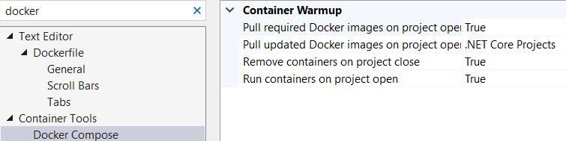

Mine

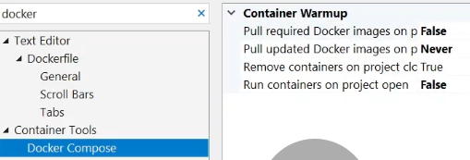

authors

Let me show you my configurations Tools | Options, search docker, can see that my container Tools in the Docker Compose the Pulls I set auto running my image to false that's why it's not pulling in the first place for me. Maybe you can see that these locks generating and the container is running in your local computer.

OK, if we come back to the compose file after the Dockerfile, we have also the composition of what if we take to the composition of light that will collect the compass. And you can see that we have some of the definition in yml format and this will be the services, including the Catalog.API. These are my sources basically specifying the image and it is indicating the local firepit services got a local talk API and occupied. This part is very important.

version: '3.4'

services:

catalog.api:

image: ${DOCKER_REGISTRY-}catalogapi

build:

context: .

dockerfile: Services/Catalog/Catalog.API/Dockerfile

That's why I'm sticking with the folder structure. This is required for the local composition when it is running the to API image in our local containers computers. OK, we have also the docker-compose.overwrite, almost like you can specify the detailed configuration here. As you can see that in here there is a entwinement, but it was a spinet. Core environment is a development and it is specifying the 80 port number.

Let me recap the local compose file, it defines all the services to be deployed in the current environment, of course, since we have one microservice, we have only one option, but we are going to continue other microservices listing in here. And these services rely on either the Dockerfile or existing container in which we are specifying in here the file. But it could be an existing decrement on the lock it up in here. We have implemented the compose.overwrites for the configurations. You can think that if you have several environment , you can configure your image properties as per the environment, for example, you can name that that could docker-compose staging, could docker-compose production yml and so on. These will be separating the configurations and the image in each other while your configuring the Dockerfile and docker-compose files. Two edits one for the image definitions and overwrite for the configurations. So you can also figure out that the running profile is changed to the Docker Compose run in here. We have a new running container in the Docker Compose and the Docker Compose is set as the startup project. So Visual Studio has the good tooling experience that you can run and debug over. We will see it later. We have created the Dockerfile and docker-compose file for Catalog.API microservices configuration? But one more left. We should add the Mong database into our local docker-compose yml file.

**25. Adding MongoDB image into Docker-Compose File for Multi-Docker Container Environment** 11 min

In this video, we are going to add Monga DBI database into the docker-compose file, let's say connection. First of all, we need to extend the docker-compose file Catalog.API and MongoDB. If you check the docker-compose yml file, while it is only we have one Microservice, which is the catalog API image, and we see beside the image and dockerFile, but we also need to add MongoDb database in order to run both the application in the same local environment. So let me add the Mongo DB database before I'm adding, I would like to say that the indentation of these yml files is very important. As you can see that there's two space indents. So this is a tree structure and all levels require two spaces. OK, so under the services, I'm going to a catalogdb. Let me get the two spaces one, two, and give the name of my services as a to TV and it enters two spaces and give the image name. Will be the Mongul. The image name is Mongo comes from the corrupt official image name once we have an official image as a monga, the compositional final check for the corrupt and dumped from the that if existing image in our local computer, it is going to use our Monga database. So we have added the two services, one for the catalog. Déby is a monument and another on the Catalog.API service, which indicating that they could file in our local composts file. We have two services now.

version: '3.4'

services:

catalogdb:

image: mongo

catalog.api:

image: ${DOCKER_REGISTRY-}catalogapi

build:

context: .

dockerfile: Services/Catalog/Catalog.API/Dockerfile

Also, I would like to add a modern definition. Let me come at the end of the local companies YAML file, and as you can see that we can specify volumes in here under the volumes whose space, Carter and I'm going to specify William or the Mongo data. So what is the volume, the volume is one of the important features, important concepts in the Docker, we will use the Docker volume support persistent database using the docker volumes in Monga database data. Volumes are basically data storage that are outside of the containers and exist on the host file system. Well that means even you remove the Mongar image because we'll be save database records, database tables and information inside of the Mongul data. If you specify the volume is a mongo data. It is very important if you would like to storing data into your file system and separating the data and the database we are using to Docker volumes. So in our case, we would like to also choose the specifying the Docker volume in order to save Monga database in my local computer. But the image also stay in here. Even the image is removing or recreating again. The data will never be disappearing. I will always see the volume definition with checking the mongo data.

dockerfile: Services/Catalog/Catalog.API/Dockerfile

volumes:

mongo_data:

OK, we have specified the Mongar database, but of course we also give the Mongar data address in the docker-compose.overwrite file what we have seen a few minutes later. But you understand the basics of the docker volume. <https://hub.docker.com/_/mongo/> And let me show you one more thing about the docker volume. If we come back to the Mongul offical image, volume definition (Where to Store Data)

$ docker run --name some-mongo -v /my/own/datadir:/data/db -d mongo

You can see the volume can be defined with this path so /data/db is provided to storing the image monga database image information into our own local file path. So this definition will provide to moving the data information into the database records in our file system. OK, so this was the look at docker ? definition and we have two services catalogdb and catalog.api.

Now we are going to configure for the docker-compose.overwrite file for the additional configuration. For that purpose I'm going to add one more service in here catalogdb. Two spaces, and I would like to always start to container the name, catalogdb. And let me specify the restart: always. If there is a problem when running the container, it will restart until it is getting success. And also we can specify the port numbers. And of course, the port number should be the normal definition with two spaces. I'm going to specify that two seven zero one seven. This is the. Official port, no, and we have exposed the same port number in our local computer. Maybe you remember we have specified these port number when we are running to the docker run command, but this time we are working with it the declarative way, not ?primitive? way. That means we specify the configurations in the yml file and we can we are going to run the docker-compose file with the overwrite file with giving these specific configurations. So I have defined the port. Also, we can specify the volume definition mongo_data. We have specified the Monga data. /data/db. We take from the mongo image document. and understand that these database related records saving in the data slash Dibia. OK, we have also created what volume definition is assigning to the mongo_data, assigned the ports and the contentainer name, it is enough for the catalog database configurations.

services:

catalogdb:

container_name: catalogdb

restart: always

ports:

- "27017:27017"

volumes:

- mongo_data:/data/db

But we have also catalog.api Asp Core Web API image. So I'm going to start with the container name and container name will be the same with the service name catalog.api. And also we have environment variables ASPNETCORE_Environemnt=Development. OK, also I would like to specify one more. This is so important for us because when we are running this application, as you can see, that in application settings we specifying ConnectionString is a Monga DB localhost says localhost and exposing this API. So but this time when we are in the current environment, we should overriding this application setting with injecting the environment variable. So let me paste in and I will explain after that. So as you can see that we have overwriting the application settings with specifying the database settings column connection string and this will be our new connection string. The only difference is the catalogdb. As you can see we are not using the locahost anymore because when we are working in the current environment, the network only knows the container names. The container name of the catalog db is catalogdb. That's why we have specified the container name explicitly. So this will be the overriding our ConnectionString otherwise it cannot be connect our Catalog.API with the mongo database in the current environment. This is very important one we are working in the current environment.

catalog.api:

container_name: catalog.api

environment:

- ASPNETCORE_ENVIRONMENT=Development

- "DatabaseSettings:ConnectionString=mongodb://catalogdb:27017"

ports:

- "80"

OK, so what we have done so far, what we can additional configurations depends on depends_on: one of the important configurations we have given depends on the another image. That means catalog.api dependent on the catalogdb, because if the catalog database is not working, the catalog API cannot be connected the database and it's going to be the unuseful. That's why we can specify the depends on configuration in here also. But this depends on not verifying that these catalogdb working fine. The only thing to depends on make it firstly start from the catalog db service and after that start from the catalog API. This is not a way to find that catalogdb is up and running properly. But at least we can order these starting image, which is starting with the database and after that continues to API. It is important for us. That's why we are specifying this dependent configuration. API project always dependent databases,

depends_on:

- catalogdb

and lastly, it is important for us we are forwarding to port 8000, when we are exposing these Docker image, we are basically port forwarding to 8000 in my local computer because we will create new microservice. Once we have creating a new microservice, we should separate these microservice support numbers. I will start with the 8000 and continue to 8001 2, 3 and so on. So this will be the provider forwarding the container port to our local environment port number. We can reach these Catalog.API microservices with localhosts:8000 port numbers.

ports:

- "8000:80"

OK, let me recap the docker-compose.overwrite file. See that we have given additional configuration details of our Catalog.API and Mongo DB image, set the port numbers in order to reach from the local computer and set the volume definition for storing Mongul database records. And the important part is overriding the ConnectionString with injecting the environment variables for catalog.api image. As you can see that we have finished the docker-compose and docker-compose.overwrite file. In the next video we are going to test our environment, our applications in the current environment.

**26. Test on Docker environment – Catalog.API and MongoDB into Docker-Compose File** 8 min

In this video, we are going to test on the current environment with catalog API and Mongo database. In the docker compose file. we have two services. So let's take an action. So in order to test the current environment, we are going to run the docker-compose command. Let me close all the other tabs. Right click the docker-compose folder and open in terminal. Run ‘ls’ to verify folder contents. OK, so before we start, I would like to take my running containers, docker ps -a. Verify shopping-mongo container is stopped. OK, for that purpose. I'm going to remove, docker rm 4char. docker image, you can see the Mongo image existing in our local computer. It's OK for us.

So for now, I'm going to run these. docker-compose file, which includes the Monga Database and catalog.api image, this will ?? image because specifying to the Dockerfile is performing to build and publishing operations with my code base. And after that, these will be injected this configuration into the docker-compose.overwrite file. We are going to run the docker-compose commands .

We are writing ‘docker compose -f .\docker-compose.yml -f .\docker-compose.override.yml up -d‘ f means files I'm going to specify docker-compose -f and docker-compose.overwrite files for the configurations and specifying up -d., working in a detachment.

**{.** – catalog.api Error, <http://localhost:8000/swagger/index.html> resolves though **}**

Get /api/v1/Catalog works.

Get /api/v1/Catalog/GetProductByCategory/{category} ‘Smart Phone' works

Postman

<http://localhost:8000/api/v1/Catalog> works

So as you can see that we have created defined the Mongo image in our compose file and exposing to port number 27017. And also we have tested with the Catalog.API microservice with exposing the 8000 port number on the ? environment. So that means now our Catalog.API microservice and Catalogue DB working successfully in our docker environment. And in the next video we are going to see how we can debug these images using VS.

**27. Debugging Docker-Compose on Visual Studio for Catalog.API with MongoDB** 16 min

In this video, we are going to debug docker-compose on VS for Catalog.API with Monga database of microservices, let's say, connection. When you add Docker Orchestrater Support it creates the Dockerfile and docker-compose file and a new VS Run Profile, Docker Compose. You can see the three files in the Solution and Run Profile in VS tool bar. So when this profile created, you will follow all your activities, for example, if you build the project, this will docker image (actually just the dll). If you can clean the project that will clean all the coal containers, for example, I'm going to right. Click and we tessellation. You can see that this will be willing to look at images from. See that this is running to the core composed comment and Willink is fine. Also, if you clean the right click clean solution, this will be running to the compost. Come on. These will be top and clean the containers from your local environment. **{.** Depends on Tools | Options | Container Tools | Docker Compose settings **}**

OK, so it is a good feature, but makes slow with your developments this way. And before we start, I would like to show you my Visual Studio Configuration about docker.

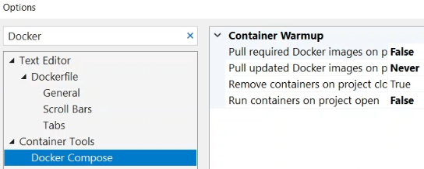

(Mine is True, .NET Core Projects, True, True)

Make sure that your configuration also the same as me, because I will show you how we can debug in this video. But the upcoming video sections, we are going to use the docker commands instead of the Visual Studio tooling. OK, so for this video, I would like to show you how the debugging features of Visual Studio with attaching the ?. So if you click to run Docker Compose this will create container from your docker file image and run this container. It is going to run the compose commands. This will create containers for us from the Catalog.API, docker file and the docker compose is going to run to run with Mongo DB database as the name of the catalogD. Also it gives ability to debug our container with Visual Studio. It is a very great feature.

docker-compose -f docker-compose.yml -f docker-compose.override.yml down (shuts down containers created with the ‘up’ command, not by Visual Studio run Docker Compose)

In the last video, we are going to test the crockpots up, OK, so it runs the compose.yml -f docker-compose.override.yml as you can see. The docker compose environment is ready and working fine. So you can see that our Catalog.API is working on docker compose Visual Studio Tooling.

Continue with explanations. First of all, I would like to show you properties and the launch settings. You can see that there is a new running profile, which name is Docker at once creating the container orchestration support. We should be adding these ?? profile for the docker operations. You can check the launch settings, Also you can take the right click and see the properties debug section, you can see that there will be a docker compost running profile (? Catalog.API is running Profile?). So we run our project in the docker-compose file and now we are inside of the docker containers from the Visual Studio, we run and now we can ready for debugging operations. We also develop application inside of the docker image. Let me start with checking the taking the looks. If you check the logs in here in the window, you can follow the darker. With operation, we can see the local operation in the. Look, (he goes to the Containers Window) I can show in here now, let me come in here. You can see the Containers and Images, well visualized here. We have a catalogue, API, immersion and latest version. And we also continuously catalogdb and Catalog.API. Also, you can check the environment, whatever's in it, in the environment, whatever it is, you can set the table settings and connected sitting or writing in here, ports 8000. You can see the logs inside of these containers running and you can see also files in here (Volumes and Labels also). So it is a very powerful feature to in order to see details from the Visual Studio.

I would like to debug into the container. In the CatalogController class. Let me come even put breakpoint on the GetProducts method, and call from Swagger. Get a timeout exception and if we checked the logs, you can see that we cannot connect to Monga Debe database (author gets in SeedData method, I get in Swagger with 500 error) so wide open. Why do you think about that. What happens when we are running in the local content. Let me close this one and you can identify that in some cases it will be alright in the local compost. When running for development purpose it reads from the appsetting.json. Need to copy the DatabaseSettings section from the appsettings.json to the appsetting.Development.json file and change localhost to catalogdb. Will override when running Visual Studio. So let's run again and see what happens and how we can debug our application. As you can see, that it is a bit trickier when you are working docker and Visual Studio together, so that's why I have shown this debug operation in this video. After that, we will follow the docker commands.

OK, let's try it out now. Let's hit enter. Yes, this time you can find the debugging feature in here. Let follow it after we retrieve products and we can inspect the products we debugging feature. So it is really cool feature because we are in the docker container now and attached to the container process and can able to debug. You can take on what that is, is debugging on staging or a production environment. Let me if I see that the bugging operation performed successfully. So let me close these running. Containers and let me you can also clean running containers with the right click and the clean solution. When I click the clean solution, you can see in the output windows to that. That could docker-compose a specifying file and the docker compose down command. That means this will clean all the running containers. So every operation inside of Visual Studio will coordinate the different commands. So if you know the underlining commands after the this operation, it is better the understanding to what is happening in the docker environment. If you are not debugging the container is good to change the two Tools | Options and the settings with the false. Because it just takes too long while you are cleaning and building solutions.

Debugging is a very powerful feature in docker compose, but instead of that, I will use the docker commands for running my docker compose file. For that purpose open the Terminal. We will use mostly docker compose commands with specifying the docker-compose and docker-compose.override files.

docker-compose -f docker-compose.yml -f docker-compose.override.yml up -d

We have already did it in the last video. Let me show you in this way. So once we're downloading the image, it very quickly started the docker containers. Can now browse <http://localhost:8000/swagger/index.html>. OK, so you have seen the how we can debug using Visual Studio Tooling in the containers.

docker-compose -f docker-compose.yml -f docker-compose.override.yml down

Now I'm going to remove the running containers specifying down not up. If we check the docker ps you can see that there is not any running containers. OK, if you check the docker images I would like to show one more thing, you can see that we have two images for our microservices with ta s latest and dev. When you are working with the Docker Compose running profile it is creating the dev tag with the image name. So that's why it is getting the information from the appsettings.Development.json file. But we are using the docker compose command it is basically generating the latest tag name that is ready for the deployment's. So you can also create the latest tag number with choosing the Release instead of the Debug mode. Also running the latest number is just for information.

As you can see it, it is a bit confusing when you are working with the Visual Studio and docker compose. It is good to use Visual Studio when in development and also use of the docker compose with ??. I will follow the manually running the docker compose commands during the course, but I would like to show how we can debug inside of the docker container. So for now I'm going to remove all the items I performed at the core composed on operation. After that we can remove the all of the containers with some of the docker PowerShell commands. For example docker ps -aq. This will be the list of the containers. docker stop $(docker ps -aq) And if we use docker stop specifying the distinct image, it is stopping all of the images that are running on your local computer? docker rm $(docker ps -aq) But if you also remove all the containers with using this command. I would like to show these commands in order to remove all of the containers and image in your computer from the fresh start. For example, we can use docker rmi $(docker images -q) removing all the images in your computer (also removed 11 other images that were not displaying in Docker Desktop). Let me remove the image. And when we are using the docker compose up the first time, it is getting the information from the ?? beginning of the docker hub and the ?build/pull? link image from the Dockerfile. So also we can see the docker system prune command.

❯ docker system prune

WARNING! This will remove:

- all stopped containers

- all networks not used by at least one container

- all dangling images

- all dangling build cache

Are you sure you want to continue? [y/N]

This will remove unnamed image which specifying ?? information in your computer. (removed NetworkS: dockercompose132…_default and several dozen build cache objets) While I'm doing this, I'm showing these commands in order to see how that we can create your image or running containers and all the definitions in your local computer.

docker-compose -f docker-compose.yml -f docker-compose.override.yml up -d

If you start from scratch, let me run from again docker compose up with detachment. This time this will be pulled image from the Mongo DB from docker hub and also build link the image from the Dockerfile with Catalog.API. So as you can see that we have seen debug conditions on docker and also see lots of useful docker commands. In the next video, we will see how we can use the MongoDB GUI options.

**28. Mongo GUI Options for MongoDb Docker Image** 5 min

In this video, we are going to see Mongo user interface options for Monga database docker image. Let's say, connection. Before we start, run Swagger Get Catalog, because I have removed the image and create from the beginning by using the docker-compose up command, because this will be the creating and seeding of the database at the first time. Verify the products return successfully. OK, so now our Monga database is populated with data and ready for the user interface operations. We can see the docker Monga database object in a GUI and a user interface, but there is no official image for that. I will show you Mongo client GUI image for ?this action?.

<https://hub.docker.com/r/mongoclient/mongoclient>

For that purpose I'm going to open the up and see that Mongo client image. So this is the that Mongo client image we can use for the GUI operations, for the Mongo database. You can see the details in here. So let's examine this image, see that how we can run this Mongo image and use Mongo client for our GUI requirements. So I can take one of the running operations docker run -d -p 3000:3000 mongoclient/mongoclient. So let me come to do our application. And let me. Could ease my command window if you passed this comment, the Koran, they should be exposing the 3000 number and specifying the image name, image name is mongoclient slash mongoclient. This will be a download to Mongo client image and run this image into the 3000 port number. Let's see how we can visualize the Mongo database, how we can see the databases, documents, collections and so on. These will be downloading the images.

If you check the docker hub it up, you can see other details about the mongoclient. You can also use another image from the visualize Mongo database. For now I would like to see mongoclient and how we can connect and see the collections. Let me check docker ps and verify that our mongoclient is working and exposing in 3000. So now I'm going to check from my browser <http://localhost:3000/> , yes, as you can see, that it is coming in at mongo ?? and if we click the Connect button, you can see that we have also default reconfigured connection. This is the looking for the localhost and the port number is the default port number, 127.0.0.1:27017, of the Monga database. If I select it and click the Connect now you can see the Mongo database in a visual way in a GUI, you can see the management tools, collections and so on. So let's check the collections settings. For now, for me, I can see the collections, but it should be in this place, I think as you can see, that we have options for using the interface of Monga database. You can also search and use any different tools like mongoclient. And the next section we will develop the Basket.API, microservice.

**Section 3: Developing Basket.API Microservice with Redis** 1hr 47min

**29. Introduction** 2 min

In this section we are going to Develop Basket.API Microservices with Redis.



Let's check our big picture and see what we are going to build one by one. As you can see that, we are in here and start to Developing Basket.API Microservices with Redis. We are going to cover Developing Basket microservice which includes; ASP.NET Web API application, REST API principles and performing CRUD operations, using Redis database connection and containerization, and applying Repository Pattern implementation. We will Analysis and Architecting of Basket Microservices, applying N-Layer architecture. And of course, containerize Basket Microservices with Redis database using Docker Compose. In the upcoming sections we will consume Discount Grpc Service for inter-service sync communication to calculate product final price in the Basket microservices. And also we will publish BasketCheckout Queue with using MassTransit and RabbitMQ. So in this section, we are going to Develop Basket.API Microservices with Redis. By the end of the section, we will have a Web API which implemented CRUD operations over Basket and Basket Item objects. These objects will be stored in Redis as a cache value so in our case we will use Redis for NoSQL database. After we’ve learned the basics we can start with the coding part.

**30. Create Asp.Net Web Api Project for Basket.API Microservice**  6 min

In this video, we are going to create Basket.API AspNet Web API microservice. First of all, create a Basket folder under the Services folder. Add a New Project, ASP.NET Core Web API , named Basket.API, in the Basket folder. .NET 5.0 (Current), No Https, Enable OpenAPI support, which is providing Swagger implementation. Verify …\src\Services\Basket\Basket.API. Let's modify the launch settings in order to set the numbers correctly. Our big picture of the architecture to modify the settings right. Click to find properties. Open the Debug section and in the launch profiles, Profile: Basket.API, Profiles: Project, App URL: <http://localhost:5001> (for Docker environment will be 8001). OK, finally, we can run the application, but before that, let me show you the changes in the appsettings.json.

So we can now run our basket microservic. In order to run our application set Basket.API as the Startup Project. Visual Studio’s run Profile is IIS Express, change to Basket.API, which is my running profile on figuring a few minutes before. So now it is ready. Let's put it this button or it the F5.

Opens in Console mode, …\src\Services\Basket\Basket.API\bin\Debug\net5.0\Basket.API.exe, and browser with <http://localhost:5001/swagger/index.html> for Basket microservice. Swagger is configured because we selected ‘Enable OpenAPI’. We can see our Basket.API microservice is running on port 5001 with the default implementation.

**31. Redis in Basket Microservice** 2 min

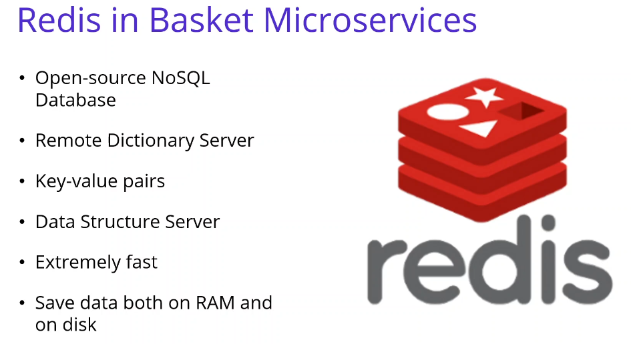

In this video we are going to talk about Redis in Basket Microservices. Redis is an open-source NoSQL database designed as key-value pairs. Redis is short for Remote Dictionary Server. It positions itself more as a data structure server. Redis is essentially an open source NoSQL database that keeps data in memory. Redis is not just a simple key-value server. One of the most important differences among other alternatives is that Redis’s ability to store and use high level data structures. The advantage of Redis we can say that It is extremely fast because it works synchronously. Also, it supports many data types, It can save data both on RAM and on disk according to the configuration what you set. Since it records on the disc, it continues to work with the same data after restart. Also it has many enterprise features such as Shading, Cluster, Sentinel and Replication. If you talk about disadvantages of the Redis, since it does not work asynchronously, you may not be able to reach the performance that asynchronous alternatives reach on a single instance. Also you will need RAM according to your data size. It does not support complex queries like relational databases. If a transaction receives an error, there is no return in the Redis. For Basket microservices we are going to store basket and basket items. data information into Redis Cache system as a JSON object format. As you can see that, we have seen the Redis and in the next video we are going to set up the Redis Cache Docker database from the DockerHub.

**32. Setup** **Redis Cache Docker Database for Basket.API Microservices.** 5 min

In this video we are going to set up the Redis Cache Docker database for the Basket API microservice. Before we start make sure that your Docker Desktop is started your local computer. First of all, we should go to the https://hub.docker.com/_/redis the latest official image. Examine the documentation, ports and so on, for example, let's search for the ports. We cannot see the port number, but I know that anyway, we can see the documentation in the case, for example, how we can start release on our local environment or other details of it, how we can use it, Redis CLI. And how we can use this from the Dockerfile and so on. So we will see these details when we are pulling image from our local computer, see that this is the pull command from the Docker hub, ‘docker pull Redis. Let's pull this image in our local computer. So basically this command provides the pulling the image from Docker hub and installing it on the local computer. OK, you can see the image.

docker run -d -p 6379:6379 --name aspnetrun-redis redis

OK, so if we would like to run this image in our local computer, you can check the documentation. Also, I'm going to write this command. We are using this docker run command, we already saw this when we are ran the Monga database in the Catalog microservice. This time we are we are in the basket microservice and the redis database will be used. So I'm going to run this image using the docker run command, -d detachment that means working background., -p specifying the port, the official port number is 6379. So I'm exposing the same port number in my local computer. This is basically the port forwarding operation and --name giving the name of this image, aspnetrun-redis. And finally, we are writing, redis, the image name of our operation. Just hit. Enter and see what happened. To check running containers, we are using docker ps. OK, see that we are forwarding the port correctly and for troubleshooting, we have some command I would like to show you how we can make troubleshooting in the docker image and container.

docker logs -f aspnetrun-redis

For example, docker logs in order to check the logs, if and we give the image name, aspnetrun-redis. Control + C to exit the image. docker exec -it aspnetrun-redis /bin/bash and also for troubleshooting, we can inspect with the interactive terminal, with /bin/bash because we would like to open a bash script in the interactive terminal. Just hit enter and see that we are in the container and able to run the redis commands. months. We will see in the next video redis cli commands. So as you can see that we have pulled the latest image from Docker hub to our local computer and run and start the container in our local computer exposing the official port number.

**33. Redis CLI Commands using Interactive Terminal For Redis Connection** 4 min

docker exec -it aspnetrun-redis /bin/bash

redis-cli

ping - PONG

set key value

get key returns “value”

set name mehmet

get name returns ” mehmet”

In this video, we are going to connect th the Interactive Terminal on the Redis connection. And we will see how to run redis commands inside the redis container. docker exec -it aspnetrun-redis /bin/bash

First of all we should run in a PowerShell, let’s use the VS PS Terminal. We can say redis-cli in order to run redis cli commands.

root@04fb97a17a22:/data# redis-cli

127.0.0.1:6379>

ping responds with PONG. So that means our key-value pair Redis dictionary server is working fine. Also you can set key and get key commands. For example if you set you can also see the example usage how we can provide the set or get key value information.



set key value I'm going to set key and give the value. And if we get key we can see that we can get the value information, “value”, but basically we are using the key value pair property functionality of the redis container. Also you can, for example, set the name. And give the name is Memet.

So we see that the value pair property functionality in redis is the same way we are going to write the json format in ?? in our basket microservice. We are going to storing the basket and basket items data in a json format as a key or K should be the user name and the value will be the json object full of the basket object. And we are going to get with the user name when we are showing the basket microservices Basket page. OK, as you can see that we have run several commands into the redis container terminal. So now we have redis cache database is running on our local computer and we are ready to connect to redis from our Basket.API microservices project.

**34. Analysis and Architecting of Basket Microservices** 7 min

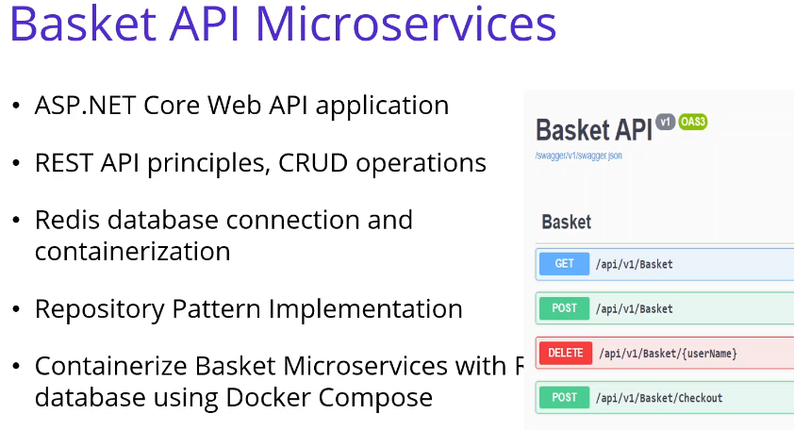

In this video we are going to develop Basket.API with Redis. So this project will be the REST APIs which basically perform CRUD operations on Basket Redis databases. basically we are going to cover the developing Basket microservice which includes the ASP.NET Web API application and REST API principles with performing the CRUD operations using Redis database connection and containerizing with Redis and the application, and applying Repository Pattern implementation in the Basket microservice. We will also analysis and architecting of Basket Microservices with applying N-Layer architecture. Of course we will containerize Basket Microservices with Redis database using Docker Compose. And also In the upcoming section we are going to consume Discount Grpc Service for inter-service sync communication to calculate product final price. Also, one of the important part is Publish Basket Checkout Queue with using MassTransit and RabbitMQ. We will see these topics in the upcoming sections.

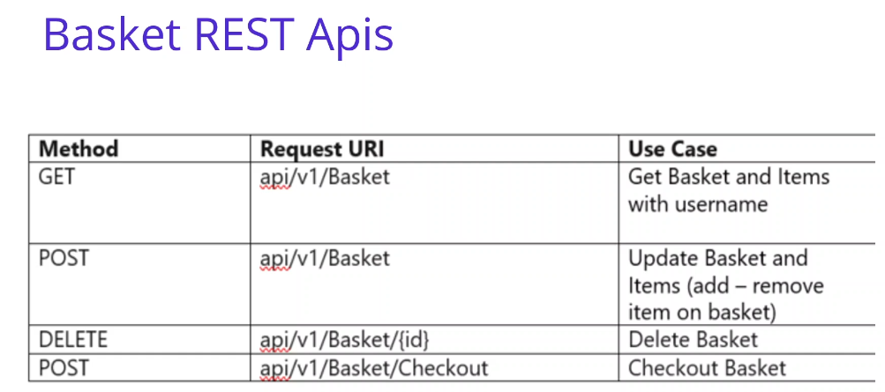

OK, if you check the REST APIs. You can see this pictures I am going to analysis and design our exposing RESTful apis for Basket microservices. We should define our Basket use case analysis. In this part we will create Basket and Basket Item entities. Our main use case are Listing Basket and Basket Items; able to add new item to the basket; also perform some CRUD operations on the Basket entity. Well that means we are going to create our main use case, that Get Basket and Items with username. This will be our first main use case. And second one is the update basket and items add or remove item on the basket. And the other one is the Delete basket, and the last one is the checkout basket, which is going to publish basket check out Queue with using Mass transit and RabbitMQ.

OK, along with this we should design our APIs according to REST perspective. We are going to create these exposing these methods with obeying the restful principles, we can see that we have a get method with exposing the api/v1/Basket and we have a post method with the same request uri. The http method is changed. Also Delete is almost the same, only id is required as a parameter. And of course we have a post operation and this operation is belongs to a for Check-Out operation.

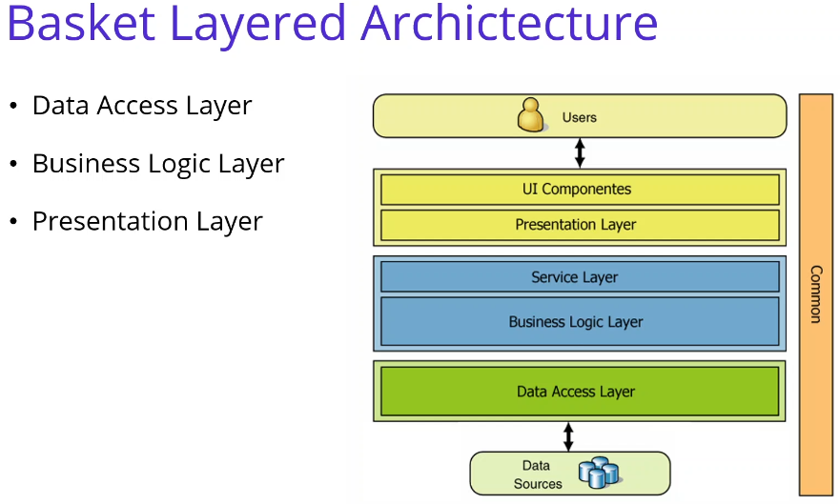

OK, if you check the architecture of the Basket Layered Archictecture, we look to the architecture of the Basket microservices, we are going to use traditional N-Layer architecture. Layered architecture basically consists of 3 layers. These 3 layers are generally the ones that should be in every project. You can create a layered structure with more than these 3 layers, which is called multi-layered architecture, but we are following this 3 Layer traditional architecture. If I can explain that this is the Data Access Layer: Only database operations are performed on this layer. The task of this layer is to add, delete, update and extract data from the database. There is no other operation in this layer other than these operations. And if you look at the business layer, business logic and the services, you can call that as a service layer also, we implement business logics on this layer. This layer will process the data taken by Data Access into the project. And we do not use the Data Access layer directly in our application. The data coming from the user first goes to the Business layer, and from this layer it will process and transfer to the Data Access layer. And finally we can talk about the presentation layer. This layer is the layer on which the user interaction can be happen. It could be in Windows form, on the Web, or in a Console application. We will use the Web applications. So this will be our client application. The main purpose is here to show the data to the user and to transmit the data from the user to the Business Layer and the Data Access layers.

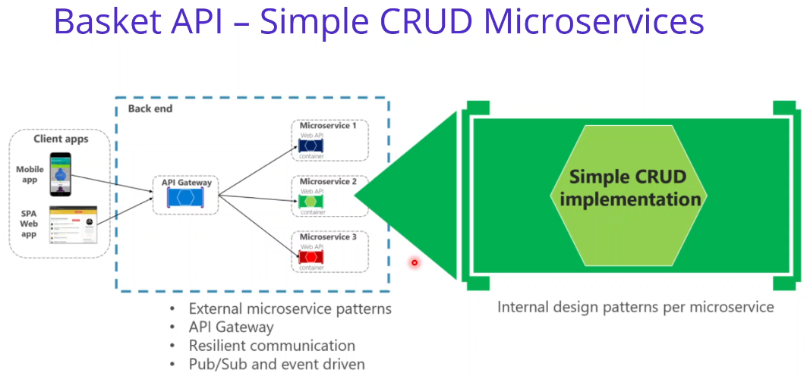

If you check the structure of our Microservices, Basket API Microservices will be the simple crud implementation on the basket and basket item data with using Redis databases. You can apply any internal design pattern per microservices. Since we have 1 project we are going to separate these layers with using folders into the project. But for the ordering microservices we also separate layers with projects with using clean architecture and ?cqrs? implementation. We will see the Ordering microservices in the upcoming lectures. So we don't need to separate layers for the basket microservices with the different assemblies, we are going to create a folder for all layers.

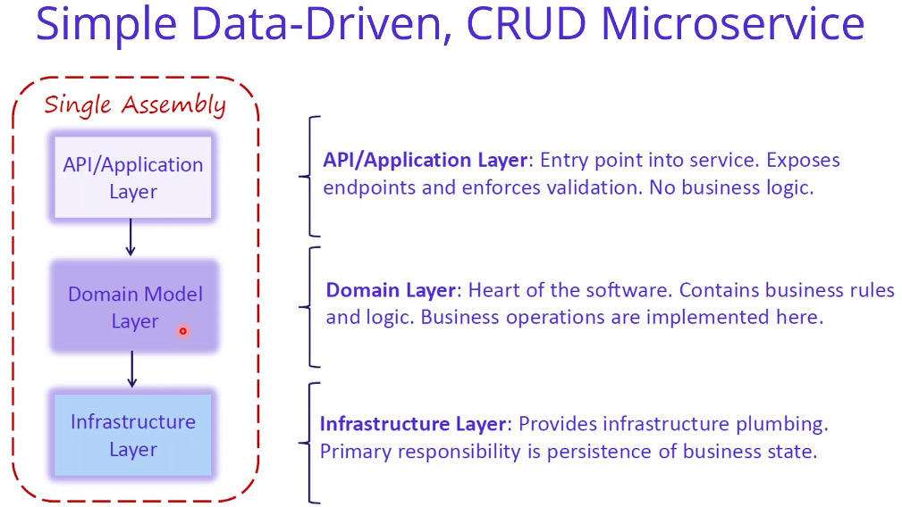

If you look at the project structure, we are planning to create these layers, Domain Layer contains business rules and logic. And the Application Layer - Expose endpoints and validations. API layer will be the Controller classes. And the Infrastructure Layer - is responsible for persistence operations with connect to database and so on. The project folder structure also following the same concepts, we are going to create entities folder, which storing Redis entities, we are going to create data folder, which will be the Redis data context class connections. And we are going to create repositories which will be the applying to business logic. And of course, when we are creating the Aspnet Web API, these will be the controller classes, which is the exposing APIs to the external systems.

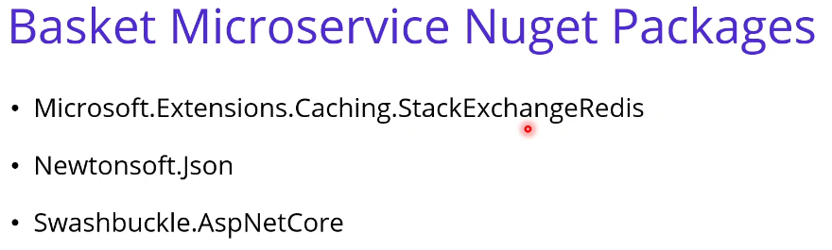

If you checked to nuget packages, we are going to use below nuget packages. The first one is the Microsoft.Extensions.Caching.StackExchangeRedis, this is for communication with the Redis databases. And we are going to use Newtonsoft.Json, for the JSON parse operations and of course, Swashbuckle.AspNetCore. This will auto install from the visual studio for swagger implementations. As you can see that we have to analyze and design our basket microservices. In the next video we are going to start with the development.

**35. Developing Basket.API Microservices Creating Entites** 6 min

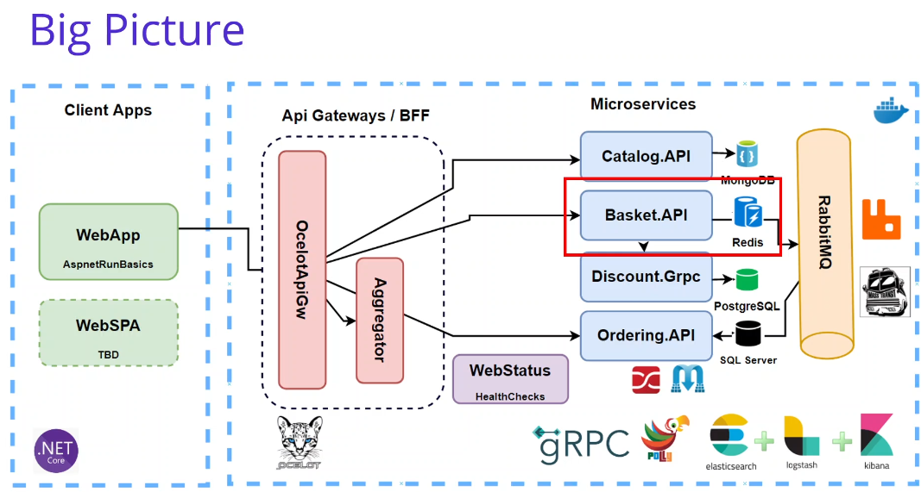

In this video we are going to start to Developing Basket.API Microservice. But before that I would like to explain that why we are choosing to Redis as the basket microservice database. Basket.API will be stored and manage baskets and basket item data in their own operations. So it is best fit for the caching these information, these basket items could be the best fit for the Redis Cache operations. But we are using Redis in here. One more reason. The reason is the Distributed Caching. A distributed cache is a cache shared by multiple application servers, and typically maintained as an external service to the application server can be access it. So that means we have a Redis Cache and Basket.API in here and other microservices can be reached these Basket data information in a distributed caching. A distributed cache can improve the performance and scalability of an ASP.NET Core applications, especially when the application is hosted by a cloud service or a server farm. So that means we are servering in the Docker Desktop, but also can be shifting to Kubernetes. So another advantage of the distributed cache is we can say that storing the individual application and when the cache data is storing the distributed the data could be consistent across the request from the multiple services. OK, now we can continue to our development.

Let me come back to Visual Studio. So first, we are going to locate the Basket API microservices, and it is the typically aspnet core Web API template project. So that's why I am going to remove the weather forecast related classes. And also, I'm going to remove the controller. Create Entities folder for storing entites objects into the redis connections. Add the ShoppingCart.cs, this will be the entity class for the Basket microservice. So in the shopping cart entity, we are going to start using the shopping cart item list. So that means this will be the root ?? object

Username, List of ShoppingCartItems, two constructors one for empty and one for username, TotalPrice method

Add a new entity ShoppingCartItem, and in this class we have several numbers, which belong to the shopping cart items.

public int Quantity { get; set; }

public string Color { get; set; }

public decimal Price { get; set; }

public string ProductId { get; set; }

public string ProductName { get; set; }

I'm going to copy and paste in here. Let me explain. Integer quantity, quantity of our shopping cart item: string colors is a characteristic, decimal price, string product ID is important because which product ID belongs to the shopping cart item. And also I would like to add product name in here because the communication of microservices is something need to network connection and consuming APIs. We don't need to consume for only getting the product name from the catalog microservices. It is good to use the duplicating data when we are adding the item into a shopping cart. We can also transmit the product name and the product id together. OK, so we have a shopping cart item and a shopping cart object in here.

I would like to add one more property in the ShoppingCart to calculate the total price. You can think of this as a function calculating the total price in the get of this property. I am basically calculating the items with iterating the shopping cart items and calculating the item price with multiplexing the quantity of the item. And this will be calculating the final total price for me. OK, that means once I get the shopping cart entity, I just called the total price property in order to get the total price of the shopping cart with inside of the items. OK, let me remove these unnecessary usings and check the shopping cart item again. And we have two entities for the Basket API. These will be stored in the redis database. As you can see, that we have created entities for storing the redis cache database. In the next video we will connect with the layers in our basket microservice.

**36. Connect Redis DockerContainer from Basket.API Microservice w/AddStackExchange** 8 min

In this video, we are going to connect Redis Docker container from our Basket.API microservice project. First of all, we are going to add Nuget packages in order to connect with the redis into theBbasket.API project. Package Manager Console, default project name should be the Basket.API.

Install-Package Microsoft.Extensions.Caching.StackExchangeRedis

StackExchangeRedis will provide to connect redis is more properly and more convenient. Also, I am going to update the package for the Basket.API (Update-Package -ProjectName Basket.API) because as you remember in the Catalog microservice, Swashbuckle needed to be upgraded to six version (5.6.3 to 6.2.3 ) four. OK, in order to verify this, you can double click the Basket API project and see that we have two PackageReference, one for the StackExchangeRedis and the other for SwashbuckleOK, let's save this csproj file.

After that, we have to configure our application in order to support the redis cache and specify the port number at which this is enabled. Startup.cs, ConfigureServices method, IServiceCollection is built-in ASP.NET Core dependency injection tools.

services.AddStackExchangeRedisCache(options => {

options.Configuration = "localhost:6379";

});

OK, so let me see the options. You can see that it is expecting some of the options and we are going to provide options that configuration, if we check the configuration part, the configuration is used for the connect to redis. So we are going to provide the redis database in the configuration. In our case, we have a redis container running in our local computers, so that's why localhost and exposing the 6397 port, which is the default port of the Redis. OK, so by this line of code we have registered the redis connection and also configuring in the registration operation with providing the redis server name and the port number for our local computer. You can also check your redis is running on your local computer with docker ps.

docker run -d -p 6379:6379 --name aspnetrun-redis redis

We can see that we have created the name of aspnetrun-redis container which is exposing to this port. OK, so that means we can basically connect this server with using the localhost colon and the port name.

OK, we have configured our connection with the redis database into our Asp.Net Basket microservice application. So now it is good to get this url from the configuration, now we are hardcoded in here, but it is not seems good. Let's move this configuration into the appsettings.json file.

"CacheSettings": {

"ConnectionString": "localhost:6379"

},

OK, so let's update the startup with getting configuration.

options.Configuration =

Configuration.GetValue<string>("CacheSettings:ConnectionString");

OK, so basically we have finished the connection of the redis database with the Basket microservices. Now it is ready to use with the IDistributedCache with this AddStackExchangeRedisCache extension method. It is provide to inject any class with I S IDistributedCache and create an instance for us. That means we are going to use IDistributedCache in the next video. And this will provide to us using IDistributedCache with for the redis database's. In the next video we are going to inject this class in the repository classes.

**37. Developing Repository Pattern on Basket.API Microservice** 13 min

In this video we are going to develop repository on Basket.API microservice. We will encapsulate data context objects in the repository classes. By this way there is an abstraction with the ?repository layer?. First of all, we should create Repositories folder and add IBasketRepository interface. This interface will basically ?pass? from the GetBaskets and CRUD operations over the basket.

Task<ShoppingCart> GetBasket(string userName);

Task<ShoppingCart> UpdateBasket(ShoppingCart basket);

Task DeleteBasket(string userName);

Well, that's why I'm going to write GetBasket. Task<ShoppingCart> comes from the entities namespace and this will getting username is a parameter. The other ones also the same for the performing the CRUD operations. You can see in here UpdateBasket, with passing the basket information, which is the ShoppingCart object type and returning to ShoppingCart again. And the last one is Delete Basket. We are going to pass in the username. Remember user name will be the key of the our key value structure in the redis dictionary databases. OK, in here we have no InsertBasket or CreateBasket method because since we have a key value pair in the redis dictionaries server we are going to use key as a user name and ?value? is the whole ShoppingCart object. So that means once the item adding into the basket this will be update the whole basket or removing an item into the shopping cart is will be also updating the whole basket information. So that's why we don't separate the add item into basket or create basket stuff. We are only using to update basket or covering all these operations. Clear unused namespaces. We will cover all these methods with the Rest API methods repository object. After that, we can implement this interface with using the IDistributedCache.

Add BasketRepository.cs and this will inherit (implement) from the IBasketRepository supposed to do. Basically we are going to implement with using IDistributedCache, it is very important. Inject the IDistributedCache using Microsoft.Extensions.Caching.Distributed from the StackExchangeRedis package. That means once we have installed that package, we are directly integrating this distributed cache structure of the Asp.Net and this is one of the best implementations when you are working with the redis or any kind of distributed cache. I'm going to give the name -redisCache. We have injected a IDistributedCache cache with dependency injection, if we check this dependency injection layer you can understand that we are going to use as a redis IDistributedCache object. This extension methods provide to us converting to distributed cache using redis.

OK, so let me start one by one implementing the interface members starting with the GetBasket. We are getting the userName and returning the ShoppingCart. Create var basket from _redisCache, you can see the redis cli commands in here, using GetStringAsync passing userName which will get the username information. With the userName K name, I'm going to get the ??. That means returning to the basket object is basket object will be the whole json object for me because I am going to add the basket object when we are adding an item into basket or creating the first time of the basket, we will see the one we are implementing update basket method. Add a Basket null check. After that, I will perform the Jason operation. We are going to use JsonConvert in order to deseialize this string to the ShoppingCart object type using the DeserializeObject method. This will convert the basket sting variable and converting and deserializing this json variable to the ShoppingCart object structure. Have VS install the latest Newtonsoft.Json package. This deserializes this object to the ShoppingCart structure. In the ShoppingCart structure we have a userName, also a list of the ShoppingCart items which include the other details into the ShoppingCart item. We have implemented the GetBasket operation.

I'm going to implement the UpdateBasket method, which will be the cover add item into the basket. The new item in the basket creates basket in the first ?shot?, all of the operations will be handled in the UpdateBasket method. Because we are writing the using the redis cache and we are writing the set async and get async methods in a json format. So let me start with directly awaitable using _redisCache and this time we are going to use SetStringAsync method. These will be specified asynchronously ???? a specified key value. So if you check the parameters the first parameter will be the UserName or since we are passing the whole basket, we can specify the basket.UserName. Also, it is requiring the value we are going to storing on the redis json format. I'm going to use JsonConvert.SerializeObject object and passing in the object, my basket object, this will be the whole ShoppingCart object, OK. Well, basically, in the first line of this method, we are writing the username key value and the value is the serializing the ShoppingCart item in json format, but this will overwrite the whole information if there is an existing username in here. That's why this method will be covered all of the operations, add item in ShoppingCart, removing item in the ShoppingCart, or create ShoppingCart in the first place. After that we are going to return await GetBasket and basket.UserName, which is the first method we have developed. I'm going to call this method inside of the UpdateBasket method.

We have only the DeleteBasket operation left from the interface. So if you can see in here the basket, only getting the username as a parameter and we have RemovAsync method from the distributed cache object and passing the key information as a username. That's all for Delete basket.

As you can see that we have implemented the basket repository. I will explain in detail, but before that, make sure that you have installed the correct JsonConvert and Newtonsoft.Json. Let me show you Basket.API project file, you can see in here I'm going to download Newtonsoft.Json version 12.0.3 is the latest version. OK, so now let me try to explain this basket repository. Basically, we are using the IDistributedCache object as a redis cache because in the Start-Up class, we have configured redis as a distributed cache. So we are using distributed cache in here. And also if we check the startup.cs this line of code provide to create the redis connection when we are using the IDistributedCache. So when we have injected this interface, this will create a redis cache instance for us. Ater that with using the IDistributedCache object almost every redis CLI commend is include in the context class as a method parameter, you can see GetStringAsync or SetStringAsync or RemoveAsync methods. So we have implemented these methods into our API requirements. We have also used the JsonConvert class in order to save and extract json objects from our redis cache databases, so our basket and basket items structure saving to redis is a json object. Well, let me save all the files and build the Basket.API project. Yes, we succeed, as you can see that we have finished the repository implementation. In the next video we are going to create ControllerClass.

**38. Create BasketController Class for the Basket.API Microservice** 12 min

In this video we are going to create Basket controller class for Basket .API microservice. First we’ll create BasketController class into the controller folder. OK, we are going to convert this controller classes as a controller for that purpose. I'm going to check the catalog API controllers and get a controller. I'm going to copy these attributes. What we have done before and paste in here, mate, is Baskette controller is the API controller, which is comes from the Microsoft agent code. And it's also routing the API version one and the controller determines approach in one basket. And one more thing we should do, of course. Don't forget the inherit from the contrabass, these will be the ace at DePaul Control, the base class, which including the lots of will and defined methods and so on. OK, well, now we are ready to implement our BasketController in the basket controller API class. We are going to inject with the IBasket repository what we have developed in the last video. Import namespace Basket repository and give the name of the repository, and I'm going to inject these as opposed to the. It generating the constructor injected in the constructor. So now I am ready to use basketry repository object in my API methods.

The first Api method is get bosket. So I'm going to use the method for the. Let me put it to you, this will be the async and awaitable function, so that's why public async and that's why we're here returning to Task object. And inside of that, we have an action result is you remember the action that comes from the controller class controller base, which basically provides us returning to 401 or 200 success HTP method two responses in our API methods. For inside of these. Actions that we can also provide, the type of information you would like to return a shopping cart information, and we this is the GetBasket method name and it is basically getting the user name is a parameter. OK, inside of that, we are performing the implementation of API method using the basket repository. We have a GetBasket method passing the username. Of course this method is a awaitable. And now I have a basket object, I'm going to return this basket with coding the OK response, which is the defined ActionResult and return to success 200 response. and inside of that, I am placing the basket object, which is our ShoppingCart object coming from the redis database.

OK, we have implemented the basket, but I would like to put in here a little logic, If Basket is not, I would like to create the new shopping cart. With the user name, with the giving user name, so why I am doing this in here, the purpose of this code, if the first time client would like to add item into Basket, we should create a new empty basket with the given user name. That's why I'm providing this code in here. If the basket comes from the null from the redis database, that means this user is the newly created and this item is the first item is going to add the basket. So that's why we're creating this shopping cart object structure in here in the first place.

OK. So we have implemented the GetBasket, but since this is a API method, we can provide some of the cool attributes. First of all, I would like to say that these will be the indicating HttpGet in order to perform, accommodate the HttpGet requests from the API version one Basket operations, exposing these API methods which using the HttpGet. But also I said that this username can be passing from the request URI with putting a slash and giving the user name in here. And this API method name is a GetBasket. Also, we have one more attribute which is providing the putting the restrictions or showing the explicit the return types into the GetBasket. We can say that produce response types as HTTPStatusCode.OK, with importing this standard package. But this will provide to explicitly say these API method only returning the OK response and also this will have to generate the ?single? output.

OK, we have implemented our first API method. Also, we have update Basket method. I'm going to follow the same concepts in here. This will be the also awaitable function. That's why async and the task. Into the Task we have ActionResult up also into the Action we have a shopping cart object type, but this time method name UpdateBasket is a parameter from the body we expecting the whole shopping cart object type. OK, so let me implement this method. This is also very easy. When we are using the posted object, we have an awaitable repository UpdateBasket method with passing the whole Bosket object and this will return us to OK response returning the shopping cart response into the ActionResult that. The action is OK. And the result inside of the result is the return type of the repository update Basket method. And of course, I also adding the HTTP methods and the ProducesResponseTypes it is very important to indicating the HttpPost with the update Basket operation. This will be ( [Route("api/v1/[controller]")] ) API version one basket accommodating this API version one basket calls from the outside and producing to type HTTP OK.

The last method is I'm going to put in here HttpDelate and given the username we are going to delete the basket with specifying as a parameter username and basically we have used the repository DeleteBasket object. If you right click and go to implementation, you can see the implementation details from the basket repository. We are basically using the redis cache behind of the scans. This redis cache is an IDistributedCache and we have using the GetString, SetString and Remove Async method in order to perform these Basket repository related operations.

OK, this is the basket controller what we have developed. Well, let me remove unnecessary name spaces and we kept these controller classes, we have basically injected IBasketRepository object and use these object when exposing APIs. You can see that we have exposed the CRUD API methods over the basket controller. Also, you can see the annotations, for example, ProducesResponseTypes, provide restriction on API method. Produce only including types of objects. Also, we have a Route definition put out to define the custom routes, mostly using if you have one more the same ?? method, you can use the Route definition also inside of the method body.

So after we have developed comptrollers, the most important part is the registering objects into the Asp.Net with independents injection. You can see, that these control class using the IBasketRepository interface, not an implementation. So how Asp.Net know that these IBasketRepository object will be convert or create as a BasketRepository as opposed to the implementation class. These should be registered, defined in the Asp.Net Startup class. So in our case, we have a IBasketRepository story and also into the BasketRepository let me open. BasketRepository also using the IDistributedCache. So both these interfaces should be registered into the Asp.Net Core built in dependency injection. Well, let me open the startup.cs and see that the IDistributedCache already registered by using the AddStackExchangeRedisCache extension method. So we should also register our IBasketRepository object into the ConfigureServices method. I'm going to use services.AddScoped and passing the IBasketRepository, let me put namespace and of course, I can say that BasketRepository. This line of code basically said that if you see any place IBasketRepository injected any class into the Asp.Net core application, these will be the convert and creating BasketRepository object. OK, so in the basket, repository we are using the IDistributedCache. This will be also converting to redis DistributedCache object it using this line of code. OK, so for IDistributedCache we have already registered with the AddStackExchangeRedisCache extension method. We can now right click and build our Basket.API microservice Project. Yes, succeed. As you can see that we have finished the development part of Basket.API project and it is time to test this application. In the next video we are going to test our Basket microservice.

**39. Test and Run Basket Microservice** 7 min

In this video, we are going to test and run our Basket.API microservice.

docker run -d -p 6379:6379 --name aspnetrun-redis redis

Run Docker Desktop and insure redis container is running. Docker ps command. See that our redis image container is running with a given port 6379. So that means we can access it is using localhost:6379. The name of the container is aspnetrun-redis. Verify the redis container is running and exposing the correct port number with matching the appsettings of our ConnectionString.

OK, as you can see, that launch browser is a swagger, Including Swashbuckle package and configured in Startup.cs (both methods). Run the application using run Profile Basket.API which opens the Console ad Browser with port 5001. Basket API, microservice swagger implementation. Try out Get with username swn it responds with an empty shopping cart items, it is creating a shopping cart for us because this is our first call but the items is empty and the total price is zero as expected. Also, you can use the delete method tests and also you can perform the post operation. If you have any items you can use to post operation, we will test these other methods with using Postman and see how we can send HttpPost ?? for are Basket microservice.

So we have Posman Collection, I have download for you. We can see that we have a post basket method in it. Change to 5001. In here, I am going to post payloads. By this way, let me show you in here, username is swn and the items I'm going to provide to some of the example quantity, color, price, the product Id and the product name. Make sure that the product Id should be the same as a catalog product Id, these will be some Id from the Mongo database and we have all of the defined products. I'm getting this id information from the Catalog microservice. Also, I have a second item, which is the Samsung 10. Just sent to this HttpPost request and it will return us to 200 OK and returning to this information for us, as you can see, the total price is one thousand five hundred. OK, the post operation also working fine. You can test with the delete operation, with changing the verb to DELETE and also providing the name. The delete also performing properly. If you get the basket again with asn you can see it is comes from the zero items, that means it is creating from the beginning. So let's make it the post and send these items again into the redis cache. Of course, we should remove the swn when we are sending the Http POST because we are passing the whole object in the body. Yes, we have a swn user name, which including two shopping cart item into the basket.

OK, so also I would like to see into the redis cli. Open a terminal and run the ‘docker exec -it aspnetrun-redis /bin/bash’ command to open an Interactive Terminal in order to run the redis-cli commend. So now if I get and the key name is swn is our username we can't see the volume because it is the json type of ??. These will not show us the json type for us, but you understand the idea. You can also check your ?? is from the interactive terminal ??. OK, as you can see that we have tested our Basket microservice is working quite well. In the next video we are going to containerize the application with the redis database and the Basket.API microservice in using docker compass.

**40. Containerize Basket Microservice with Redis using Docker Compoe** 1o min

In this video we are going to containerize Basket.API microservice with redis using docker compose. After testing commit the Basket.API changes into the GitHub for Basket.API microservice. We are going to add the docker compose file for the Basket microservice solution. In order to separate containerization operation and the development stuff I have committed the code to GitHub. First we should go to the Basket.API and in order to create the Dockerfile the docker compose file we use visual studio container orchestration support. Maybe you remember in the Catalog microservice, we have already added the container orchestration support when we edit this container orchestration support the Dockerfile is created and also the docker-compose files are generated from the Visual Studio. If you check the docker-compose file we have two services, which is the catalogdb and catalog.api. And also we have a docker-compose.overriding file which has two services. In this video we also containerize Basket.API microservice with the orchestration support. for these services will be the for which including the basket database redis and also Basket.API microservice indicating the basket, DockerFile. Right click add Container Orchestration, support. We have orchestrated are using the Docker Compose and target operating system Linux. OK. Well, this will create the DockerFile and also make changes into the docker-compose.yml file, Visual Studio creates the Dockerfile and updates the docker-compose.yml with newly added basket.api image. Let's examine the Dockerfile and the docker-compose file.

You can see that the file is edited, is expected, and we have lots of definitions in here. Basically, the purpose of the creating the Dockerfile is when we ask to docler extract the image for our Basket microservice it will search for a file which name is Dockerfile in the project, and this will make our application work according to the settings in our file. Well, that means when we are building this application, with using docker compose or docker build commands, this will be gets this Dockerfile as a ?sip? of their creating an image this Basket.API. So if you check these file, we have some of the commands in here. The Dockerfile consists two main parts. The first part is the build the application. and the second part is the run (publish) the application If you look at what commands are inside the file, the first command is FROM specifying which library from project used in. So that means we will use detnet 5 sdk image as a base image for us. For the second command is WORKDIR this means working directory. It is specifying which the container will copy the files of our project. So you can see the Expose (port) command and also the FROM command continues in the second place. And we have Copy commands. COPY command provide that ?? projects from the local file and paste into the docker image. In our project we will first copy and restore the C# project file, then copy all these files again and create our application by running that and publish command. You can see the dotnet build and dotnet and publish commands in here. And we have also RUN command into the Dockerfile it is provide that using for the docker commands that needs to run while the containers are being prepared. First it is ensured that the build is taken and then it is published. We are running the first command is the build and the second command is dotnet the publish command. This will be the dotnet SDK commands. You can also verify that we are using the console application.

So we have also one more command, the ENTYPOINT command is specify the first command and parameters that will run when the container is up. So that means while the container is running, these will be run the Basket.API.dll will be executed with the dotnet command. That means this will be start our application into the docker container. Well, you can see the output's and the when we are building is docker image you can check the outputs. These will be step by step applying the commands into docker. We will also see that when we are performing the docker compose command. But if we examine the docker-compose.yml file, you can also figure out that the Basket.API microservice added in here. So Basket.API image name is basketapi and under the build section, you can see the Dockerfile specifying in this file path. This is so important because when we are composing the all services with using to docker compose command it is taking to the Dockerfile and building the image according to this Dockerfile path.

If you check the docker-compose.override file you can see that these also adding from Visual Studio overriding configurations in here. So in here, let me add some additional configurations in here, for example, container_name basket.api, same as the catalog.api and also environment. But this time we are overriding different settings, which is not database settings. We have a CacheSettings and we are going to override these CacheSettings and ConnectionString. Let me write in here. So as you can see that this line of code provide a way of overriding the reids conditions, it only knows the basketdb, but we didn't specify a basketdb yet. We will add basketdb in the next video but you can verify that we should override the localhost information inside of the docker-compose file. And of course I have to add the depends_on and these will be depend on the basketdb. And lastly, the port numbers, as you can see that the port number for the Catolog.API is 8000 so this will be 8001 for the basket.api. We are going to point to the eight prefix for the ?docker? environments and five prefix for the development. In the launch settings you can see the we are using the 5001 but the docker file we are going to use 8001. The docker-compose file defines all the services to be deployed in the docker evnironment, these services rely on either the Dockerfile or an existing contaimer name. You can check in the docker-compose file this is relying on the image name or his is relying on the docker-compose file.

OK, in here we have implementing the docker-compose.override.yml file or the detailed configurations, you can think that if you have several environments you can configure your image properties as per the environments. If right click the docker-compose.yml you can add new item (how? The only way I could find to do was directly editing the docker-compose.dcproj file.

<None Include="docker-compose.override.yml">

<DependentUpon>docker-compose.yml</DependentUpon>

</None>)

docker-compose.staging.yml or docker-compose.production.yml. You can apply these configurations when you are running docker compose command.

docker-compose -f docker-compose.yml -f docker-compose.override.yml up -d

Maybe you remember when you are running the docker compose command you are specifying the filenames when we are the first file name is docker-compose.yml which is the root yml file and the second is the configuration yml file you can change this is the environment variables like be is the staging production and development yml file. So we have adding the new Dockerfile and we have changed updating the docker-compose.yml file and overriding some of the configurations, or as a summary we have created the Dockerfile file and the docker-compose file for the basket microservice services. But one more left. We have to create a basketdb services into the docker-compose file. In the next video we are going to create a new service container docker image data for the basket database.

**41. Adding Redis image into Docker-Compose File for Multi-Container Docker Env** 6 min

Adding redis to the docker-compose file with redis-alpine. <https://hub.docker.com/_/redis>

Alpine is a lighter version of Linux and uses much less space. In the docker-compose file add a new database under services (database first then microservices).

basketdb:

image: redis:alpine

Configure in the docker-compose.override file. Add a redisdb section under services.

basketdb:

container_name: basketdb

restart: always

ports:

- "6379:6379"

Not going to save Basket ShoppingCart data because this is a distributed cache so no volume needed.

Basket api uses basketdb:6379 and exposes port *001.

**42. Test on Docker environment – Basket.API and Redis into Docker-Compose File** 7 min

Remove existing redis container with docker rm xxx.

Run docker-compose -f docker-compose.yml -f docker-compose.override.yml up -d

Basketdb and basket.api are started and can browse to at localhost:8001/swagger/index.html

Test GET jserName = swn. Test from Postman (import file) POST with two items, then GET and DELETE.

Verify Catalog.API is still working at localhost:8000/swagger/index.html

**43. Container management with Portainer** 12 min

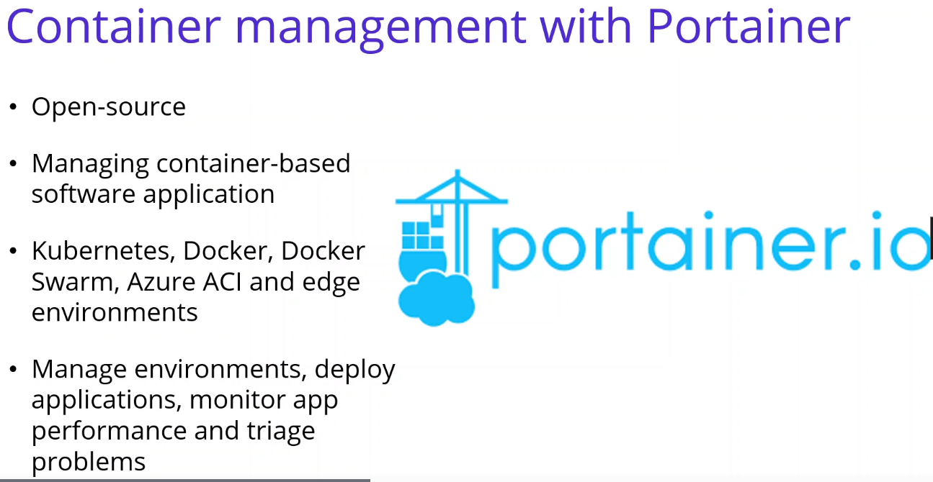

In this video we are going to see how we can manage our containers with Portainer tool. Portainer is a Container management tool. That means it is an open source tool for managing container-based software applications in Kubernetes, Docker, Docker Swarm and so on. It can be used to set up and manage environments, deploy applications, monitor application performance and to see the problems. It is used by software engineers, devops and infrastructure teams all over the world to simplify the processes, reduce the risks and streamline the operations. It allows anyone to deploy and manage containers without the need to write any code. It makes Docker management easy and visualizes docker components in a dashboard.

<https://portainer.readthedocs.io/en/stable/deployment.html> routes to

<https://docs.portainer.io/v/ce-2.9/start/intro> Very different than video. Go to <https://docs.portainer.io/v/ce-2.9/start/install/server/docker/linux#deployment>

No mention of Linux containers.

docker volume create portainer_data

docker run -d -p 8000:8000 -p 9443:9443 --name portainer \

--restart=always \

-v /var/run/docker.sock:/var/run/docker.sock \

-v portainer_data:/data \

cr.portainer.io/portainer/portainer-ce:2.9.3

You can see two ports exposing and forwarding, the name and additional; configurations.

<https://hub.docker.com/r/portainer/portainer-ce> Management dashboard.

**Portainer Community Edition** is a lightweight service delivery platform for containerized applications

Will pull this image, docker pull portainer/portainer-ce

Add Portainer into docker-compose file under services.

portainer:

image: portainer/portainer-ce

Add volume configuration to store user information.

volumes:

mongo_data:

portainer_data:

Add Portainer into docker-compose.override file under services.

portainer:

container_name: portainer

restart: always

ports:

- "8080:8000"

- "9000:9000"

Use 8080 to avoid conflict with Catalog.API

Add volumes configuration

ports:

- "8080:8000"

- "9000:9000"

volumes:

- var/run/docker.sock:/var/run/docker.sock

- portainer_data:/data

By default, Portainer generates and uses a self-signed SSL certificate to secure port 9443. Alternatively you can provide your own SSL certificate during installation or via the Portainer UI after installation is complete. If you require HTTP port 9000 open for legacy reasons, add the following to your docker run command: -p 9000:9000

Run docker-compose -f docker-compose.yml -f docker-compose.override.yml up -d

Browse <http://localhost:9000> and create admin account: Username admin; password: admin1234

Home displays local

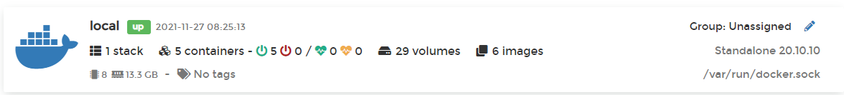

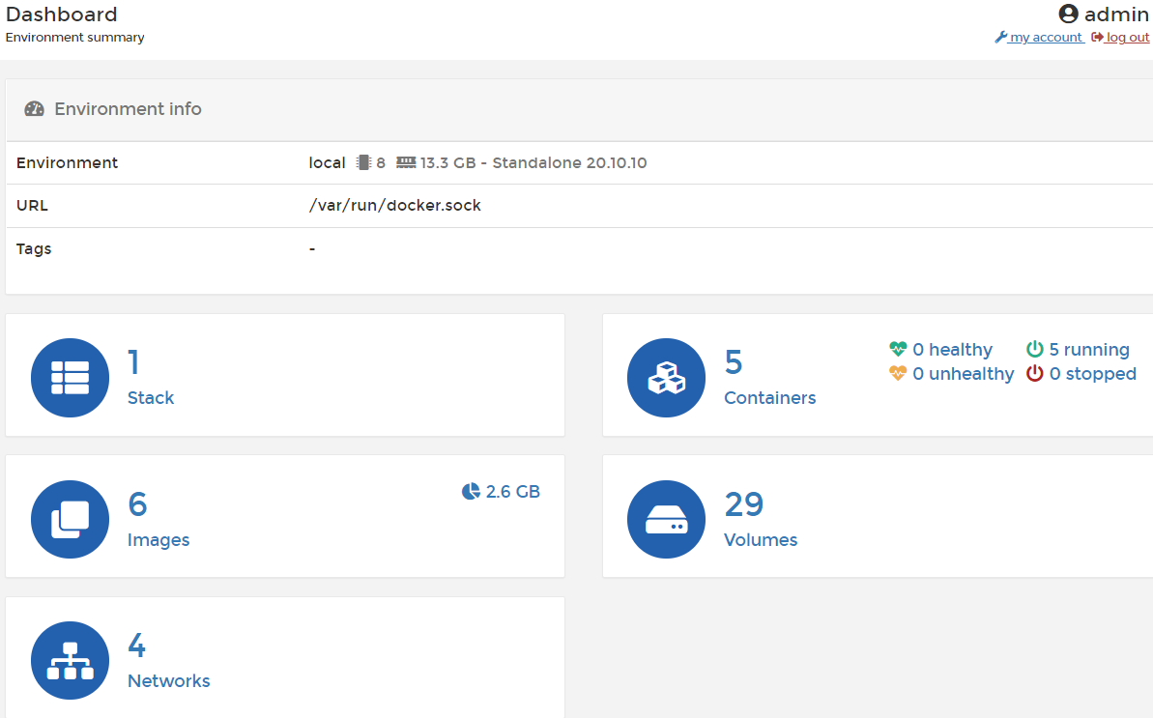

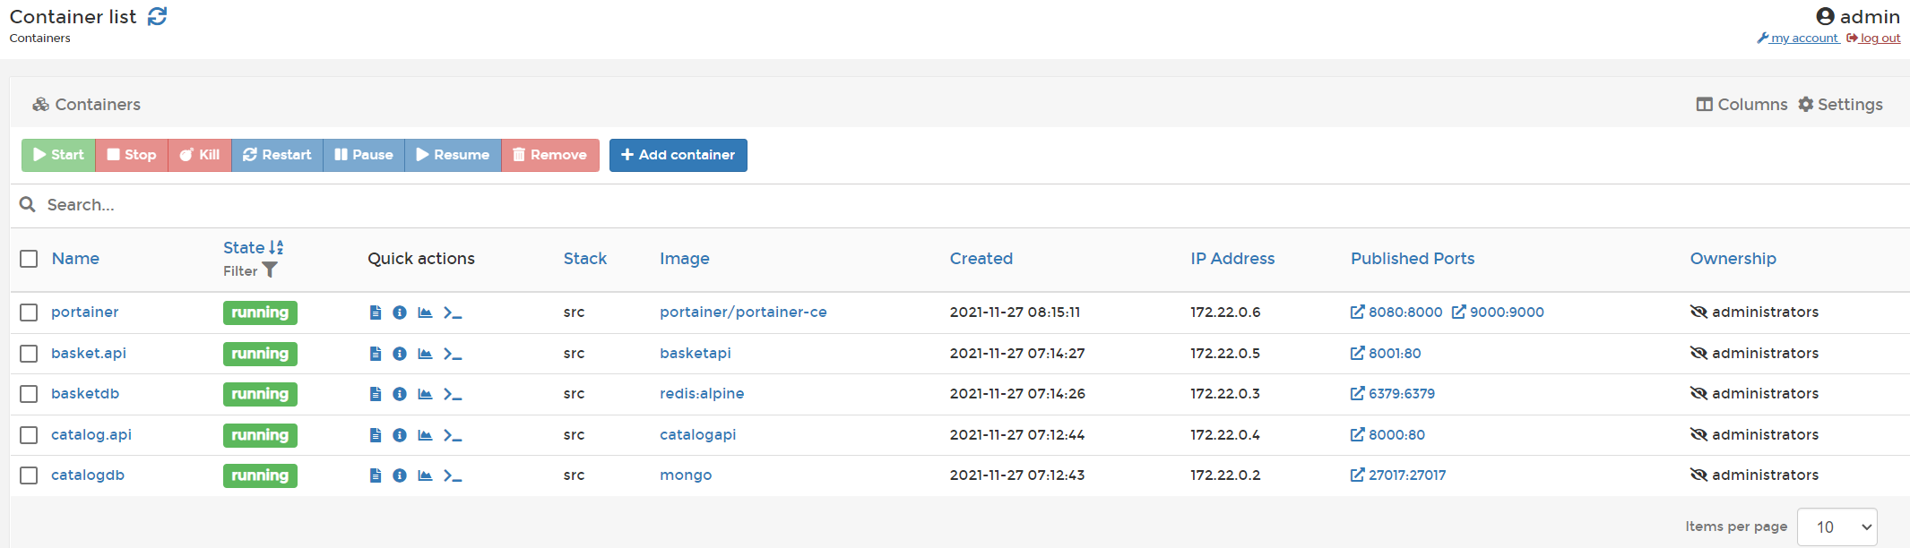

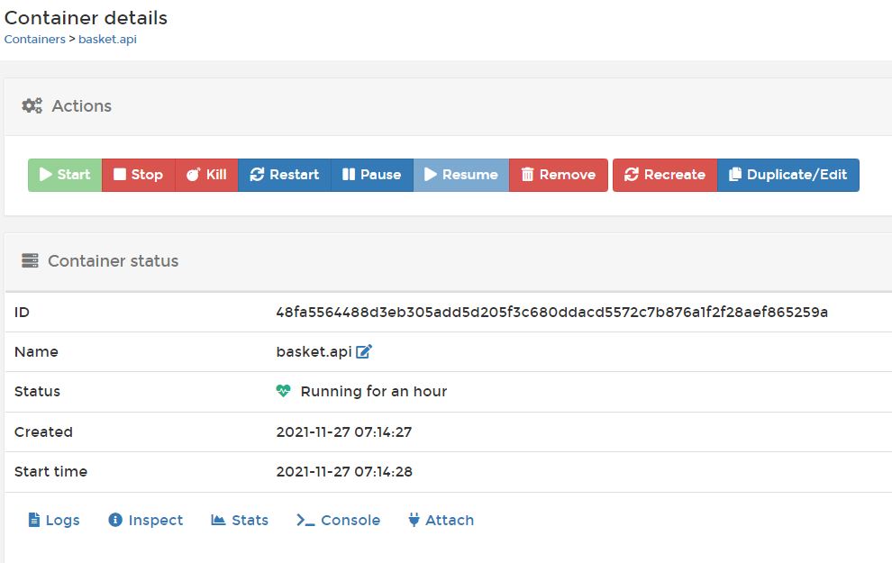

ENTRYPOINT, ENV, LABELS, RESTART POLICES and Connected networks

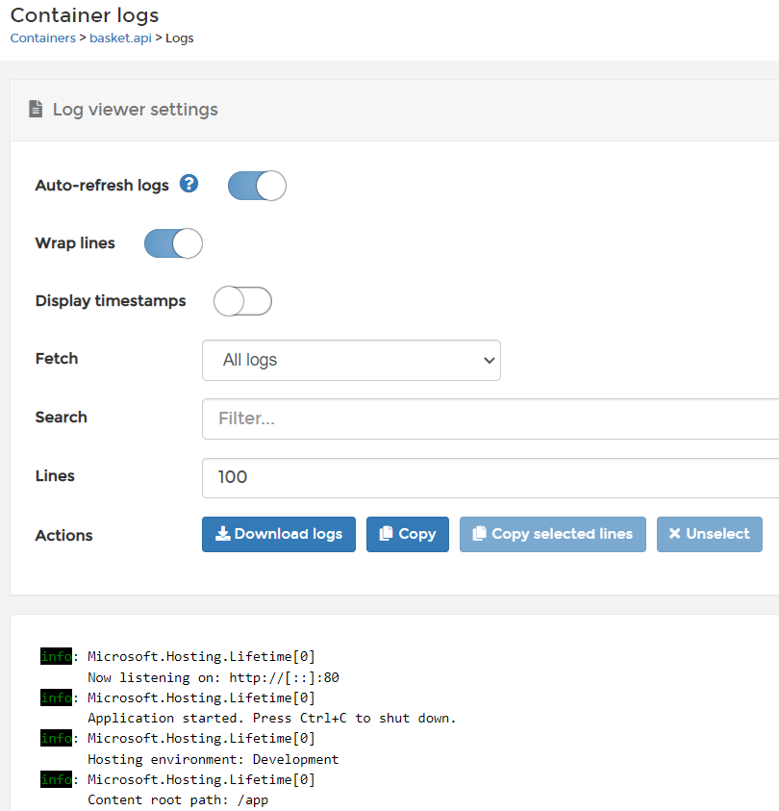 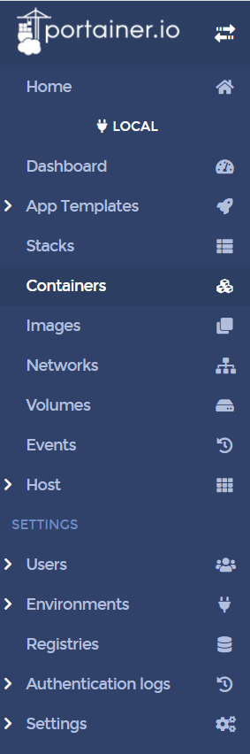

**Section 4: Developing Discount.API Microservices with PostgreSQL** 2hr

**44. Introduction** 2 min

In this section we are going to develop Discount.API Microservices with PostgreSQL. Let's check out the big picture and see what we are going to do it one by one.

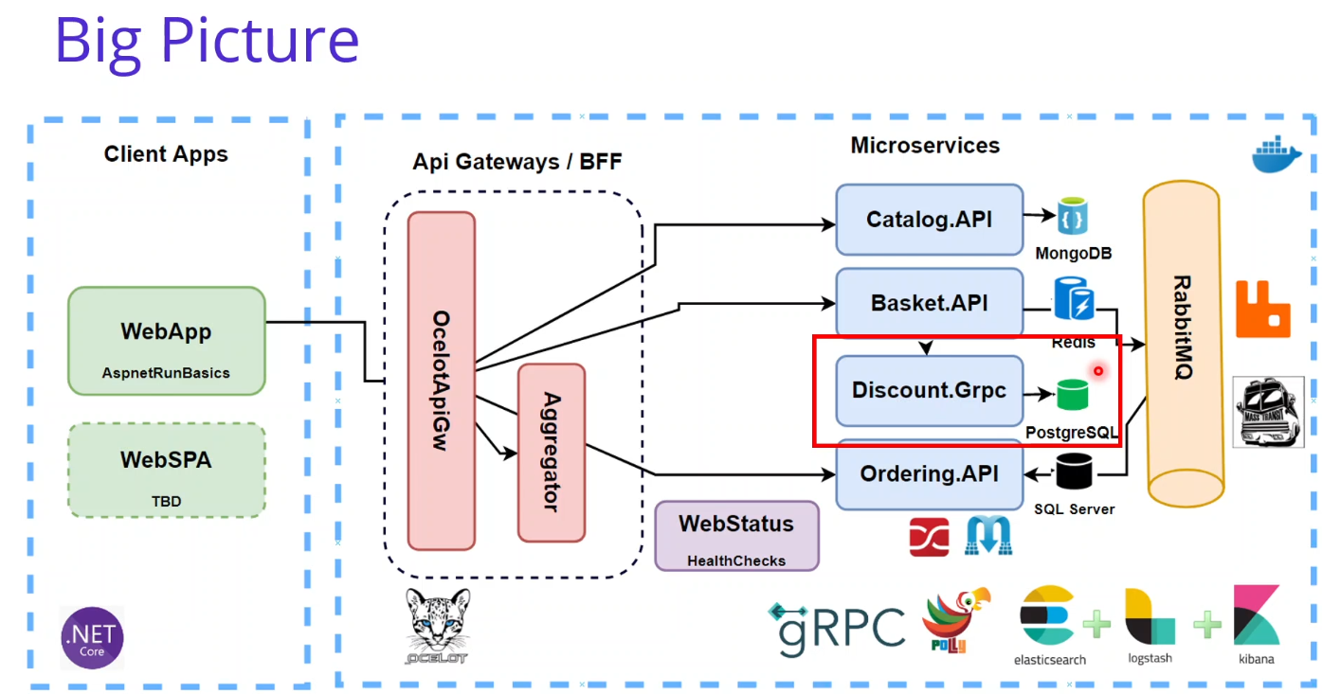

So as you can see that, we are in here and start to Developing Discount.API Microservices with using PostgreSQL databases. Well, we are going to cover the Developing Discount microservice which includes; ASP.NET Web API application, REST API principles, CRUD operations, using PostgreSQL database connection and containerization applying the Repository Pattern implementation, Using Dapper for micro-orm implementation to simplify data access and ensure high performance. And using PostgreSQL database connection and containerization. We will Analysis and Architecting of Discount Microservices, applying N-Layer architecture. Containerize Discount Microservices with PostgreSQL database using Docker Compose Also in the upcoming sections, we are going to develop ASP.NET Grpc Server application for Discount.Grpc developments and build a Highly Performant inter-service gRPC Communication with Discount Microservice Of course we have to Exposing Grpc Services with creating Protobuf messages So in this section, we are going to Develop Discount.API Microservices with PostgreSQL. After we’ve learned the basics, we can start with the coding part.

**45. Create Asp.Net Web API Project for Discount.API Microservice** 5 min

Same as Catalog and Basket. Ports 5002 and 8002

**46. PostsgrSQL in Discount Microservice** 2 min

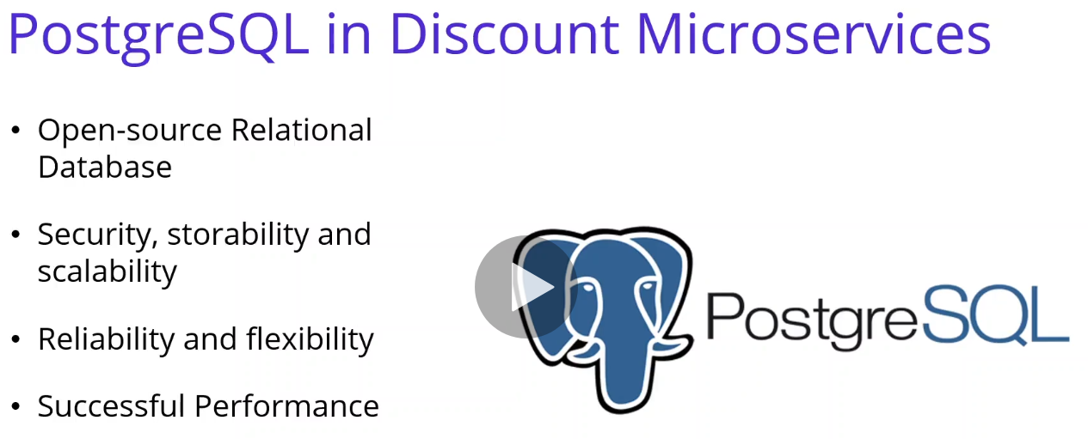

n this video we are going to talk about PostgreSQL in Discount Microservices. PostgreSQL is an open source and completely free object relational database system with powerful features and the advantage. Taking advantage of the security, storability and scalability features of the SQL language, PostgreSQL is also used as a database manager in many areas. PostgreSQL is one of the most accepted database management systems in the industry today. Because it offers users the advantages of successful data architecture, data accuracy, powerful feature set, and open source. source. PostgreSQL is supported by many major operating systems such as UNIX, Linux, MacOS and Windows. In terms of performance, PostgreSQL has been found to be more successful compared to other commercial or open source databases. In the face of some database systems, it is fast in some areas, but slow in others. Compared to PostgreSQL, MySQL and databases in the same class, it is slower in INSERT/UPDATE INSERT/UPDATE transactions because it works transaction-based. But In some cases, PostgreSQL and MySQL have significant advantages in terms of features, reliability and the flexibility. Aside from that the highlights of PostgreSQL, this service is offered completely free of charge by open source developers. For Discount microservices, we are going to store discount coupon data information into PostgreSQL database in a Coupon table. In the next video, let's set up the PostgreSQL database in Docker environment.

**47. Setup PostsgrSQL Docker Database for Discount.API Microservice** 5 min

<https://hub.docker.com/_/postgres> docker pull postgres

In this video, we are going to set up PostgreSQL, the database for discount app, micro sources for, let's say, connection. Before we start, make sure that your bucket could stop is started. First of all, we should go to the club and find PostgreSQL official image. This is the poster, this girl, or we shall image others. You can also. Open your browser and see the details and we can examine documentation and why material supports and so you can see the support it takes in his. And also, you can see the basic information about the quake and this is the example running to. Pollsters call in the moment you can specify the employment it was and give the inmates name Postgres also there is an example of the could compulsivity.

docker run --name some-postgres -e POSTGRES_PASSWORD=mysecretpassword -d postgres

services:

db:

image: postgres

restart: always

environment:

POSTGRES_PASSWORD: example

adminer:

image: adminer

restart: always

ports:

- 8080:8080

You can see the docker compose in his. So the important part is looking for the environment variables it was we are going to also use these imams voice when we are confident in this call in the local compost.

POSTGRES_PASSWORD, POSTGRES_USER

$ docker run -d \

--name some-postgres \

-e POSTGRES_PASSWORD=mysecretpassword \

-e PGDATA=/var/lib/postgresql/data/pgdata \

-v /custom/mount:/var/lib/postgresql/data \

Postgres

All right. It is a password to post this user and so on, so you can get the basic information and the conjugations in the official image based off to the. But this time, we are going to directly use the Docker Desktop instead of running the docker run command, so that's why I'm going to open the docker-compose file.

In services add

discountdb:

image: postgres

volumes:

mongo_data:

portainer_data:

postgres_data:

In docker-compose.overide file in services add:

discountdb:

container_name: discountdb

environment:

- POSTGRES_USER=admin

- POSTGRES_PASSWORD=admin1234

- POSTGRES_DB=DiscountDb

restart: always

ports:

- "5432:5432"

volumes:

- postgres_data:/var/lib/postgresql/data/

To get default port number <https://www.postgresql.org/docs/current/app-psql.html>

**48. Setup pgAdmin Management Portal for PostgreSQL Database for Discount.API Microservice** 13 min

<https://pgAdmin.org>

pgAdmin is one of the popular and feature rich Open Source administration and development platform for PostgreSQL. We will use pgAdmin for managing PostgreSQL Discount database creation and add same records into that table for Discount microservices. It is basically provide a management tool and we can create a database, update the records and so on.

<https://hub.docker.com/r/dpage/pgadmin4/> dpage/pgadmin4

docker pull dpage/pgadmin4

pgAdmin Deployment

<https://www.pgadmin.org/docs/pgadmin4/latest/container_deployment.html>

docker pull dpage/pgadmin4

docker run -p 80:80 \

-e 'PGADMIN_DEFAULT_EMAIL=user@domain.com' \

-e 'PGADMIN_DEFAULT_PASSWORD=SuperSecret' \

-e 'PGADMIN_CONFIG_ENHANCED_COOKIE_PROTECTION=True' \

-e 'PGADMIN_CONFIG_LOGIN_BANNER="Authorised users only!"' \

-e 'PGADMIN_CONFIG_CONSOLE_LOG_LEVEL=10' \

-d dpage/pgadmin4

In docker-compose file in services add

pgAdmin:

image: dpage/pgadmin4

volumes:

. . .

pgAdmin_data:

In docker-compose.overide file in services add:

pgAdmin:

container_name: pgAdmin

environment:

- PGADMIN_DEFAULT_EMAIL=admin@aspnetrun.com

- PGADMIN_DEFAULT_PASSWORD=admin1234

restart: always

ports:

- "5050:80"

volumes:

- pgAdmin_data:/root/.pgadmin

Run docker-compose -f docker-compose.yml -f docker-compose.override.yml up -d

Browse to localhost:5050 and log in to pgAdmin.

11:00 Add New Server (Have to click on Servers in the upper left first)) never opens. Get this error in console:

app.bundle.js:1 Uncaught TypeError: Cannot read properties of undefined (reading 'length')

at Object.add_new_server (app.bundle.js:1)

at HTMLAnchorElement.onclick ((index):1)

<https://redmine.postgresql.org/issues/7015>

Work around:  
If I click on "Servers" in the left hand tree view, this seems to initialize something, and from then on, I can proceed to add a new server using the quick link.

Name: DiscountServer Connection | Host name/address: discountdb Password: admin1234

Save and you can see the DiscountServer under Servers. Drill down into DiscountDb database and you can see the details. Under the Schemas | Tables you can create tables.

**49. Create Coupon Table in the DiscountDb of PostgreSQL Database with pgAdmin Manage** 7 min

Can create Table manually or with a SQL script. Tools | Query Tool

CREATE TABLE Coupon(

ID SERIAL PRIMARY KEY NOT NULL,

ProductName VARCHAR(24) NOT NULL,

Description TEXT,

Amount INT

);

Will search and insert by ProductName. After Running had to refresh Schemas to see Coupon table.

Run from Query Tool window:

INSERT INTO Coupon (ProductName, Description, Amount) VALUES ('IPhone X', 'IPhone Discount', 150);

INSERT INTO Coupon (ProductName, Description, Amount) VALUES ('Samsung 10', 'Samsung Discount', 100);

**50. Analysis and Architecting of Discount Microservices** 6 min

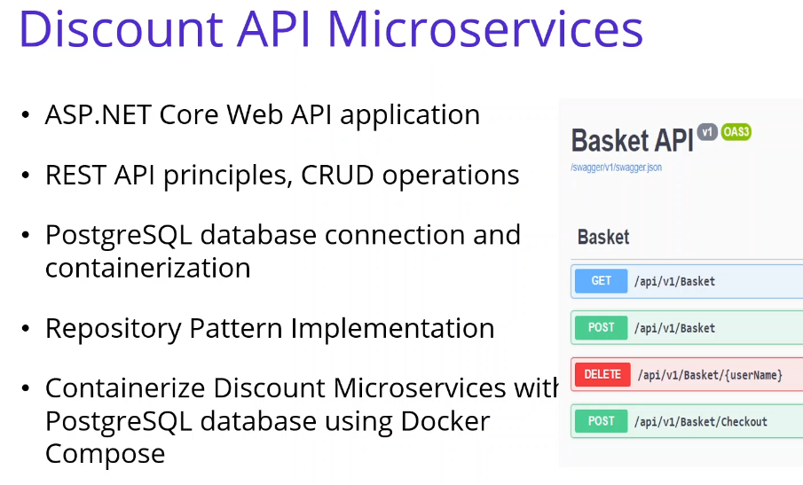

Same APIs as Catalog and Basket microservices.

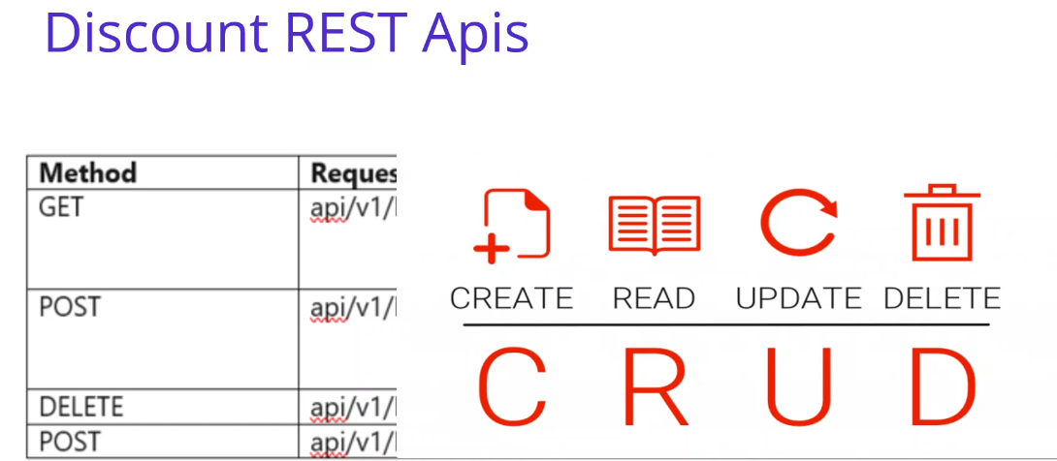

Will use traditional N-Layer Architecture.

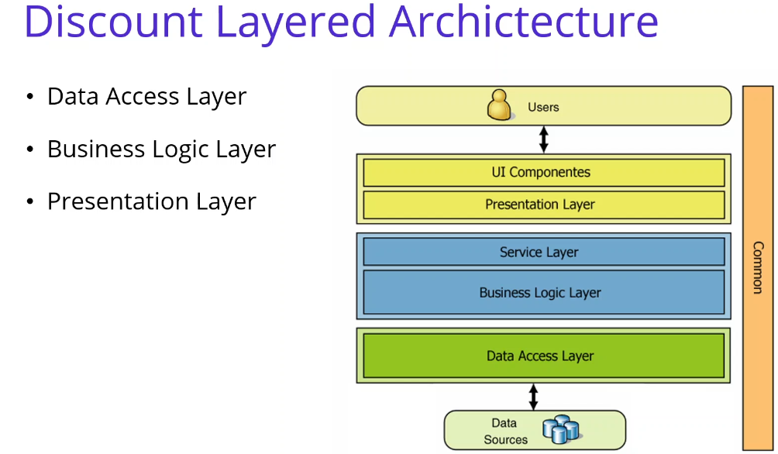

CRUD with Coupon data. Will structure using folders not assemblies.

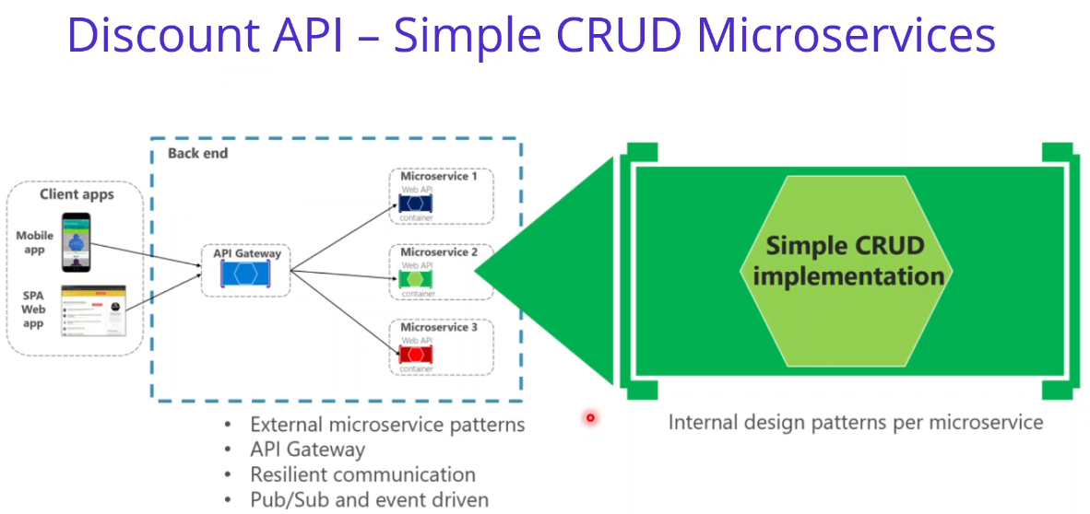

Same as Catalog and Basket microservices.

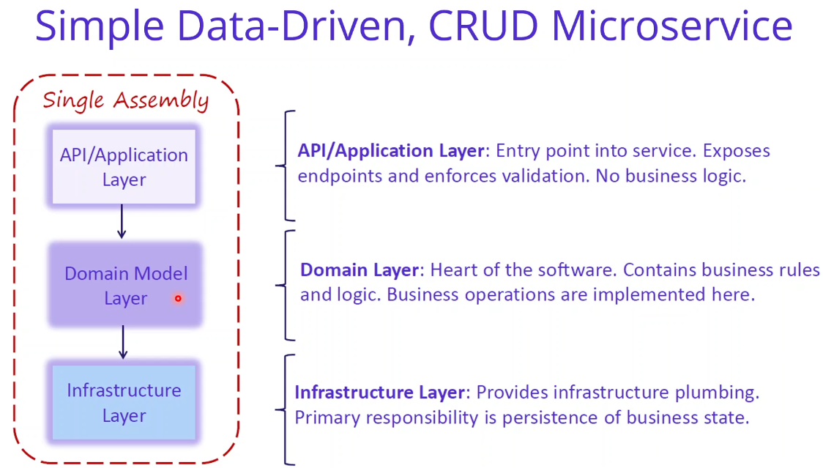

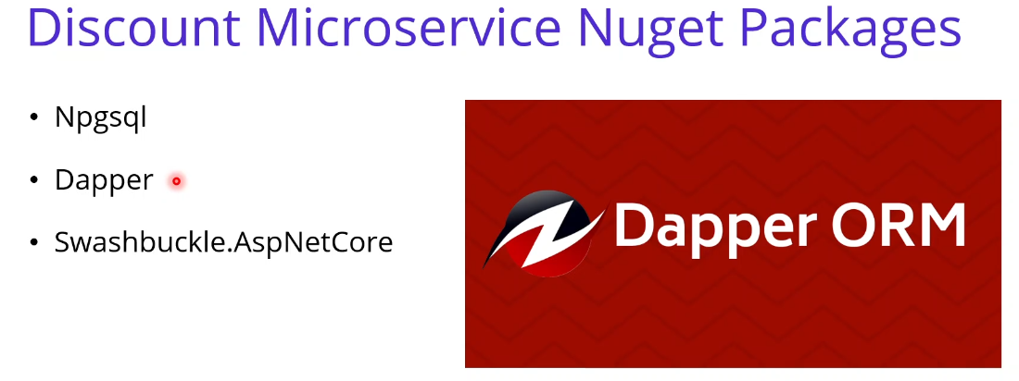

Dapper is an ORM object relation mapper developed by the StackOverflow team as a lightweight and published open source on GitHub. It is support for most database like SQL Server and PostgreSQL and so on. We will use Dapper for the process CRUD databases. Basically in ?? dot net we perform all queries and processes using SQL data readers and SQL comments. So Dapper takes the burden of writing these objects from us. We can do our filtering by using ?? extension methods by writing less code we can execute our queries in a short time and convert them to various type what we want. So the biggest feature is that the Dapper is working very fast speed and very close ?? dot net speed.

**51. Developing Discount.API Microservices Creating Entites** 2 min

Create Entites/Coupon.cs

**52. Developing Repository Pattern Connect PostgreSql use Dapper on Discount.API** 19 min

Install-Package Npgsql Install-Package Dapper

Update-Package -ProjectName Discount.API

<PackageReference Include="Dapper" Version="2.0.123" />

<PackageReference Include="Npgsql" Version="6.0.0" />

<PackageReference Include="Swashbuckle.AspNetCore" Version="6.2.3" />

Create IDiscountReposiotory and implementing class.

productName is the product key in this architecture.

Will implement using Npgsql connection.

**53. Create DiscountController Class for Discount.API Microservice** 8 min

Same as Catalog and Basket.

**54. Test and Run Discount.API Microservice** 9 min

Same as Catalog and Basket. Swagger IPhone X Samsung 10

Postman Huawei Plus

**55. Containerize Discount Microservices with PostgreSQL using Docker Compose** 6 min

Same as Catalog and Basket. Adding ‘Container Orchestration Support’ creates Dockerfile and updates docker-compose.yml docker-compose-override.yml files.

docker-compose-override.yml

discount.api:

container_name: discount.api

environment:

- ASPNETCORE_ENVIRONMENT=Development

- "DatabaseSettings:ConnectionString=Server=discountdb;Port=5432;Database=DiscountDb;User Id=admin;Password=admin1234;"

depends_on:

- discountdb

ports:

- "8002:80"

**56. Adding PostgreSQL image into Docker-Compose File for Multi-Container Docker Env** 3 min

Reviewed discountdb configuration.

**57. Migrate PostgreSQL Database When Discount Microservices Startup** 23 min

In Program.cs Main method create extension method for IHost object which will be the MigrateDatabase function and ?? the Host creation creating method in the IHost object

public static void Main(string[] args)

{

IHost host = CreateHostBuilder(args).Build();

host.MigrateDatabase<Program>();

host.Run();

}

Create Extensions/HostExtensions.cs

TContext is generic. Add retry for delay in docker container start.

public static class HostExtensions

{

public static IHost MigrateDatabase<TContext>(this IHost host, int? retry = 0)

{

int retryForAvailability = retry.Value;

using var scope = host.Services.CreateScope();

IServiceProvider services = scope.ServiceProvider;

var configuration = services.GetRequiredService<IConfiguration>();

var logger = services.GetRequiredService<ILogger<TContext>>();

try

{

logger.LogInformation("Migrating postgresql database.");

using var connection = new NpgsqlConnection(configuration.GetValue<string>

("DatabaseSettings:ConnectionString"));

connection.Open();

using var command = new NpgsqlCommand { Connection = connection };

command.CommandText = "DROP TABLE IF EXISTS Coupon";

command.ExecuteNonQuery();

command.CommandText = @"CREATE TABLE Coupon(Id SERIAL PRIMARY KEY,

ProductName VARCHAR(24) NOT NULL, Description TEXT, Amount INT)";

command.ExecuteNonQuery();

command.CommandText = @"INSERT INTO Coupon(ProductName, Description, Amount)

VALUES ('IPhone X', 'IPhone Discount', 150);";

command.ExecuteNonQuery();

command.CommandText = @"INSERT INTO Coupon(ProductName, Description, Amount)

VALUES ('Samsung 10', 'Samsung Discount', 100);";

command.ExecuteNonQuery();

logger.LogInformation("Migrated postgresql database.");

}

catch (NpgsqlException ex)

{

logger.LogError(ex,"An error occured while migrating postgresql database.");

if (retryForAvailability < 50)

{

retryForAvailability++;

System.Threading.Thread.Sleep(2000);

MigrateDatabase<TContext>(host, retryForAvailability);

}

}

return host;

}

}

It is not migrating anything. Perhaps a better name would be SeedDatabase.

Shouldn’t the table be checked to if it is empty before rgenerting?

**58. Test on Docker environment – Discount.API and PostgreSQL into Docker-Compose** 10 min

docker-compose -f docker-compose.yml -f docker-compose.override.yml up -d

From browser tested Catalog, Basket and Discount are running (GET Method);

Portainer, pgAdmin

Test Discount.API with Postman

docker-compose -f docker-compose.yml -f docker-compose.override.yml down

**Section 5: Developing Discount.GRPC Microservices for Microservices Grpc Communication Discount.GRPC with PostgreSQL** 1 hr 5min

**59. Introduction** 2 min

In this section we are going to Develop Discount.Grpc Microservices with PostgreSQL. last section, we have developed Discount.API microservice, which is the Aspnet Web API project, but this time we are going to develop Discount.Grpc microservices for microservices Grpc communication with using PostgreSQL database.

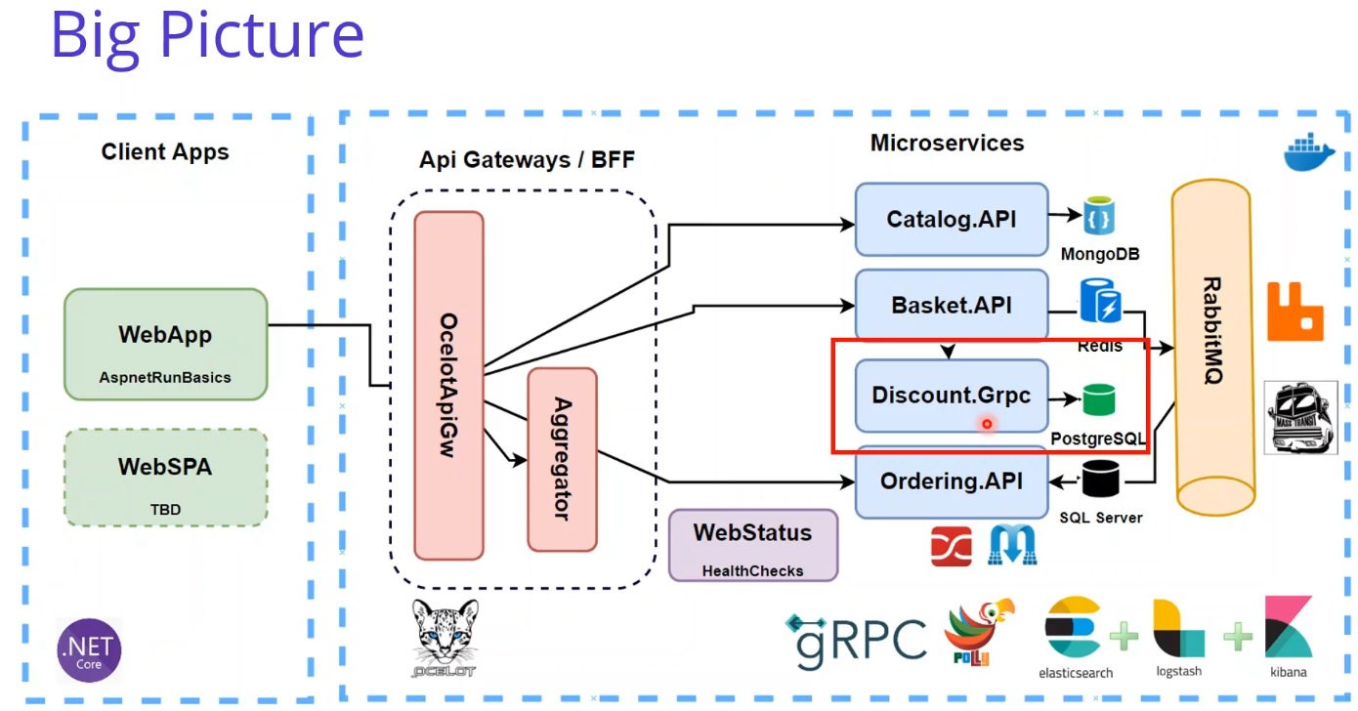

Let's check our big picture and see what we are going to build one by one. As you can see that, we are in here and start to Developing Discount.API Microservices with PostgreSQL. And we are going to cover Developing Discount Grpc microservice which includes; ASP.NET Grpc Server Applicaion Building a Highly Performant inter-service gRPC Communication with Discount Microservice Exposing Grpc Services with creating Protobuf messages Using PostgreSQL database connection and containerization and Using Dapper for micro-orm implementation to simplify data access and ensure high performance.

In Discount Grpc microservices, we are going to expose grpc services for Basket.API microservices. When client add item into shopping cart, Basket microservice will consume this discount grpc services in order to calculate latest discounts from the product item. So in this section, we are going to Develop Discount.Grpc Microservices with PostgreSQL. After we’ve learned the basics we are going to see what is the Grpc and where is the Grpc usage of Microservices communication.

**60. gRPC usage of Microservices Communication** 2 min

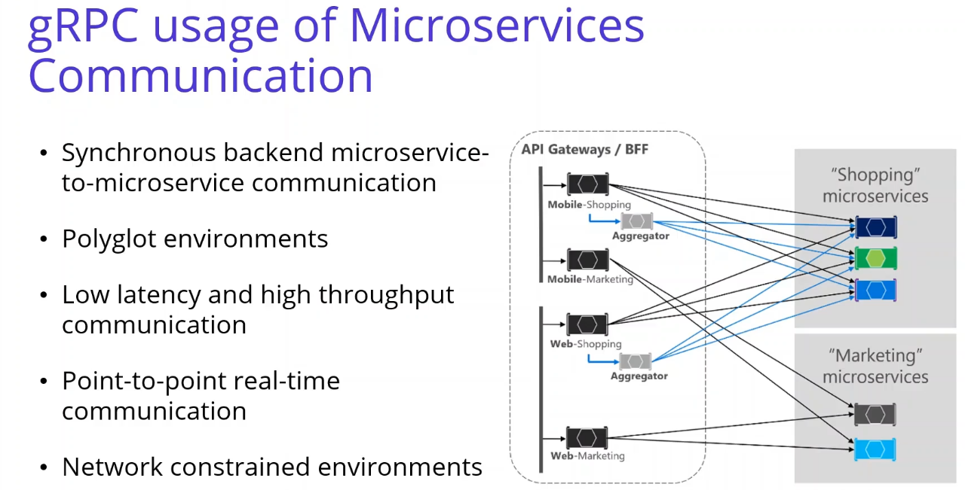

gRPC usage of Microservices Communication At the time of this course, gRPC is primarily used with backend microservices. But also gRPC using for the following scenarios: Synchronous backend microservice-to-microservice communication where an immediate response is required to continue processing. Also Polyglot environments that need to support mixed programming platforms. like one microservice is python and another is c#. It is very good to use with the polyglot environments grpc communication. Also, we can say that Low latency and high throughput communication where performance is critical. and also we can say that Point-to-point real-time communication, gRPC can push messages in real time without ?pooling? and has excellent support for bi-directional streaming. And the last thing could be the Network constrained environments, The binary gRPC messages are always smaller than an equivalent text-based if we compare to JSON message.

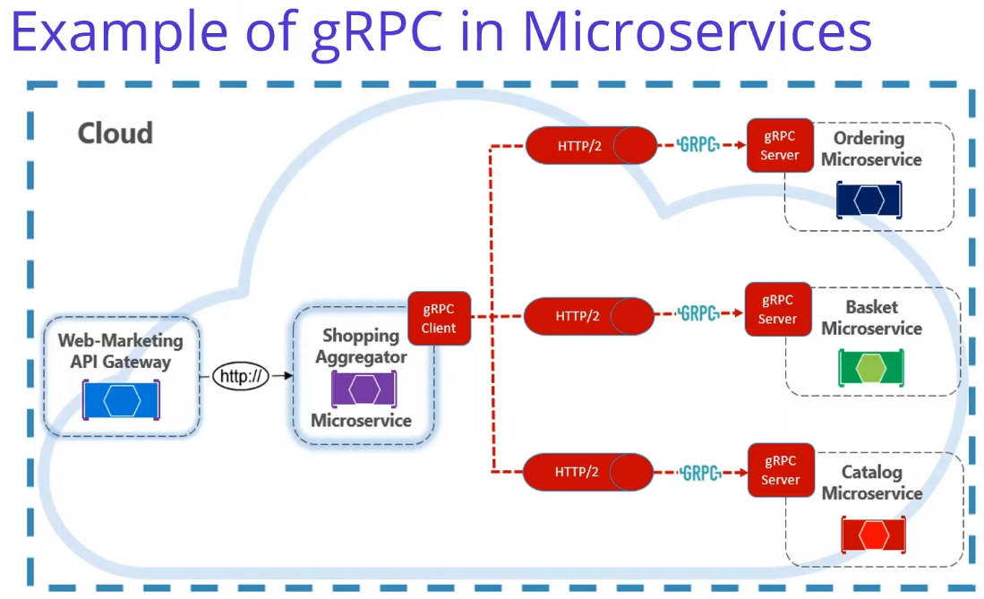

Example of gRPC Microservices, Think about that we have a Web-Marketing API Gateway and this will forward to request to Shopping Aggregator Microservice. This Shopping Aggregator Microservice receives a single request from a client, dispatches it to various microservices, aggregates the results, and sends them back to the requesting client. Such operations typically require synchronous communication as to produce an immediate response. In this example, backend calls from the Aggregator are performed using gRPC. gRPC communication requires both client and server components. You can see that Shopping Aggregator implements a gRPC client. The client makes synchronous gRPC calls to backend microservices, this backend microservices are implemented gRPC server. As you can see that, The gRPC endpoints must be configured for the HTTP/2 protocol that is required for gRPC communication. So in microservices world, most of communication use asynchronous communication patterns but some operations require direct calls. gRPC should be the primary choice for direct synchronous communication between microservices. Its high-performance communication protocol, based on HTTP/2 and protocol buffers, make it a perfect choice.

**61. Using gRPC in Microservices Communication with .Net – Example Repository** 2 min

<https://github.com/aspnetrun/run-aspnet-grpc>

<https://medium.com/aspnetrun/using-grpc-in-microservices-for-building-a-high-performance-interservice-communication-with-net-5-11f3e5fa0e9d>

If you want to learn more about grpc in Microservices communication, I strongly recommended to you check aspnetrun grpc repository. You can go to github aspnetrun organization page and you can see the gRPC repository in here. You can find all details how to use gRPC in Microservices Communication with .Net 5. We are going to learn how to Build a Highly Performant Inter-service Communication with gRPC for ASP NET 5 Microservices, and Microservices are modern distributed systems so with gRPC in ASP.NET 5, we will develop high-performance, cross-platform applications for building distributed systems and APIs. It’s an ideal choice for communication between backend microservices and internal network applications, or Iot devices and services, With the release of ASP.NET 5, Microsoft has added first-class support for creating gRPC services with aspnet5. This repository will let you get started building, developing and managing gRPC servers and clients on distributed microservices architecture Basically we will implement e-commerce logic with only gRPC communication. We will have 3 gRPC server applications which are Product, ShoppingCart and Discount grpc services. And we will have 2 worker services which are the Product and ShoppingCart Services. So in the same way in this course, we are going to create a Discount.Grpc microservices for the exposing APIs to Basket microservices in order to calculate latest price of the products. In the next video, we are going to start with the coding part.

**62. Create Discount Grpc Microservices Project in Microservices Solution** 14 min

In Discount folder Create ‘ASP.NET Core gRPC Service’ Discount.gRPC project

.csproj has

<ItemGroup>

<Protobuf Include="Protos\greet.proto" GrpcServices="Server" />

</ItemGroup>

<ItemGroup>

<PackageReference Include="Grpc.AspNetCore" Version="2.34.0" />

</ItemGroup>

Has default Protos\*.proto file Services\*Services.cs class.

Services calls rpc method defined in .proto file.

In Startup.cs ConfigureServices services.AddGrpc(); and Configure

app.UseEndpoints(endpoints =>

{

endpoints.MapGrpcService<GreeterService>();

endpoints.MapGet("/", async context => { await context.Response

.WriteAsync("Communication with gRPC endpoints must be made through a

gRPC client. To learn how to create a client, visit:

https://go.microsoft.com/fwlink/?linkid=2086909"); });

});

In appsettings.json have

"Kestrel": {

"EndpointDefaults": { "Protocols": "Http2" } }

LaunchSettings.json has one profile

"profiles": {

"Discount.Grpc": {

"commandName": "Project",

"dotnetRunMessages": "true",

"launchBrowser": false,

"applicationUrl": "http://localhost:5000;https://localhost:5001",

"environmentVariables": {

"ASPNETCORE_ENVIRONMENT": "Development" } } }

proto file Properties

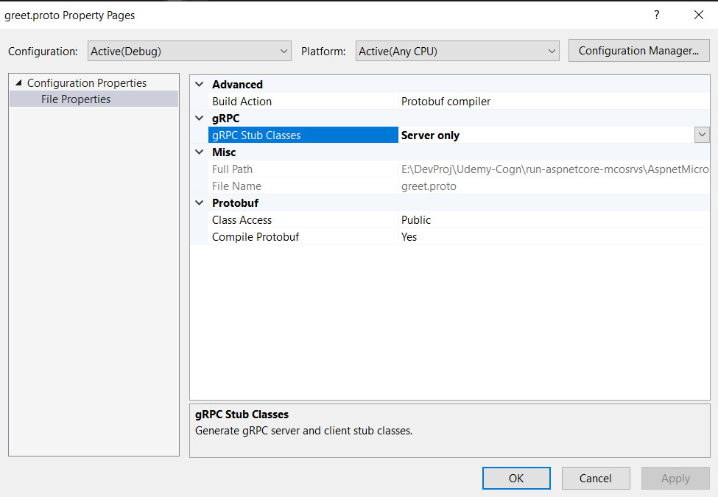

Build Action converts proto file to C# classes

gRPC Stub Classes exposes the proto package to external systems

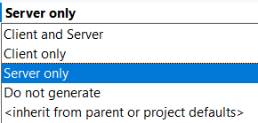

When build project creates C# classes in bin\obj\Debug\net5.0\Protos folder

Service class inherits from the base class. GreeterService : Greeter.GreeterBase

In Launchsettings.json change applicationUrl to <http://localhost:5003>

**63. Managing PostgreSQl Database Operations in Discount Grpc** 9 min

Going to add PostgreSQL database with same structure as Discount.API.

In .scproj file copy over Dapper and Npgsql PackageReference.

Update-Package -ProjectName Discount.Grpc.

Copy following folders and update namespace to Grpc

Entities, Repository and Extensions folder

Copy DatabaseSettings in appsettings.json

In Startup.cs register services.AddScoped<IDiscountRepository, DiscountRepository>();

In Program.cs update

IHost host = CreateHostBuilder(args).Build();

host.MigrateDatabase<Program>();

host.Run();

6:00 Finish copying and now test (why run Migration seed twice?).

docker-compose -f docker-compose.yml -f docker-compose.override.yml up -d

Run profile Discount.Grpc and verify that service runs and connects to discountdb database.

info: Discount.Grpc.Program[0]

Migrating postgresql database.

info: Discount.Grpc.Program[0]

Migrated postgresql database.

info: Microsoft.Hosting.Lifetime[0]

Now listening on: http://localhost:5003

info: Microsoft.Hosting.Lifetime[0]

Application started. Press Ctrl+C to shut down.

info: Microsoft.Hosting.Lifetime[0]

Hosting environment: Development

info: Microsoft.Hosting.Lifetime[0]

Content root path: E:\DevProj\Udemy-Cogn\run-aspnetcore-mcosrvs\AspnetMicroservices\src\Services\Discount\Discount.Grpc

In Grpc use proto service classes instead of Controllers.

**64. Developing discount.proto ProtoBuf file for Exposing CRUD Services Discount Grpc** 10 min

Delete default proto file and service.

In Startup.cs comment out //endpoints.MapGrpcService<GreeterService>();

Add Protos/discount.proto file. Uses proto language.

syntax = "proto3";

option csharp_namespace = "Discount.Grpc.Protos";

Service definition, CRUD API operations.

rpc Name(parameter message) returns (message)

service DiscountProtoService {

rpc GetDiscount(GetDicountRequest) returns (CouponModel);

}

Define complex types GetDicountRequest and CouponModel

Members of classes names are camel case and require an order number

message GetDicountRequest {

string productName = 1;

}

message CouponModel {

int32 id =1;

string productName = 3;

string description = 2;

int32 amount = 4;

}

Define other CRUD methods

rpc CreateDiscount(CreateDicountRequest) returns (CouponModel);

rpc UpdateDiscount(UpdateDicountRequest) returns (CouponModel);

rpc DeleteDiscount(DeleteDicountRequest) returns (DeleteDicountResponse);

message CreateDicountRequest { CouponModel coupon = 1; }

message UpdateDicountRequest { CouponModel coupon = 1; }

message DeleteDicountRequest { string productName = 1; }

message DeleteDicountResponse { bool success = 1; }

When run will convert protoBuf Service classes into C# classes

**65. Generate Proto Service Class from Discount proto File in Discount Grpc** 5 min

discount.proto file Properties:

Set Build Action: Protobuf compiler

gRPC Stub Classes Server only. We are creating a Server to expose Discount Services

Save file

In .csproj file delete ItemGroup None Remove="Protos\discount.proto" />

Verify following added:

<ItemGroup>

<Protobuf Include="Protos\discount.proto" GrpcServices="Server" />

</ItemGroup>

Build the project and it will generate C# classes in

. . .\src\Services\Discount\Discount.Grpc\obj\Debug\net5.0\Protos

Discount.cs and DiscountGrpc.cs

In …Grpc.cs public abstract partial class DiscountProtoServiceBase

contains 4 CRUD methods.

Now you can use the logic and connect to Discount.Grpc

**66. Developing DiscountService class to Implement Grpc Proto Service methods** 10 min

Create Services/DiscountService.cs. Inherit from : DiscountProtoService.DiscountProtoServiceBase

Inject IDiscountRepository and ILogger.

Implement GetDiscount

public override async Task<CouponModel> GetDiscount(GetDicountRequest request, ServerCallContext context)

{

Coupon coupon = await _repository.GetDiscount(request.ProductName);

if (coupon is null) throw new RpcException(new Status(StatusCode.NotFound,

$"Discount with ProductName={request.ProductName} is not found."));

CouponModel couponModel = _mapper.Map<CouponModel>(coupon);

return couponModel;

}

Will implement AutoMapper in next video.

In Startup.cs add endpoints.MapGrpcService<DiscountService>();

**67. Implementing AutoMapper into DiscountService Class of Discount Grpc Microservice** 5 min

Install-Package AutoMapper.Extensions.Microsoft.DependencyInjection

Create Mapper/DiscountProfile.cs

public class DiscountProfile : Profile {

public DiscountProfile() { CreateMap<Coupon, CouponModel>().ReverseMap(); } }

Inject IMapper into DiscountService class.

Add log statement to GetDiscount method.

Register IMapper in Startup.cs services.AddAutoMapper(typeof(Startup));

**68. Developing CRUD in DiscountService class to Impleent CRUD Grpc Proto Service** 6 min

Implemented Create, Update and Delete methods in DiscountService class.

**Section 6: Consuming Discount Grpc Service From Basket Microservice When Adding Cart Item** 1hr 11min

**69. Introduction** 2min

When adding Cart Item into Shopping Cart to Calculate Final Price

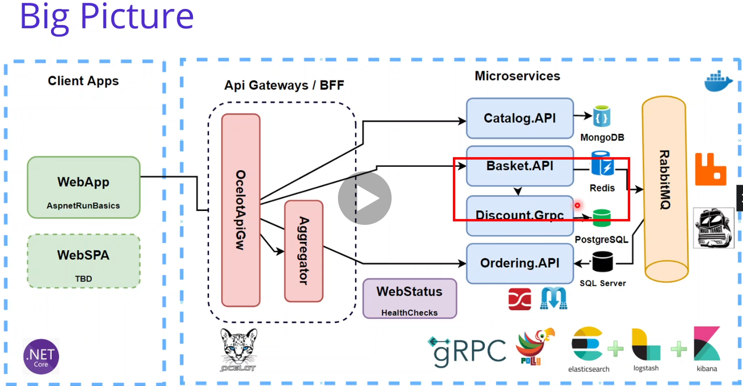

Will register Discount.Grpc Client and Discount.Grpc Service into the Basket.API Asp.Net Dependency Injection in Startup.cs.

Use Dapper for micro-orm implementation to simplify data access and ensure high performance

Containerize Discount Grpc Microservices with PostgreSQL using Docker Compose

Consuming Discount.Grpc services from the Basket API. Basket.API will be the client of our Discount.Grpc microservice.

**70: Consuming Discount Grpc Service From Basket Microservice When Adding Cart Item 1** 9min

Expand Basket.API project.

In BasketController UpdateBasket method will consume Discount.Grpc Service

// TODO : Communicate with Disocunt.Grpc and Calculate latest prices of products into shopping cart

Basket.API will be the Client of Discount.Grpc.

Will use Connection Service Of Visual Studio. Add Connected Service. Add Grpc Service reference.

Select gRPC. File: . . .\src\Services\Discount\Discount.Grpc\Protos\discount.proto

type of class: Client

Checking project for required NuGet packges...

Installing NuGet packages to project...

Installing package 'Grpc.AspNetCore' with version '2.32.0'.

Adding service reference discount to the project...

SuccessSuccessfully added service reference(s)

Verify Grpc.AspNetCore package and Protobuf have been added to .csproj file.

<ItemGroup>

<Protobuf Include="..\..\Discount\Discount.Grpc\Protos\discount.proto" GrpcServices="Client">

<Link>Protos\discount.proto</Link>

</Protobuf>

</ItemGroup>

VS creates pseudo Protos/discount.proto file with Protobuf compiler and gRPC Stub Classes Client Only. (it is actually the Discount.Grpc\Protos\discount.proto file)

Build the project and it will generate C# classes in

. . .\src\Services\Basket\Basket.API\obj\Debug\net5.0\Protos

Discount.cs and DiscountGrpc.cs (in Client mode)

public partial class DiscountProtoServiceClient : grpc::ClientBase<DiscountProtoServiceClient>

**71: Consuming Discount Grpc Service From Basket Microservice When Adding Cart Item 2** 12min

// Calculate latest prices of products into shopping cart

Will call Discount.Grpc Service for every item added to the ShoppinCart.

If you have frequent inter-microservice communication you should rely on gRPC for performance and robust communication.

Create new class to encapsulate Grpc client operation and create an abstraction, which will cover the client operations. GrpcServices/DiscountGrpcService.cs

Inject DiscountProtoServiceClient.

Create GetDiscount methid.

public async Task<CouponModel> GetDiscount(string productName) {

var discountRequest = new GetDicountRequest { ProductName = productName };

return await _discountProtoServiceClient.GetDiscountAsync(discountRequest); }

In Basket.API BasketController inject DiscountGrpcService (will adjust in next video

In UpdateBasket method add:

foreach (ShoppingCartItem item in basket.Items) {

var coupon = await _discountGrpcService.GetDiscount(item.ProductName);

item.Price -= coupon.Amount; }

The Grpc Service and Dapper are important for performance with making multiple calls.

**72: Register Discount Grpc Client and Discount Grpc Service into the Basket.API** 8min

In Startup.cs ConfigureServices method add:

services.AddGrpcClient<DiscountProtoService.DiscountProtoServiceClient>( o =>

o.Address = new Uri(Configuration["GrpcSettings:DiscountUrl"]));

services.AddScoped<DiscountGrpcService>();

In appsetting.json add:

"GrpcSettings": { "DiscountUrl": <http://localhost:5003> },

**73: Test and Run Discount Grpc Basket Microservice** 9min

Run Docker Desktop and start and ensure all Services are running

docker-compose -f docker-compose.yml -f docker-compose.override.yml up -d

Place breakpoint in BasketController UpdateBasket method on foreach

and Dsicount.Grpc DiscountService GetDiscount coupon.

Set multiple startup projects Basket.API and Discount.Grpc.

From Postman Post to Basket to Basket and it hits the Controller breakpoint. Step through and a Basket with totalPrice of $1100 is returned.

Shut down containers

docker-compose -f docker-compose.yml -f docker-compose.override.yml down

**74: Containerize Discount Grpc Client Microservice with PostgreSQL using Docker Compoe** 6min

In Discount.Grpc project add Container Orchestrater Support.

Dockerfile created and .csproj, docker-compose.yml and docker-compose.override.yml all updated.

In docker-compose.override.yml discount.grpc add container_name, DatabasseSettings, depends_on and edit port.

discount.grpc:

container_name: discount.grpc

environment:

- ASPNETCORE_ENVIRONMENT=Development

- "DatabaseSettings:ConnectionString=Server=discountdb;Port=5432;Database=DiscountDb;User Id=admin;Password=admin1234;"

depends_on:

- discountdb

ports:

- "8003:80"

**75: Adding Grpc DiscountUrl Configuration in Basket.API image configuration on DC** 4min

In docker-compose.override.yml basket.api environment: add:

- "GrpcSettings:DiscountUrl=discount.grpc"

**76: Test on Docker environment – Basket.API integrate Discount.Grpc into DC** 21min

Since we made changes to the Basket.API we need to rebuild its image.

Run Docker Desktop and start and ensure all Services are running, using --build

docker-compose -f docker-compose.yml -f docker-compose.override.yml up --build

At 5:03 in video get a discount.grpc Fail:

discount.grpc | fail: Discount.Grpc.Program[0]

discount.grpc | An error occured while migrating postgresql database.

discount.grpc | Npgsql.PostgresException (0x80004005): 23505: duplicate key value violates unique constraint "pg_class_relname_nsp_index"

Also get error on my machine. But passes after retrying and discountdb is ready.

Get Server 500 Error System.UriFormatException: Invalid URI: The format of the URI could not be determined.

Need to provide http:// prefix to GrpcSettings:DiscountUrl. Without http it cannot understand the connector. It uses the http protocol.

Update In docker-compose.override.yml basket.api environment:

- "GrpcSettings:DiscountUrl=http://discount.grpc"

Rebuild and run docker-compose with -d

Can look at detail of Update operation in discount.Grpc logs from Portainer.

Shut down: docker-compose -f docker-compose.yml -f docker-compose.override.yml down

**Section 7: Developing Ordeing Microsevices with Clean Architecture and CQRS Implementation** 5hr 48min 35 sections (77-111)

**77. Introduction** 2min

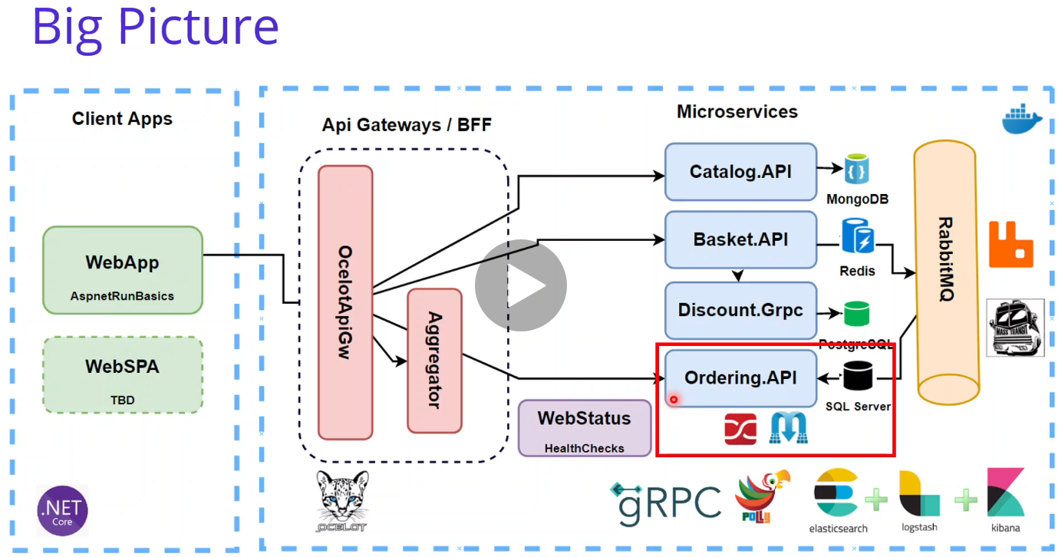

In this section we are going to Develop Ordering.API Microservices with SqlServer database and also applying Clean architectures and CQRS implementation. Let's take our big picture and see what we are going to build one by one. As you can see we are in here and starting to Develop Ordering.API Microservices with SqlServer. We are going to cover Developing Ordering microservice which includes; ASP.NET Core Web API application obeying REST API principles, performing CRUD operations, using Entity Framework Core Code-First approach and Implementing DDD, CQRS, and Clean Architecture with using Best Practices, applying SOLID principles, Developing CQRS implementation on commands and queries using MediatR, FluentValidation and AutoMapper packages and using the SqlServer database connection and containerization, using Entity Framework Core ORM and auto migrate to SqlServer when application starts up. And also In the upcomming sections, we are going to consume RabbitMQ BasketCheckout event queue using MassTransit-RabbitMQ configuration. So we will Analysis and Architecting of Ordering Microservices, applying Clean architecture and CQRS Design Pattern. Containerize Ordering Microservices with SqlServer database using Docker Compose. So in this section, we are going to Develop Ordering.API Microservices with SqlServer database Implementing DDD, CQRS, and Clean Architecture with using Best Practices applying SOLID principles.

**78. Analysis and Architecting of Ordering Microservices.** 7min

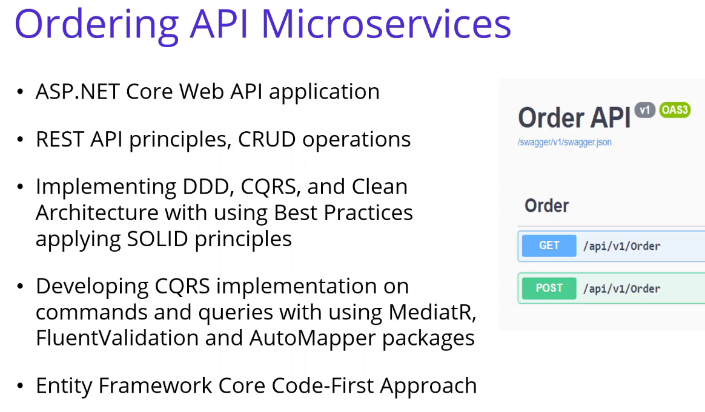

CQRS Command and Query Responsibility Segregation

Ordering microservice use ASP.NET Core Web API reference application with Entity Framework Core, demonstrating a layered application architecture with DDD best practices. And also Implements

N-Layer hexagonal architecture (Core, Application, Infrastructure and Presentation Layers) and Domain Driven Design (Entities, Repositories, Domain/Application Services, DTO’s…) and aimed to be a Clean Architecture, with applying SOLID principles in order to use for a project template.

Also implements CQRS Design Pattern into their layers in order to separate Queries and Command for Ordering for ordering microservice. We will be following best practices like loosely coupled, dependency-inverted architecture and using design patterns such as Dependency Injection, logging, validation, exception handling, localization and so on.

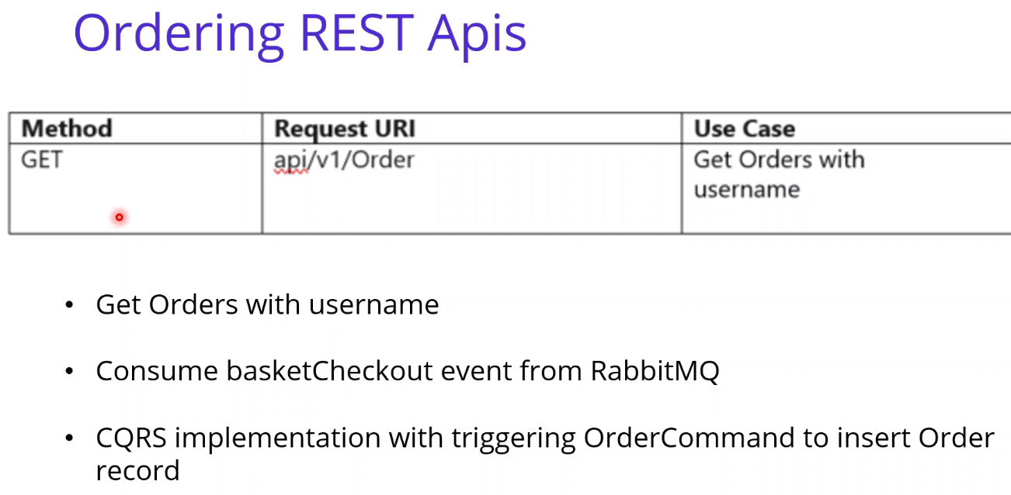

Well, if we check the restful APIs. We will start with the analysis and design our exposing restful apis for Ordering.API microservices. So as you can see in here, ORDER REST GET API - explain asp.net core controller class and attributes Also we will add Post operation in order to test checkout from Controller

But one more main responsibility, which is not exposing APIs. It is Consuming RabbitMQ BasketCheckout event queue. So when we consuming RabbitMQ BasketCheckout event queue with using MassTransit-RabbitMQ Implementation. These will be handled in the Ordering microservices. We are going to consume RabbitMQ BasketCheckoutEvent with using MassTransit-RabbitMQ in Ordering microservices. Of course we are going to CQRS implementation with triggering OrderCommand to insert Order record into SqlServer database.

Basically, we will have a Web API which implemented CRUD operations over Order entity and perform as a RabbitMQ Listener which consume basketCheckout events from Basket Microservices with CQRS design pattern using MediatR.

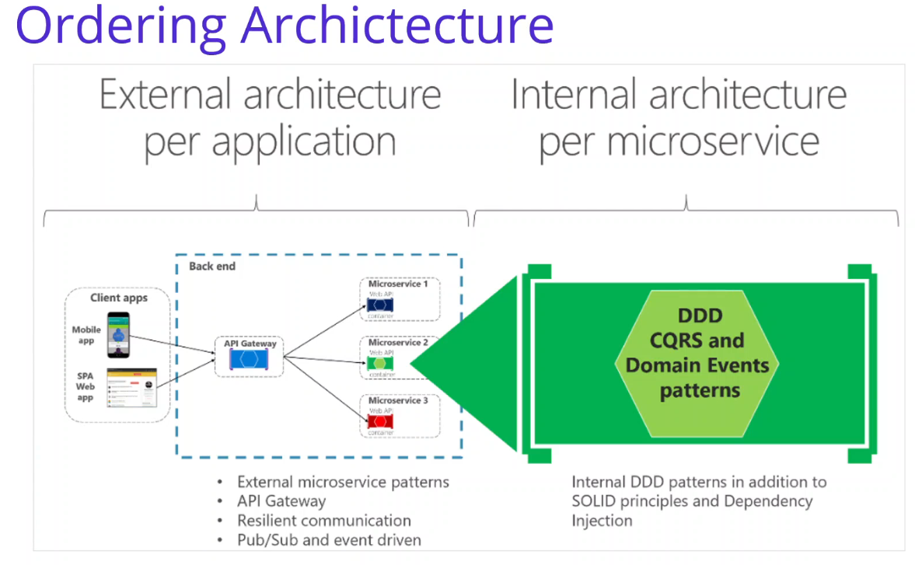

After that, if we look at the architecture of our Ordering microservices, We are going to use DDD, Clean Architecture and CQRS design pattern. We are going to Design a domain model for each microservice or Bounded Context that reflects the understanding of our business domain. The architecture patterns used in this section are based on domain-driven design (DDD) and Command and Query Responsibility Segregation (CQRS) Command and Query Responsibility Segregation pattern (CQRS) approaches, you can see in this picture in this picture also, and You can see External microservice architecture versus internal architecture patterns for each microservice. For Catalog, Basket and Discount microservices we used to N-Layer Architecture implementation. implementation. But for Ordering microservices, we are going to apply Clean DDD Architecture with CQRS design pattern implementation. design, pattern implementation. So we will explain DDD patterns in addition to SOLID principles and Dependency Injection in the upcoming videos.

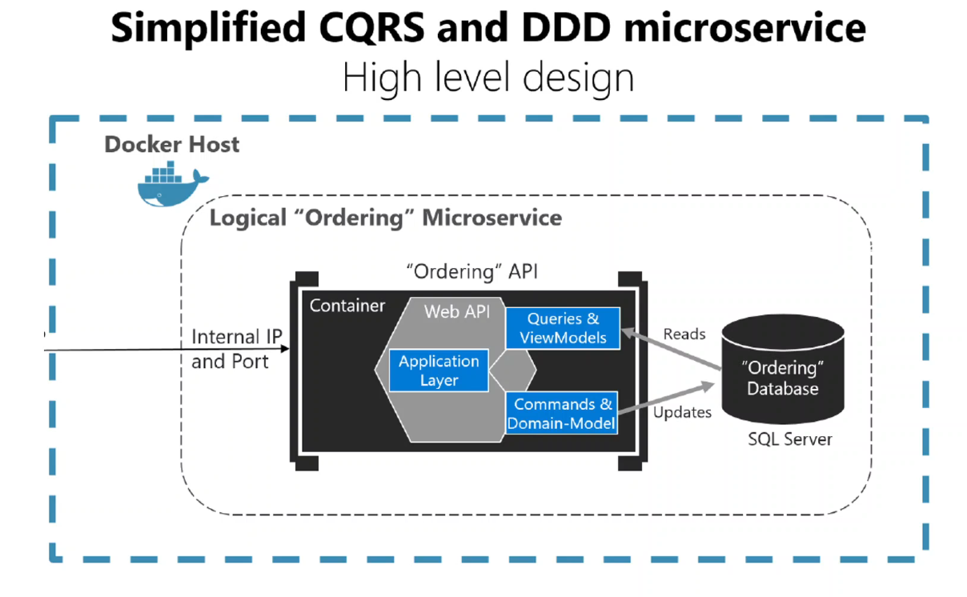

OK, if we check Simplified CQRS and DDD microservice view. Ordering api microservices will be Apply simplified CQRS and DDD patterns in a microservice. CQRS is an architectural pattern that separates the models for reading and writing data. The basic idea is that you can divide a system's operations into two sharply separated categories: One is the queries you can see in here. these queries returns as a result and don't change the state of the system. and they are free of side effects. There's no effect for the application, but the other one is the commands. These commands change the state of the system. So that means we have clearly separated queries and commands in our ordering my resources with a applying cqrs design pattern. The separation aspect of CQRS is achieved by grouping query operations in one layer and commands in another (parallel) layer. Each has its own data model. As you can see, that we have one database, but you can separate the queries and the command database differently and is built using its own combination of patterns and technologies. Ordering microservice implements a microservice based on a simplified CQRS approach. It is using a single data resource or database which will be SqlServer but 2 logical models, plus domain driving design patterns for the transactional domain, as you can see in this image.

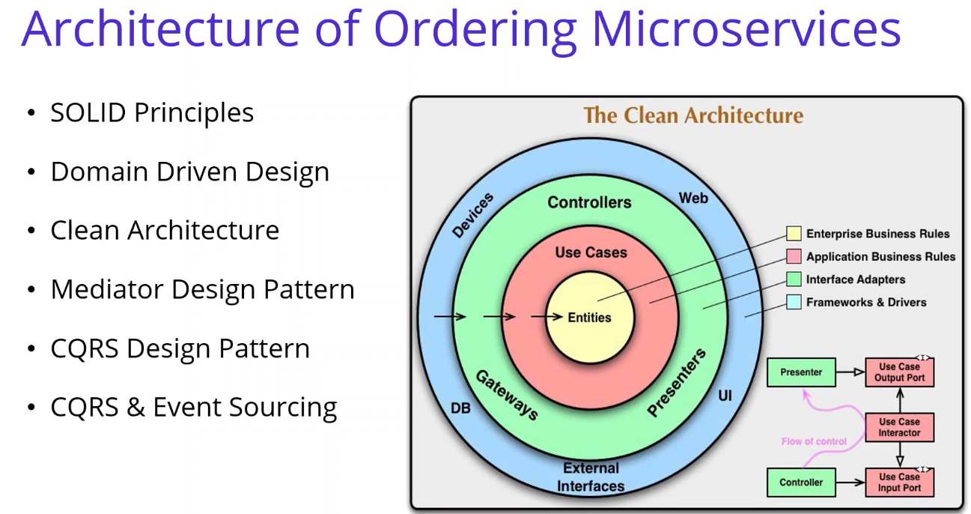

So if you look at the architecture of Ordering Microservices, Ordering Microservices Architecture will be the Clean Architecture but applying DDD principles and CQRS Design Pattern. So before start to developments, We should understand architecture principles and best practices of SOLID, DDD, Clean Architecture and CQRS Design pattern. Well, I'm going to explain these base patterns and best practices before we start architecture, we should know the design principles and some of the design patterns of the over the clean architecture. In upcoming videos, we are going to talk about these design principles and the best practices.

**79. Design Principles - SOLID** 3min

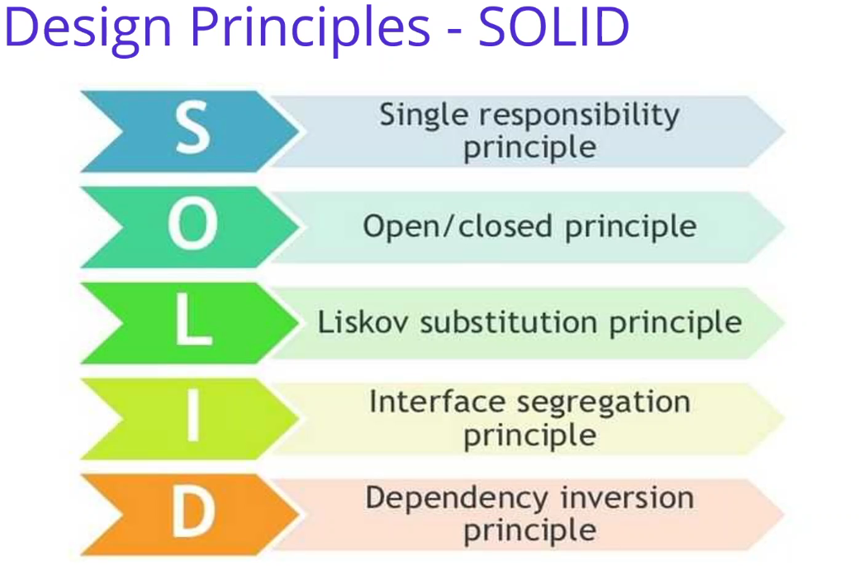

In this video we are going to see our first Design Principles - SOLID. SOLID software principles, is the set of principles put forward by Robert C. Martin, which ensures that the software developed is flexible, reusable, sustainable and understandable, prevents code repetition. So the main purpose of these principles, in order to easily adapted to requirements in the future and easier to add new features without the need to change anything in your code and also minimal change in code despite the new requirements and minimize the loss of time caused by the problems, such as the continuous correction on the code or even re-writing to code. So we have five principles. Let me start with the **single responsibility principle**. This will be you can't think about that, a class can only be changed for the sake of the purpose, it is the responsibility that is imposed on that class. So that class has only one job to do. We can talk about all the class and this class, only responsible one job and do not do anything else inside of that class or into the methods. And second, the principle is **open, close principal**. Again, a class or function should preserve existing properties and not allow changes. so that means it should not change its behavior and it should be able to gain new features. So that means open for the extensibility close for the modifications. And the third one is the **Liskov substitution principle**, we should able to use subclasses instead of the upper classes from which they derive without needing to make any changes in our code So that means we can use interfaces which are changing to any implementation code. These interfaces can be manage with the substitution each other. And the third one is the **interface segregation principle**. Instead of to collecting all responsible turns into a single interface, we should create more customized interfaces. We can separate the interfaces as per the responsibilities. It will be manage Easier to manage your interfaces and the dependencies. And the last one is a **dependency. inversion principle**. Dependencies between classes should be as low as possible, and especially upper classes should not be dependent on the lower classes. But these are the main principles and all these principles is very similar to each other. We have some connection with these principles, but we can see that how we can apply these principles one by one when we are developing Ordering microservices.

**80. Design Principles – Dependency Inversion Principle (DIP)** 3min

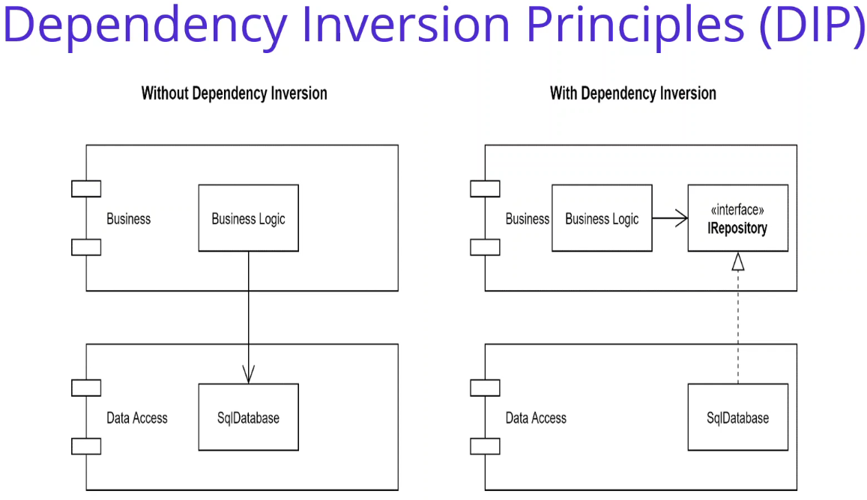

In this video we are going to talk about Design Principles - Dependency Inversion Principles (DIP). we can say that DIP. Let me start with a definition of dependency. What is dependency? We can explain that a class is dependent on another class that means, a class needs another class in order to work properly. As you can see on the left hand side in here, the upper level layers using the lower level layers classes, interface and so on. We can say that the level is dependent on the other layer. As for the reusability, we think that a class can be used in various part of the project, but we can define a code that higher level libraries can be used in and other projects without touching to code. We should do this because of the interdependence of classes in well defined software. At this point in order to break this dependency. We have a Dependency Inversion Principle (DIP), which is an important software principle that needs to be implemented in order to develop more flexible and reusable models. So briefly explain this method for the Dependency Inversion Principle (DIP), we can say that upper level models, class or other stuff. Lower level classes must not be dependent on the modules. But that means lower level modules must be dependent on the higher level modules interface or the other modules or shorty we can call a dependency inversion principle. Let's see the picture and how I applied this principle on the left hand side. we found a Layered Application where the Business Logic depends on the SqlDatabase implementation. It is a coupled way to write code. On the right side, by adding an IRepository and applying DIP then the SqlDatabase has its dependency pointing inwards. By this way, we can inward the dependencies from lower level to upper level, which using the interfaces and broke to direct dependencies in order to use reusable modules and any code change can be happened to be. Both sides of the layers can be changed.

**81. Design Principles – Separation of Concerns (SoC)** 2min

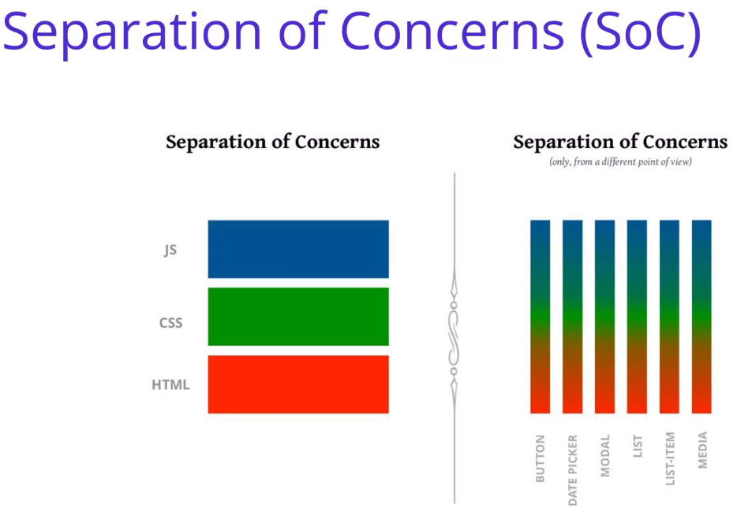

In this video. We are going to talk about design principles, which is the Separation of Concerns we can say that SoC the separation of concerns, says that the elements in the software should be unique to them not to share the responsibilities with other models. So what benefits does this separation of concerns do? Separation of concerns enables us to make improvements in every new model or existing model improvements that we develop in our application without destroying or affecting other models. Basically, we distinguish between the concepts of layers and certain responsibilities. In other words, the namespace of our software companies can also be used as limits to allocate responsibilities. So low-coupling, high-cohesion is indispensable. Being close to each other in their responsibilities within the components will reveal re-usability. we can give an example to separation of concerns that the development of WebUI. As you can see the right hand side, the UI elements in example button needs to configure by 3 structure; HTML— CSS — JS. and JavaScript. There are also additional principles like don't repeat yourself to implement the DRY principles. It will encapsulate common solution into a unique place in your code and also persistent ignorance and so on. But all these principles is going to be will domain drive design and clean architectures. So in the next year, we can talk about DDD.

**82. Design Principles – Domain Driven Design (DDD)** 5min

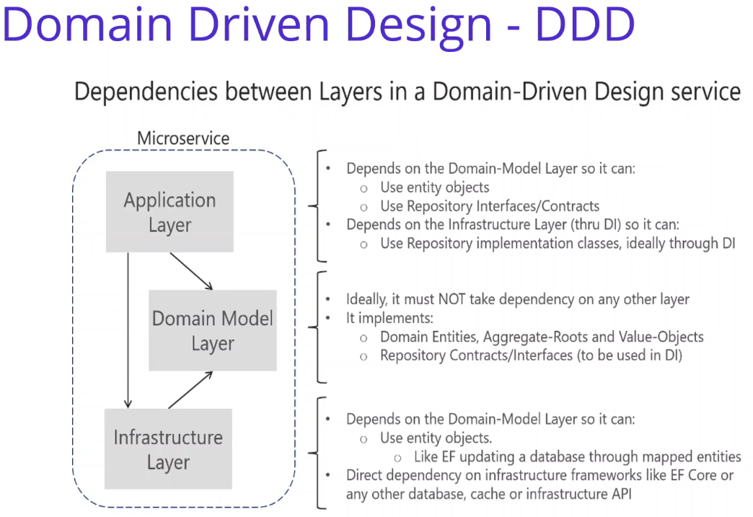

<https://medium.com/aspnetrun/cqrs-and-event-sourcing-in-event-driven-architecture-of-ordering-microservices-fb67dc44da7a>

In this video we are going to talk about Domain Driven Design - DDD. Domain Driven Design (DDD) is not an improved technology or specific method. Domain Driven Design (DDD) is an approach that tries to bring solutions to the basic problems frequently experienced in the development of complex software systems and in ensuring the continuity of our applications after the implementation of these opposing projects. To understand Domain Driven Design (DDD), some basic concepts need to be mastered. With these concepts, we can enter the Domain Driven Design (DDD). We can say that four main concepts we have, including in the domain driven design, first is the **ubiquitous language**, and the second is the **entity value objects**. Third is the **aggregate root**. And the last one is the **Bounded context**.

If you talk about one by one ubiquitous language, it is that one of the cornerstones of the domain driving design, we need to be able to produce the desired output of the software developers and to ensure the continuity of these output, to be able to speak the same language as the domain experts on the same language is very important. Afterwards, we must transfer this expertise to the methods and the class that we use while developing our applications by using the names of the concepts used by the domain experts. For every service we will use in our project must be a response in the domain. For that reason, everyone involved in the project can speak this common language and understand each other. This is the first concept of the DDD

And also, I would like to talk about the Bounded Context, Bounded Context, also, one of the main concepts of the Domain Driven Design. Bounded Context is recommended approach to use in Domain Driven Design (DDD) complex systems. systems. The complex system may contain subdomains within a domain. It should also include domain driven design. If you talk about the example of the e-commerce application, also we have developing the e-commerce application, the bundled context should be order management, customer management, stock management, delivery management, payment system management, product management. User management may contain many subdomains as these subdomains are grouped, bundled context, referring to structures in which the group of individuals most logically associated with each other in terms of the rules of the aggregate, root and group together and the responsibilities of the group are clearly defined. So that means when you combine the subdomains, it will reach the Bounded context and we should group these Bounded context in responsibilities and clearly defined.

If you look at the figures, you can see that dependencies between layers, according to Domain driving design, they will also follow these layers in the structures. It is start with the domain model. You can see in here domain that ideally it must not take dependencies on in other late. So this should be a no dependencies. It is including to implementing the domain entities, aggregators, roots and value objects. Also, you can define as opposed to the context and interfaces.

And the other one is the application is it is depending on the Domain layer and you can use the entities objects from the domain it and use the interfaces. And of course, it is depends to the Infrastructure layer in order to use Repository implementation class. Ideally, we are going to use dependency injection, of course, in the infrastructure layer. It is depending on the domain model layer and using the entity objects. And for example, you can implement the database operation in the infrastructure layer, in our case. Also, we are going to implement Entity Framework Core Code-First Approach in order to connect to SqlServer database database. As you can see that we have understand the DDD and see one of the implementation into the microservices. In the next video, We will talk about the clean architectures with domain driven design.

**83. Clean Architecture with Domain Driven Design (DDD)** 10min

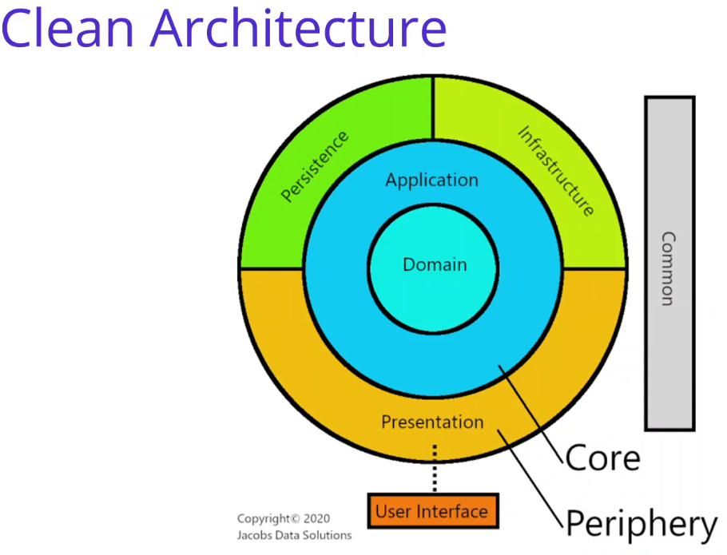

<https://medium.com/software-alchemy/a-brief-intro-to-clean-architecture-clean-ddd-and-cqrs-23243c3f31b3>

In this video we are going to talk about Clean Architecture with DDD. Clean Architecture, also known Onion Architecture, Hexagonal Architecture as know as Ports and Adapters pattern, is one strategy to decouple the use cases from the external details. It was coined by Alistar Cockburn more than 13 years ago, and this received improvements with the Onion and Clean Architectures. It evolved over time from several other architectures including Hexagonal Architecture, Ports and Adapters, and Onion Architecture. Uncle Bob emphasizes five qualities of Clean Architecture, The first one is the **Framework independence**. That means the architecture is decoupled from third party frameworks. The second one is the **Testability**, the architecture is easy to write unit tests against. The third one is the **UI independence**. the architecture can be unplugged from the user interface. And the third one is the **Database independence**, the architecture is decoupled from the underlying data store, databases. And the last one is the **External agency independence**, External agency independence, the business rules of the architecture are isolated and know nothing about the outside world. So I take this image from medium article of Jacobs Data Solutions, you can find the link below. It is very well visualized what we are going to develop for Ordering microservices.

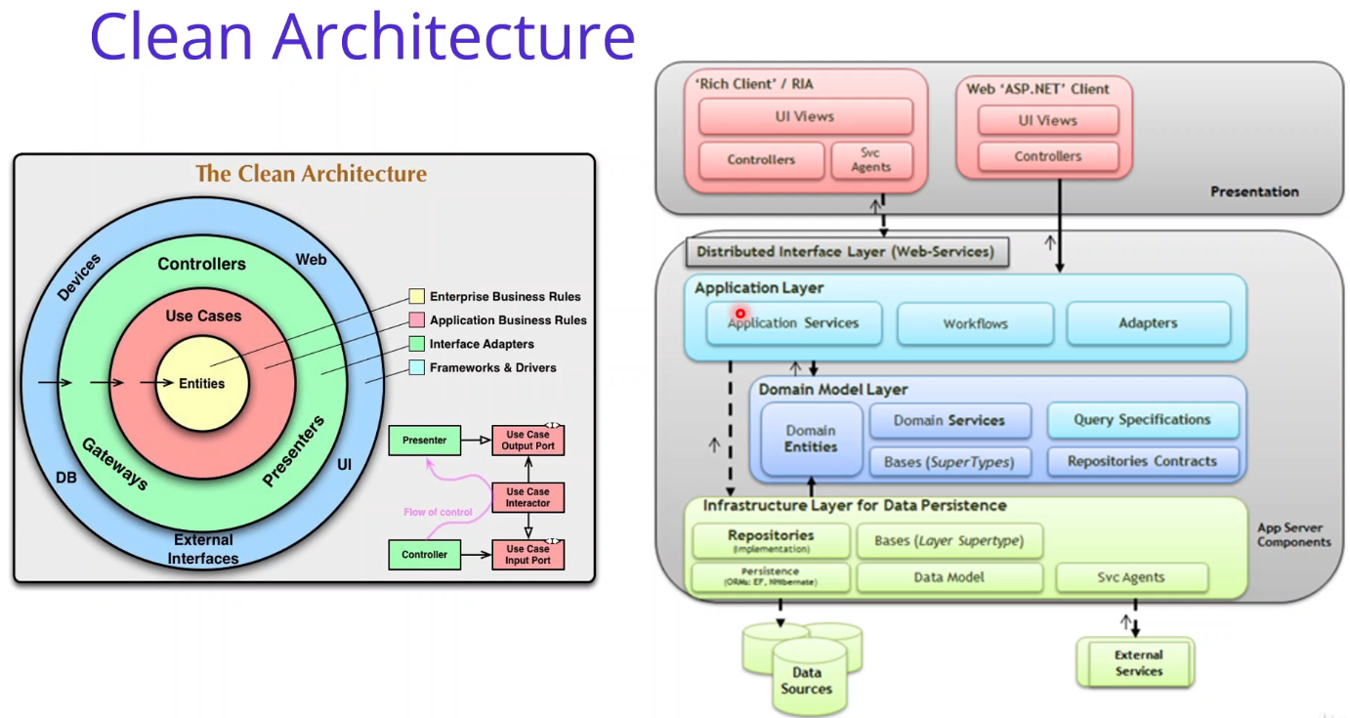

You can find different views for the Clean Architecture images like concentric circles, each representing a different layer of the application, or you can see these layers in the Clean architecture. So basically, The main principle is Dependency Rule, as we already seen in Dependency Inversion Principles. principles, This rule says that source code dependencies can only point inwards. So dependencies should be always inwards. The inner circle can know anything at all about something in an outer circle. outer circle. So in our case, the entities I mean Domain Layer didn't know anything about the use cases, the application layer and the application layer didn't know about the presentation layer, and the other infrastructure, external dependencies. So this is the our main principle, the inner circle can know anything at all about something in an outer circle on the implementations of those abstractions will become external outer layers.



OK, if you come back to main slide, As you can see the image, note that there is separating 2 main concepts; concepts, one for the Core layer and the other for the Periphery layers which surrounding with the Core layer. If we check the Core Layer, we have domain and application layers, if we check the Periphery Layer We have presentations, persistence and infrastructure details, which is the external dependencies, external outer layers for the Core Layers.

OK, Core module includes both Domain and Application layers, Periphery module includes all external outer layer which's are Persistence, Infrastructure and Presentation layers. Of course all these layers using the Dependency Inversion principle. Inside Core layers should have pure logic and abstractions. And never have any knowledge about the outside layers, implementations. So Inside layers work with the abstractions that are defined within those layers, and the actual implementation logic exists in the outside layers. the outer layers. So The Dependency Inversion principle provide to work with abstraction and implement them outside layers. outside layers.

But in a concept manner we can distinction between, what is essential - the Core and what is a detail -the Periphery we can say that these domain and the application will be the Core Layer is the essential of our application. And these are the details of the application. We can call that Periphery Layers.

Lets talk about Core Layers Let me start with the domain layer. Development of Domain Logic with abstraction. Interfaces drives business requirements with light implementation. implementations, The Core project is the center of the Clean Architecture design, and all other project dependencies should point toward it. This layer is built out using DDD principles, and nothing in it has any knowledge of anything outside layers. For the most part, dependency injection is not used here. For most part, dependency injection is not used in here because Domain should not have any dependencies from the external systems.

If you talk about Application layer, This layer for Development of Domain Logic with implementation. The Application layer declares interfaces and other abstractions which stand for infrastructure, persistence, and presentation components. The actual implementations for these components are not declared in this layer but are provided to Application components via dependency injection. Interfaces drives business requirements and implementations in this layer. in these layers.

Application Layer in order to implement our business logics, use case operations. The first point of implementation is definition of Model classes. So that means, Application Layer should be implement our business requirements, business use cases. But these should be handled with the abstractions of the external systems there should be not an implementation of any persistence or infrastructure implementation. These should be used abstractions, interfaces and performing business use, case business rules, business validations into the Application Layer.

OK, if we talk about the Periphery Layers and start with the infrastructure layer, this is the implementation of the Core interfaces in this project with Entity Framework Core and other dependencies. That means we call that Domain and Application Core Layer. And these infrastructure layer contains implementations for these infrastructure interfaces declared from the application and domain layer. Most of your applications dependence on external resources should be implemented in classes which is defined in the infrastructure project, these classes must implement the interface defined in the core layer. That means domain or the application layer. If you have a really large project with many dependencies, it makes sense to have more than one one infrastructure project or for example, you can say that infrastructure.data, infrastructure.external calls and so on, you can split one more infrastructure in order to implement your dependencies and separated responsibilities in the infrastructure layers. But in most cases, in most project one infrastructure project is enough for it. OK, this could be includes, for example, email providers while Access Web API clients and so on, one of these repository only dependent sample data access and basic domain actions. By the way, there will be no direct links to our core layer or UI projects.

Well, if you talk about the presentation layer, the presentation layer is an API layer that brings together all the application layer components and injects them with the proper implementations, development of the UI logic with implementations. Interfaces drives business requirements and implementations in this layer. Our application Presentation Layers will be the ASP.NET Core web project. will be the ASP.NET Core Web API projects and this will be the our Microservices exposing API layers we already did it When we are developing Catalog, Basket and Discount microservices. We had Controller classes.



So here you can see different illustration of Clean Architecture. You can see that Domain Model layer has no dependency but Application and Infrastructure layer depended to Domain layer. We will also call these Domain and Application Layer as a Core layer, and Infrastructure and UI layer will be the Periphery layers. Ordering Microservice, implements these Layers with Clean architecture, Domain, Application, Infrastructure and Presentation Layers and Domain Driven Design Practices, Entities, Repositories, Domain and Application Services, DTOs. Also implements and provides a good infrastructure to implement best practices such as Dependency Injection, logging, validation, exception handling, localization and so on. So we are going to develop Ordering Microservices with implementing the Clean architecture and obeying the domain driven design principles and best practices.

**84. CQRS (Command Query Responsibility Segregation) Design Pattern** 2min

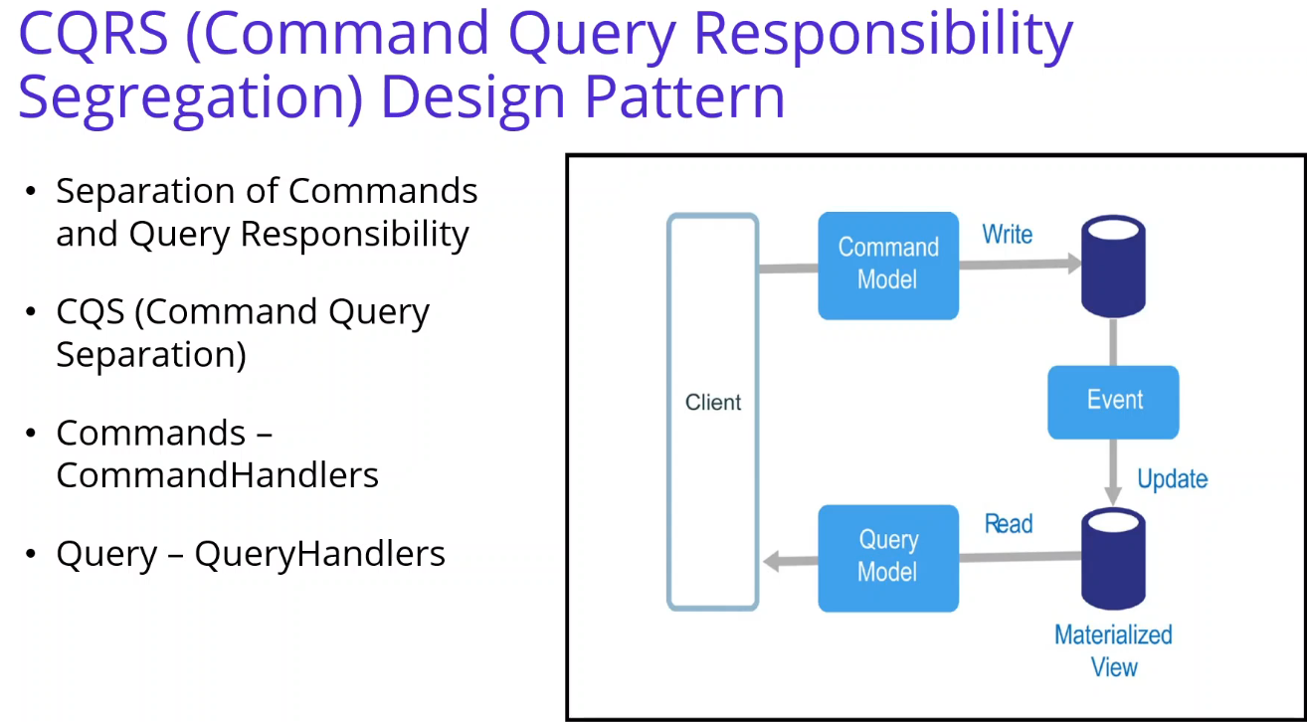

In this video we are going to talk about CQRS (Command Query Responsibility Segregation) Design Pattern. Pattern. CQRS means separation of command and query responsibilities. Although it has become an increasingly popular pattern in recent years, it has increased in popularity after this article written by Martin Fowler when he saw this pattern by Greg Young. We can say that it is based on the CQS (Command Query Separation) principle for the CQRS architecture. The main idea of CQS is to separate the interfaces between our operations that read the data and the operations that update the data. In CQRS, this is added to the separation of our business models. CQRS is a software development pattern based on conducting reading and writing / updating processes on different models. The data you read and the data you write are stored in different database tools.

If we check the image, you can see the Commands writing in another database and queries is reading a Materialized View database. If you talk about Commands, First of all, command type is the only way to change something in the system. If there is no command, the state of the system remains unchanged. Command types should not return any value. any value. Command types often act as plain objects that are sent to CommandHandler as parameters when used with CommandHandler and CommandDispatcher types. types.

If he come to the Query, The only way to do similar reading is the type of Query. They can't change the state of the system. They are generally used with QueryHandler and QueryDispatcher types.

After doing Command and Query parsing in our system, it will be clear that the domain model we use for data for data writing is not suitable for reading data. So in our Ordering microservice, we also implement CQRS Design Pattern but we are going to use for 1 data sources for writing and the reading data.

**85. Eventual Consistency and Event Sourcing with CQRS Design Pattern** 6min

<https://github.com/jasontaylordev/CleanArchitecture>

Clean Architecture with ASP.NET Core 3.0 - Jason Taylor - NDC Sydney 2019

<https://www.youtube.com/watch?app=desktop&v=5OtUm1BLmG0mG0>

<https://twitter.com/gillcleeren/status/1367863587163766787>

Gill CLEEREN: Clean architecture with ASP.NET Core | UCP2019

<https://www.youtube.com/watch?v=BxtHt7tsX-c&t=4s>

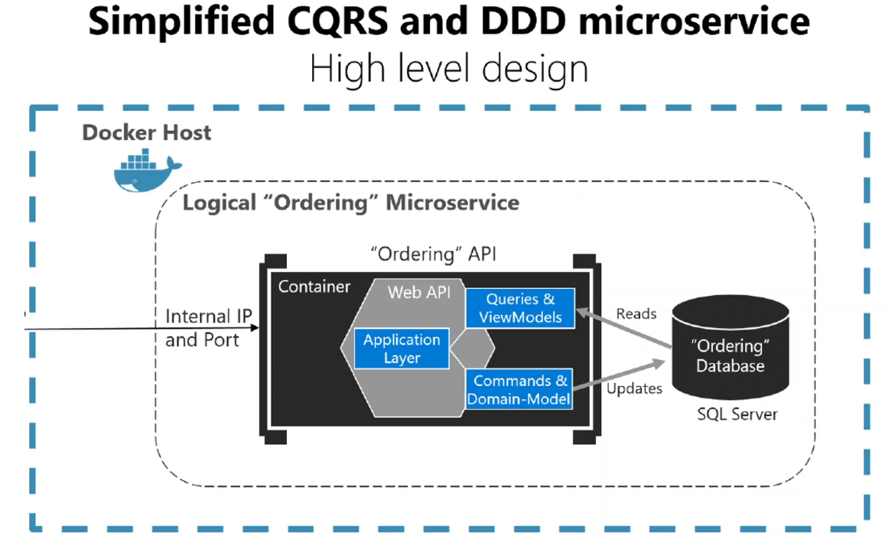

In this video we are going to talk about Code Structure on CQRS and DDD Implementation in Ordering Microservices. In this section, we are going to develop ordering microservices, with simplified CQRS and DDD microservice. Ordering microservice use ASP.NET Core Web API reference application with Entity Framework Core, as a ORM tool, demonstrating a layered application architecture which is the Clean Architecture. And implementing these Clean Architecture and DDD best practices and so on. Also, we will implement CQRS Design Pattern into our layers in order to separate Queries and Command when performing the Ordering microservice business requirements.

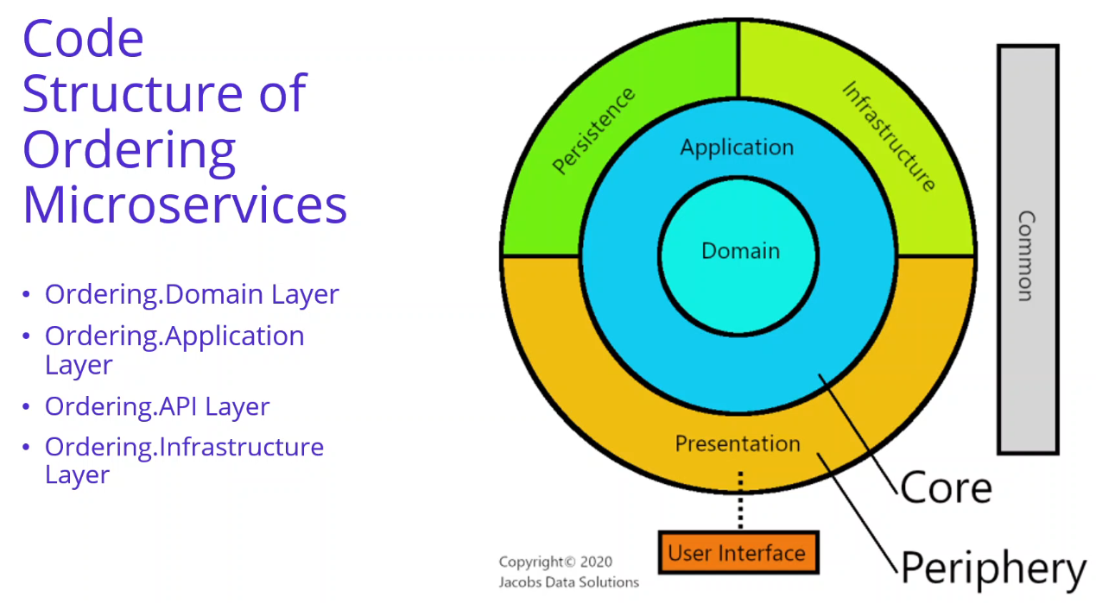

If you check the code structure of our Ordering microservices, we can analyze an architect of Ordering microservices In order to applying Clean architecture and CQRS Design Pattern, we should create these 4 layer. Ordering.Domain Layer and Ordering.Application Layer These will be the Core Layers And after that, we have Ordering.API Layer, which is the presentation layer and Ordering.Infrastructure Layer which is the infrastructure later we can call these 2 layer is Periphery Layers.

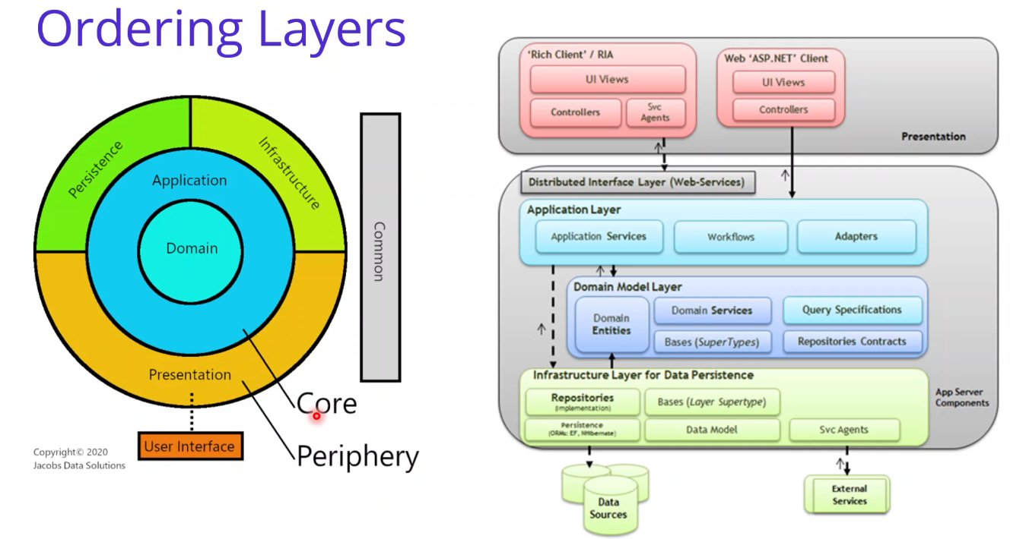

OK. So,Ordering.Domain Layer and Ordering.Application Layer will be the Core Layer and Ordering.API Layer and Ordering.Infrastructure Layer will be the Periphery layer of our reference application. If we look inside of these layers, you can see the picture on the right side For Ordering.Domain Layer, we should have Domain entities and has no dependency. Ordering.Application Layer, we will have Application Contracts, Behaviors and Features which implement CQRS design pattern with using MediatR nuget packages. And when it comes to Ordering.Infrastructure Layer, this will handle both persistence concerns and other infrastructure concerns like mail sender. And lastly we have Ordering.API Layer, This will expose api to external microservices.

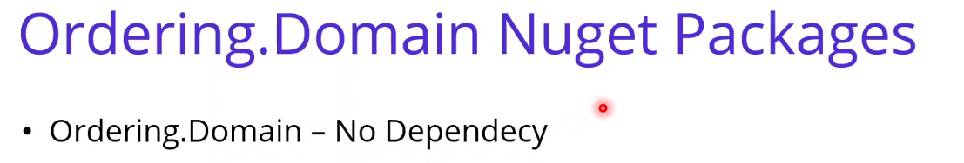

OK, if you check the Nuget Packages, for the Ordering Domain, we should have no dependency.

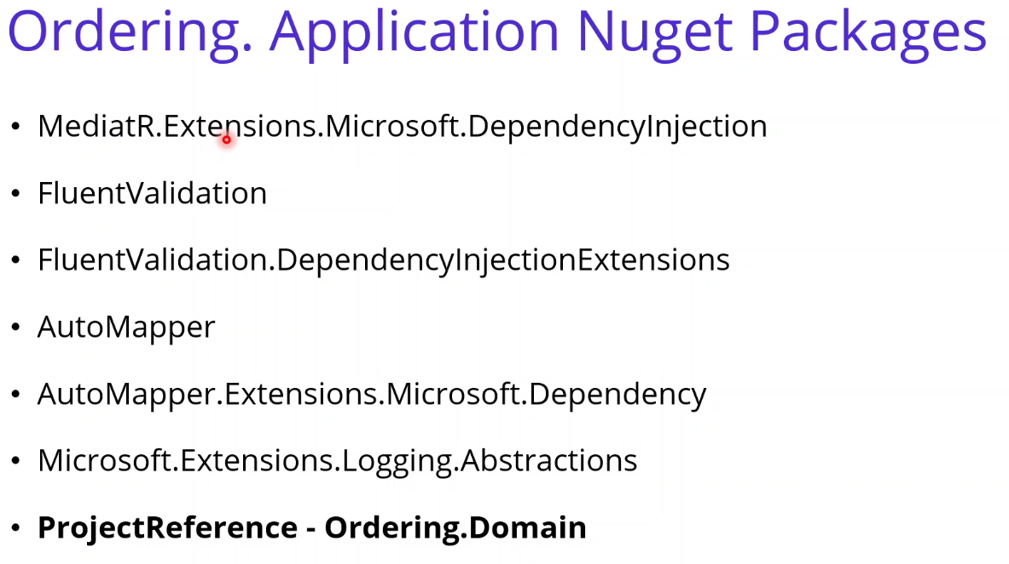

with Ordering.Application Layer, We have a mediator extension package, which will be using the MediatR. And we have a FluentValidation package for the performing validations when applying to CQRS design pattern And we will have AutoMapper for the mapping operations and of course, we have a logging abstractions and these all ordering application, it should be a project reference, which is the ordering domain dependency.

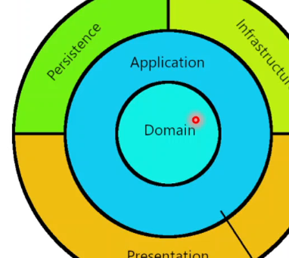

You can also check in here. We can see that the application layer should be dependent domain layer. layer, as a project reference. OK, as you can see, that we have also using the extensions, because these will provide to injected aspnet project and this is the also including the mediator itself. But that's why it's good to use the extension methods. And as the same point, FluentValidation, we also have the dependency injection extensions is the same way. We also have the AutoMapper extensions.

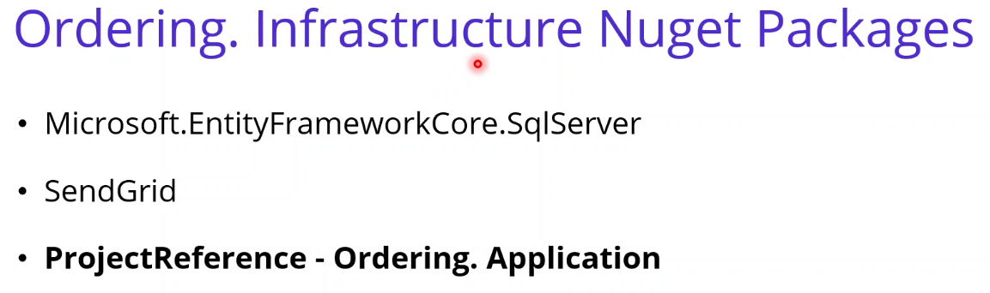

OK. if we proceed, we can talk about the ordering infrastructure. ordering infrastructure responsible by the database operations and also other external systems. Well, that's why we are going to install Microsoft Entity framework Core Sql Server package. This will be communicate with SqlServer databases and also SendGrid for the sending mail operations for the project reference, infrastructure should be get the application layer in order to use Core and Core layer application and domain Layers, entities and so on.

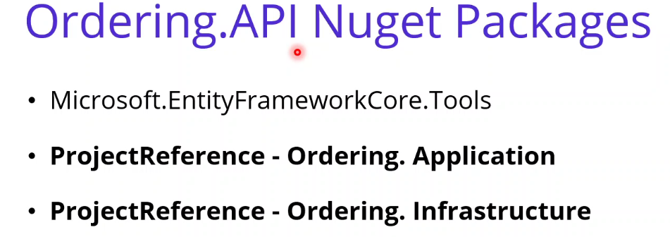

Or if we go further, we can talk about the Ordering.API layer, this will be the our presentation layer, which is a Periphery layers, and these will be required to EntityFrameCore.Tools in order to perform the migration's Code-First approach. But the important thing to Ordering API has a 2 project reference, one for the application layer and another for the infrastructure layer Layer. Application Layer reference you can think about the Core Layers because Application already referenced Domain Layer. And of course Core Layers should be dependent the Ordering.API and also Infrastructure Layer will provide to make operations in the Controller classes.

And one more thing I would like to mention that before we start to developments, I would like to mention that these two guys, Jason Taylor and Gill Cleeren. I have examine lots of clean architecture repository on GitHub and figure out that the best implementations belongs to Jason and Gill. Jason has a great clean architecture repository on GitHub, you can check this repository and also very good speech to explain the clean architecture on the youtube. Also, Gill has wonderful pluralsight courses on pluralsight and also you can find his speech about clean architecture on the YouTube. So I have to say that, I am heavily inspired by the Jason and Gill when implementing Clean architecture and CQRS design pattern in Ordering microservices. So as you can see that we have finished to design architecture of ordering microservices, now it is time to development.

**87. Create Asp.Net Web Api Project for Oerdering.API Microservice** 4min

Add Services\Odering folder.

Same as other APIs. Port 5004

**77. Introduction** 2min

**77. Introduction** 2min

**77. Introduction** 2min

**77. Introduction** 2min